Role Description

 | Role Title  Easy Read Trainer
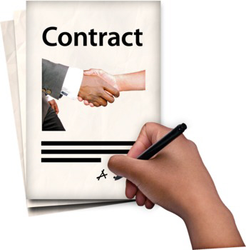   | Hours  This role is for 21 hours per week.  The contract will be from July 2021 to 31 May 2022
 | Salary  You would be paid £13,800 in total for the year. This is the equivalent of £23,000 if you worked full time.
   | Location  You can work from your own home to do this job.  You can also work in our office based in Glasgow.
 | Report to  You would be managed by the Operations Manager.
About Disability Equality Scotland
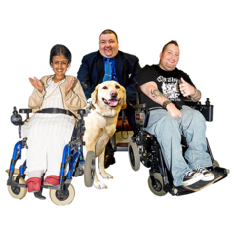   | We are a membership organisation for disabled people and disability groups.  We want to make Scotland fully accessible.
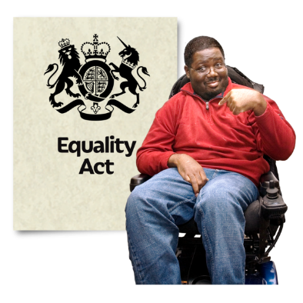 | We want disabled people to have the same opportunities as everyone else.  We work to promote access.  This could be access to the built and natural environment, access to information, to inclusive communication and to decision making.
Easy Read Service
We provide a professional and efficient Easy Read service.
This is part of our aim to improve access to information for everyone.
Easy Read – what is it?
 | Easy Read is an accessible format.  It makes written information easy to understand.  It uses simple language without jargon, and short sentences.  It has images to help people understand.

Why produce Easy Read documents?
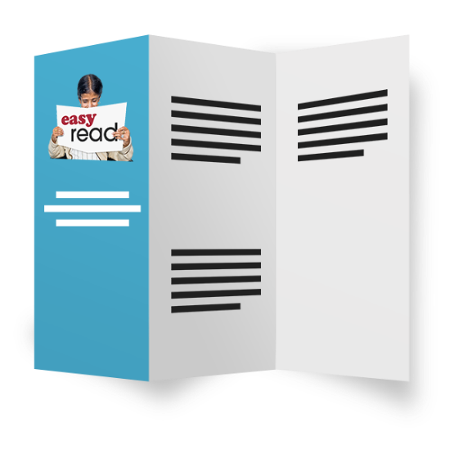   | Easy Read documents make information more accessible for people with learning disabilities.  They can also be useful for people with other communication difficulties.  This includes:  - acquired brain injury  - dyslexia  - people with hearing impairment whose first language is British Sign Language (BSL)  - people who do not speak English as their first language  - people who find reading difficult  - people with cognitive impairments such as dementia.

Job purpose
 | To do this job you will need to work with different people.  This includes staff at Disability Equality Scotland and our partners.
Key tasks and responsibilities
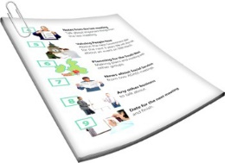  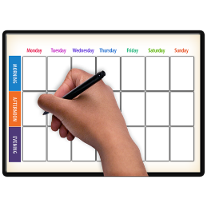          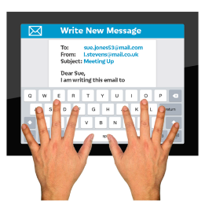     | You will have to:  - develop an Easy Read training course to teach other people about Easy Read  - deliver the training course to teach other people about Easy Read  - help to make sure Disability Equality Scotland communications are converted into Easy Read  - Help to design a new website to promote our Easy Read Service.  - Promote and communicate our Easy Read Service using all available mediums (Social Media, websites, posters, leaflets, magazine and newsletters)  - Represent the organisation to promote our mission and maintain good working relationships with stakeholders.
  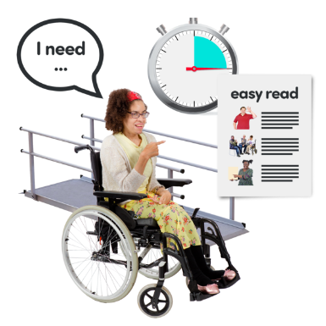 | You will also have to:  - Be a professional member of our staff team and work to the organisations policies and procedures in our employee handbook.  - All employees are also expected to promote and agree with the organisations policies on equality and diversity.

Description of skills, knowledge and experience needed for this role
    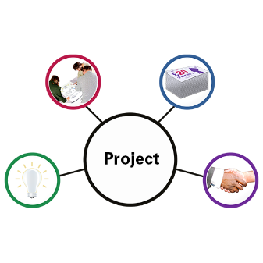    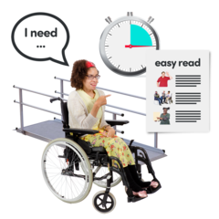       | To get this job it is essential that you:  - Have a qualification in training.  - Have experience of using Easy Read.  - Understand Inclusive Communication and know how important it is for disabled people.  - Can use Microsoft Office, Outlook, Excel and Internet software to a high standard.  - Have excellent skills at taking information and making it easy to understand.  - Have excellent administration and organisation skills.  - Have excellent skills in writing and can write reports.  - Can work effectively on your own as well as in a team and can do lots of different tasks at once.  - Can communicate effectively with different types of people.  - Can show commitment to learning more skills.  - Can be a leader of equality and values diversity.  - Have experience and understand Easy Read.  - Have knowledge and understanding of inclusive communication and delivering information in inclusive formats.  - Can be flexible and have an adaptable approach to work.  - Is calm and can meet deadlines.  - Are enthusiastic and committed to the work.
   | It would also be good, but not essential that you:  - Have experience of equality initiatives: have an interest in / or understanding of disability.  - Have an understanding of inclusive communications and can share information in these formats.  This role will require a high level of detail in finding the right information.

Equal opportunities
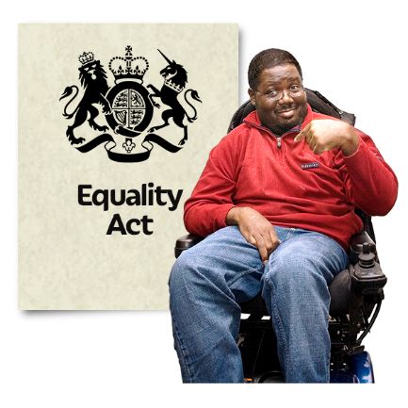 | We are committed to being disability-smart and an employer of choice, regardless of race, sex, sexual orientation, gender reassignment, religion or belief, marital or civil partnership status, age, disability or pregnancy and maternity.
 | We want our staff to be representative of wider society.
 | When we are recruiting, disabled candidates who meet all of the essential criteria will be guaranteed an interview.
 | Disability Equality Scotland is a disability confident employer.

How to apply for this role
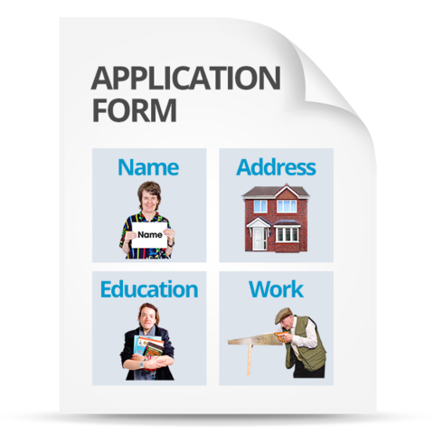 | Go to our website page  http://disabilityequality.scot/work-for-us/ and download and complete application form
 | Return your completed application form to:  Emma Scott  Operations Manager  Suite 204b, The Pentagon Centre  36 Washington Street, Glasgow  G3 8AZ
   | You can also contact Emma Scott if you would like to discuss the role.  Telephone number: 0141 370 0968  Email: emma@disabilityequality.scot

