Easy Read Trainer
Job Advert

 |  |  | Disability Equality Scotland want an Easy Read Trainer to join our team.  The Easy Read Trainer would design and deliver Easy Read training, helping us to deliver our Easy Read Service.
   |  |  | This role is for 21 hours per week.  The contract will be from July 2021 to 31 May 2022.
   |  |  | You can work from your own home to do this job.  You can also work in our office based in Glasgow.
   |  |  | We are a membership organisation for disabled people, and disability organisations.
   |  |  | It is important we communicate clearly to everyone and encourage others to do this too.
   |  |  | Disability Equality Scotland wants to make sure all its information, products and services are accessible to everyone.
How to apply for this role
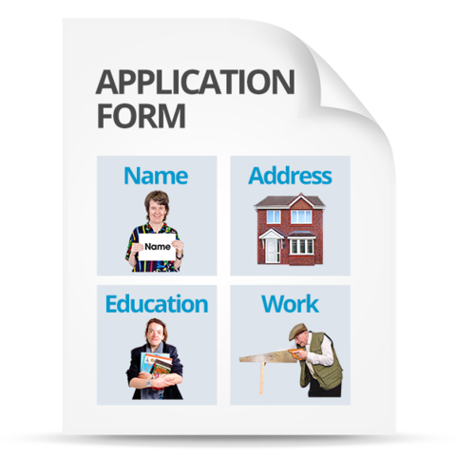 |  | Go to our website page  http://disabilityequality.scot/work-for-us/ and download and complete an application form.
 |  | Return your completed application form by 02 July 2021 to:  Emma Scott  Operations Manager  Disability Equality Scotland  Suite 204b  The Pentagon Centre  36 Washington Street, Glasgow  G3 8AZ
   |  | You can also contact Emma Scott if you would like to discuss the role.  Telephone number: 0141 370 0968  Email: emma@disabilityequality.scot
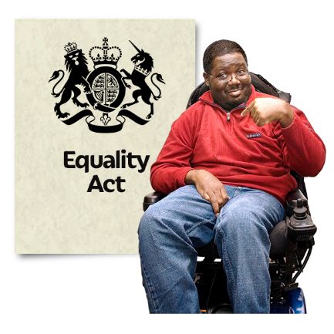 | Equal Opportunities  We are committed to being disability-smart and an employer of choice, regardless of race, sex, sexual orientation, gender reassignment, religion or belief, marital or civil partnership status, age, disability or pregnancy and maternity.  We want our staff to be representative of wider society.
 | When we are recruiting, disabled candidates who meet all of the essential criteria will be guaranteed an interview.
 | Disability Equality Scotland is a disability confident employer.

