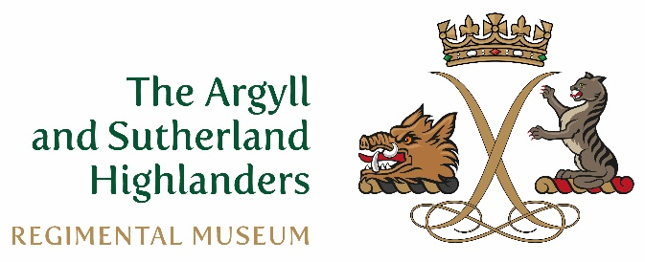
The Argyll and Sutherland Highlanders Museum
Charity registered in Scotland SC042084

Administration Officer
- General
Position | Administration Officer
Location | Stirling Castle
Supervisor | CEO
Status | Part Time (3 days per week)
Closing Date | Close of business 2nd July 2021

- Roles
The post holder is principally responsible for the smooth running of the Museum’s support functions, including inbound communications (mail and telephone), maintenance of office equipment, maintenance of personnel attendance and pay records and maintenance of accounting records, including the fundraising database.
The post holder is also responsible for providing administrative support to allocated Regimental functions, including the Ball, Dinner Club and Thin Red Line magazine.
The post holder is further responsible for providing administrative support to the Regimental Association in conjunction with the Secretary and Treasurer of the Regimental Association.
- Key Accountabilities
  - Museum Administration
- Collect and distribute inbound mail each day.
- Act as the primary responder to inbound telephone calls and distribute as required.
- Maintain contract and maintenance records for all office equipment (including telephones) and deal with any invoicing or technical issues which arise.
- Ensure that office supplies are replenished at appropriate intervals.
  - Regimental Administration
- Provide administrative support (mailing invitations, recording payments, maintaining contact lists, etc.) for the Dinner Club, Ball and Thin Red Line magazine.
- Provide administrative support if required for Regimental and Museum Trustees meetings.
  - Regimental Association
- Support the Secretary and Treasurer of the Regimental Association as required.
  - Finance
- Adhere to relevant Museum administrative and financial policies and procedures.
- Make regular journal entries in the Sage accounting system to record all receipts and payments relating to the Museum Trust and Regimental Trust.
- Make required returns to HMRC accurately and in a timely manner.
- Support the Museum’s external accountants as required, particularly with respect to provision of documentation for audits, tax returns, funding claims, and the like.
  - Fundraising
- Populate and maintain the E-Tapestry fundraising database and check on a monthly basis that E-Tapestry receipts and balances agree with the accounting system.
- Process Charities Aid Foundation returns for donations received.
  - People
  - Maintain staff payroll records and provide to the payroll service as required.
  - Maintain staff leave and attendance records.
  - Work cooperatively with other members of the Museum team to develop and deliver assigned projects.
  - Events
- Provide administrative support, if required, for Museum events within and outwith the Castle, in line with overall Activity Plan objectives.
  - Marketing
- Represent the Museum professionally and positively in all dealings with outside parties.
- Promote the Museum’s mission to relevant outside parties.
- Essential Requirements
- Experience, or at least an understanding of, the UK military.
- Experience, or at least an understanding of, the museum sector.
- Ability to engage positively with a wide variety of people, both within and outside the Museum
- Ability to work on multiple tasks simultaneously, while adhering to deadlines.
- Accuracy in maintaining records and interacting with outside agencies.
- Museum Mission
To develop the Regimental Museum of The Argyll and Sutherland Highlanders, as a premier attraction within a world-class heritage site at Stirling Castle; as a lasting tribute to those who served in the Regiment; and to support the work of the Museum Trust, which includes community engagement and education, and contributing to the support of veterans.

- Further Information
- https://www.argylls.co.uk/
- https://twitter.com/ArgyllsMuseum
- https://www.facebook.com/TheArgyllAndSutherlandHighlandersRegimentalMuseum

