**Role Profile -** **Engagement and Communications Manager (Colleagues and Stakeholders)**

**Reports To:**

Director of Marketing of Communications

**Role Purpose:**

You will lead strategic colleague communication across the charities, ensuring high levels of understanding and engagement amongst colleagues, enabling them to be ambassadors for the organisation. You will also be responsible for devising appropriate communications messaging and channels for key external audiences related to any change related programmes as well as encouraging engagement with service users and families on issues related to strategy and service development.

You will be responsible for drafting corporate communications strategies and messaging on behalf of members of the Executive Team, including the Chief Executive. You will ensure that internal and external messages are aligned when appropriate and timed effectively for release. You will advise senior management on strategic communications approaches relating to colleagues, change, crisis and issues of a sensitive and / or confidential nature.

You will be a member of the Marketing and Communications Department and liaise closely with the People Team on communications relating to colleague engagement, culture, values and other people related initiatives.

All roles within Sight Scotland and Sight Scotland Veterans are expected to work to our values and Our Ways of Working framework:

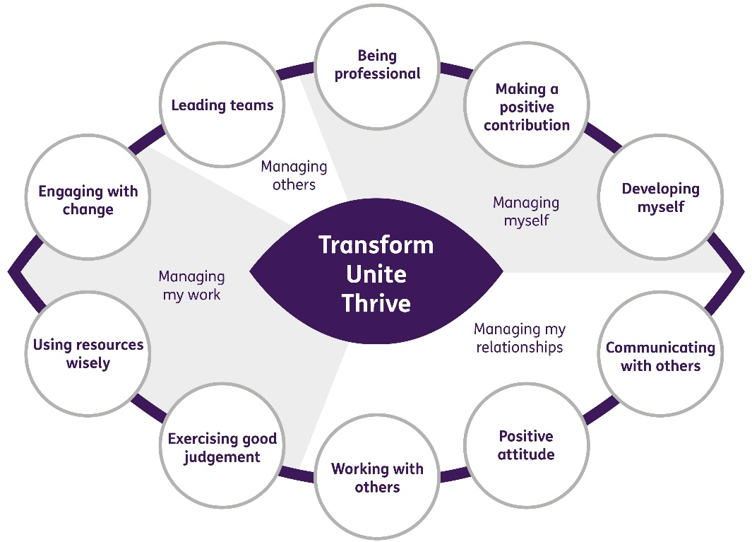

**Our Ways of Working – Managing My Work**

**The main responsibilities and accountabilities of this role are that you will:**

**Internal communications**

* Contribute towards the achievement of organisational goals and plans, engaging colleagues across the charities through a strategic approach to delivering high quality, effective, inclusive internal communications
* Develop and deliver an effective internal communications and engagement strategy which is aligned to the organisational strategy, the Marketing and Communications strategy and the People strategy
* Write and produce regular colleague newsletters and utilise other key channels to inform and engage colleagues in news, strategy and organisational developments
* Oversee and write content for the intranet, ensuring it is current, informative and engaging, working with IT on technical updates and changes
* Draft all colleague messages relating to strategy on behalf of the Chief Executive and other members of the Executive Team
* Support the organisation of colleague focus groups, research, surveys and internal events, as and when required
* Develop marketing collateral appropriate for internal communications campaigns
* Engage colleagues in the charities’ stories to enable them to develop, protect and enhance the brands and reputation
* Co-ordinate network of Brand Champions and engage them in encouraging brand consistency across the charities
* Develop strong working relationships with other members of the Marketing and Communications team to ensure alignment between internal and external communications messages
* Work with the People Team to ensure staff induction and training and other key initiatives are aligned with the brand and agreed communications messaging
* Monitor and evaluate internal communication activities on an ongoing basis

**Change communications**

* Actively support and advocate change within the organisation, embracing opportunities and encouraging others to support change processes and a positive culture
* Develop internal and external communications strategies and plans relating to change management and strategic decisions impacting on a range of audiences including colleagues, customers, service users and their families
* Anticipate both opportunities and risks and advise on strategic communications accordingly
* Draft communications to internal and external audiences relating to change as and when required, consulting with colleagues in the People Team, Marketing and Communications and services where relevant
* Ensure messaging across all channels and audiences is aligned, consistent and timed appropriately
* Prepare Frequently Asked Questions for internal and external audiences
* Work with Director of Marketing and Communications to prepare messages and spokespeople for reactive communications relating to change
* Liaise with PR, policy and social media colleagues when change communications may result in political and media attention
* Should a difficult situation arise affecting internal and / or external audiences, support the Director of Marketing and Communications as required in drafting appropriate messages and preparing communications strategies

**Engagement with service users and families**

* Develop strategies for engaging service users and families in the strategic development of the organisation, working with service Heads, the Executive Team and the Head of Policy, Public Affairs and Research.

**Our Ways of Working – Managing Myself and Managing my Relationships**

**To do this role, you will have:**

Professional experience of:

* Working in a strategic internal communications role
* Delivering change related communications, including around organisational culture
* Writing messaging on behalf of senior leaders, including content of a sensitive and / or confidential nature
* Developing communications and engagement strategies working across different channels, multiple stakeholder audiences and utilising a variety of tactics
* Managing content on an intranet site
* Writing or editing staff newsletters and other materials for internal promotional campaigns

Skills:

* High level of attention to detail
* Excellent written and verbal communication skills with strong grammatical accuracy
* Ability to deal with confidential information, prioritise and work to tight deadlines
* Ability to communicate with a wide range of internal and external audiences in a sensitive and empathetic manner, listening to and valuing opinions
* Ability to engage with staff at all levels including senior leaders
* Responding and behaving positively to change, identifying and acting upon new opportunities and encouraging others to embrace change
* Strong understanding of what matters to employees, service users, families and customers
* Strong level of personal resilience
* Commitment, energy and enthusiasm for achieving organisational goals

Other:

* Willingness to work flexibly according to organisational need, with the ability to work out of hours for which TOIL will be granted

**To do this role it is desirable that you have:**

Experience of:

* Sharepoint
* Crisis communications
* External communications

**On a day to day basis you will work with different people and teams, these could be:**

* Executive Team
* Senior Leadership Team
* Staff within services and head office departments
* Service users
* Families of service users

**Requirements of this role are:**

* You are a member of the PVG scheme (paid for by Sight Scotland and Sight Scotland Veterans)
* You will have a 6 month probation period
* You participate in all staff training and development and maintain your own professional development
* You will wear the appropriate PPE in accordance with current guidance for the role.

**What we can offer you:**

* Generous annual leave entitlement
* Generous pension scheme
* Access to learning and development opportunities
* Employee Assistance Programme
* Cycle to Work scheme
* And many more, please visit our website for more information

This job profile is not exhaustive. The duties of the post holder may be reviewed from time to time and the employee may be called upon to work in other locations within Sight Scotland and Sight Scotland Veterans.