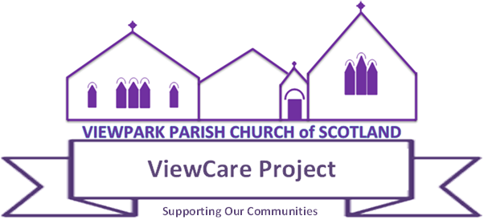
Post Title | ViewCare Project Coordinator
Accountability | ViewCare Board of Trustees
Salary | £10,140
Weekly Hours | 16, the precise hours to be negotiated with the successful candidate.
Contract Term | 3 years
Location | Viewpark Parish Church, 400 Old Edinburgh Road, Uddingston, G71 6PJ
Job purpose: The coordinator is responsible for ensuring the day-to-day management of the ViewCare Project. The successful candidate must be able to build strong links with the local community, volunteers, businesses, schools, churches, local support organisations and existing partners.
Background:
The ViewCare Project was established in May 2016, building on a number of initiatives taken by Viewpark Parish Church to support those in need in the community. The ethos and motivation of our services are rooted in the teaching and example of God’s love for people living in poverty and our responsibility to help. Whilst it is not necessary for employees or volunteers to be practising Christians, their behaviour should reflect the Christian standards of respect and sensitivity to everyone who works in the Project or seeks help. The Project has now been registered as a SCIO (Scottish Charity Incorporated Organisation).
The ViewCare Project is innovative in seeking to bring together in the one place a range of services to assist those in poverty, in debt and in need directly from within the Project and also through the extensive partnerships that have been developed. The services offered are open to anyone in the community of any faith, denomination or none. The key strands are:
- Home Comforts providing basic household necessities, the goods being deposited in the church and delivered to the storage area in Coatbridge: New St Andrew’s Parish Church.
- ViewCare Food Bank providing foodstuffs. Distribution of foodstuffs takes place from the Church on 3 half days.
- Hampers at Christmas providing foodstuffs and toys, gifts etc.
- Clothing/Household Goods Bank collecting and distributing clothing.
Our Mission:
To make positive change for the people in our communities by providing basic emergency essentials, giving practical debt advice and temporary relief to help stabilise their wellbeing, allowing people to take steps to independently deal with the root cause of their financial difficulties.
Main duties and responsibilities:
This post requires a comprehensive skills set, being pastoral, administrative and managerial in nature. The job description gives an outline of key duties and is not intended to be an exhaustive list. The post holder may be asked from time to time to take on other responsibilities as reasonably requested by the ViewCare Board.
- Uphold the aims and objectives of the ViewCare Project and follow its policies and procedures.
- Ensure clear lines of communication at all time with the ViewCare Board.
- Attend ViewCare Board meetings for service update reports on a quarterly basis and discussion of policy matters
- Formulate, implement and monitor Project Development Plan in consultation with all stakeholders
- Record and update ViewCare excel income and expenditure weekly/monthly, sending to Treasurer and meeting on monthly basis to discuss finances.
- Manage all ViewCare social media platforms.
- Coordinate, support and manage volunteers, ensuring the smooth running of all service delivery, including preparation of monthly rotas.
- Recruit new volunteers and deliver inductions, ensuring volunteers feel supported and equipped to deliver services.
- Coordinate and facilitate annual volunteer team-building day.
- Publicise the work of the Project in the local area and beyond to encourage donations from the wider community and to extend the network of referrals.
- Develop partnerships with relevant agencies, community groups and local businesses
- Undertake and initiate regular talks with local community, businesses, agencies, donor groups, churches, schools and partners to raise project awareness, and in gaining donations and funding.
- Prepare grant applications to support the work of the Project.
- Input referral information on ViewCare datasheet, maintaining confidentiality as per our General Data Protection Regulation (GDPR).
Experience:
The post requires experience in the following areas:
- Delivering community projects supporting people in poverty/in need and/or having worked within the voluntary sector.
- Leading and managing teams.
- Working with organisations that recruit, train and support volunteers
- Formulating, implementing and monitoring project plans
- Planning events and delegating tasks
Personal Skills/Abilities
- Ability to work unsupervised and manage own work performance effectively
- Ability to manage and inspire volunteers.
- Ability to deal with conflict and to manage conflict resolution
- Ability to motivate and lead a team as well as being part of a team
- Ability to motivate, empower and successfully engage with clients to help transform their lives.
- Ability to communicate in large group, small group and one-to-one settings
- Excellent written, verbal communication and listening skills
- Good administration, organisational and IT skills (use of Microsoft Office Word, Excel and PowerPoint and using funding software, funding application processing, funding reporting and social media platforms).
- Excellent time and task management.
- Willingness to undertake training and be open to new ideas
- Honest, trustworthy and an awareness of confidentiality
- Hold a full UK driving licence.
Application
Application should be made to the under-noted by email and including a CV along with the names and addresses of 2 referees by 15 July 2021 to:
Mrs A Moore, Secretary
annemoore25@hotmail.com

