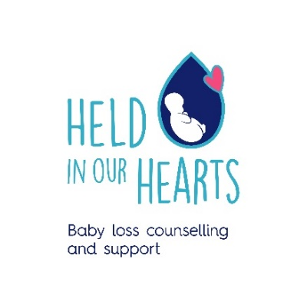
Who are we?
We provide baby loss counselling and support to bereaved families. Our families are at the heart of everything that we do. The majority of staff that support families directly, are bereaved parents themselves, so through shared, lived experience, we provide compassion and support to each other and connect through our care for our families and each other. All our support is free, personal to each family and for as long as is needed. Our support includes counselling, one to one befriending, group support and events.
Since 1996 we have been working hard to provide specialist baby loss counselling and support to bereaved families in the community. We now have a team of 13 and work face to face across sites in Edinburgh and West Lothian. We also support remotely in Fife and Forth Valley.
What are our values?
Our core values are empathy, connection and love. Our charity values were carefully chosen to reflect who we are and how we care for families and each other. We empathise with our families’ losses, as the majority of the team have experienced this ourselves. We remember and feel their pain and can give hope and light when their world is dark. We connect through our shared lived experience and we journey with them for as long as they need us, and love, well love for our little ones is what remains and is the thread that connects us all. These values are shared within the team as we provide compassion and support to each other and we connect through our care for our families and each other. There is always love in everything we do as it comes from the heart.
How does this role fit within the wider team?
We are a team of 13 – 4 counsellors, 4 befrienders, 2 Senior Managers (CEO and COO), Fundraising Manager, Fundraising Assistant and Office Manager. Our main office is in Craiglockhart in Edinburgh, where this role will be based. The role is central to the successful day to day running of the charity, being office based, so that the post holder can be the 1st point of contact for phone calls, emails and drop in visits, as well as welcoming families coming in for befriending/counselling support. Furthermore the post holder has responsibility for the day to day administrative functions of the charity, such as processing payments, booking meetings and organising mailouts.
It is an exciting time to join the team, as we are in a period of growth, in response to demands on our service with expansion in the staff, as well as the geographical areas that we serve. We pride ourselves on creating a sense of community for all our employees and this role would be at the heart of all the essential work that we are delivering as an organisation.
For more information: If you would like to know more about the role or if you would like an informal discussion, please email Angie Alexander on angie@heldinourhearts.org.uk

