Clydesdale Citizens Advice Bureau
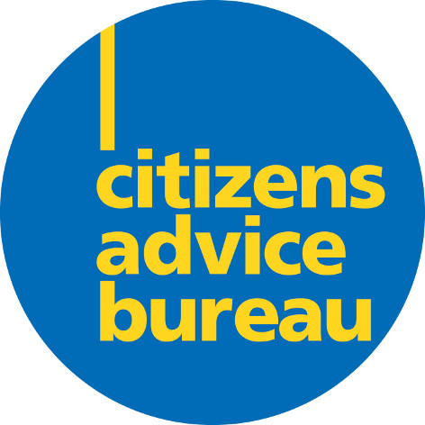

Patient Adviser
The post is funded until 31st March 2016.

Background:
Our Bureau provides confidential, free, independent and impartial advice to those who live and work in the Clydesdale area. We offer generalist advice on issues in areas such as Benefits, Consumer Matters, Council Tax, Employment, Utilities, Family and Personal Matters, Housing and Debt. Our specialist services offer counselling and representation with regard to debt, benefits, issues with the NHS and services for Money Advice, on pensions and for members (and ex-members) of the Armed Services and their families.
Advisers not only offer advice but also negotiate and act on behalf of clients. All advisers are trained to Citizens Advice Scotland standards.
The Bureau provides a service to the people of Clydesdale through its office in Lanark and through outreach provision in a number of outlying areas.
Advice is based on an electronic information system provided by Citizens Advice Scotland of which the Bureau is a member.
The Bureau has a Manager, five paid posts and a team of volunteers. All staff of the Bureau and its Board of Directors place great value on the teamwork, which is a noteworthy characteristic of it. Core funding is provided by South Lanarkshire Council.

The Patient Advice and Support Service, to which this post relates, was created by the Patient Rights (Scotland) Act which was passed in February 2011 to promote awareness of patient rights and responsibilities, and provide advice and support to those wishing to give feedback or comments, or raise concerns or complaints about NHS care received.

Purpose of the Post:
Patient Advisers work with the Citizens Advice bureau/x in their local health board area. The Patient Adviser will provide advice and information to clients who wish to give feedback or comments, or raise concerns or complaints to the NHS, support bureaux volunteers, produce quarterly statistical reports, carry out marketing and liaise with external organisations.

Main Responsibilities
Advice and Information
The Patient Adviser will provide information, advice and support
- about the services that the PASS provides
- and, where appropriate, representation services for clients wishing to make complaints, raise concerns or give feedback where the case is technically complex and/or requires a high level of support.
- and, where appropriate, direct clients to
  - other reliable sources of advice and support
  - organisations providing representation and advocacy services
- about the rights and responsibilities of patients (notably the forthcoming Charter of Patient Rights and Responsibilities)
- and maintain expertise in relevant legislation/guidance e.g. NHS, welfare rights in order to do so.
- to prisoners, where appropriate, and as agreed with the local prison/s.

Supporting Bureaux Advisers
Provide training and support to, or support bureau trainers to train bureaux advisers/volunteers to
- gain an awareness and understanding of the rights and responsibilities of NHS patients and promote these to clients
- deliver information and advice to assist clients to give feedback or comments, or raise concerns or complaints to the NHS

Reporting
- Maintain detailed statistics of individual cases to produce quarterly statistical reports for Health Concerns and Client Profiles for
  - the local NHS Board
  - Citizens Advice Scotland (CAS)
- Provide case studies for 5-10% of cases to indicate trends, issues, departments, staff groups, etc for the local Health Board.

Promotion
Publicise the patient advice and support service to ensure clients, health professionals and health care providers are made aware of and know how to access the service by
- Developing and delivering a marketing strategy in collaboration with CAS and the local health board, including
  - distribution of relevant marketing material to local CAB offices, the NHS and appropriate local organisations
  - attendance at relevant local events, conferences and seminars
  - liaison with local newspapers and radio to advertise and raise awareness of the service
  - attendance at meetings and training sessions with NHS colleagues to promote the PASS
  - promotion of PASS on CAB websites, where appropriate
- Working with NHS colleagues to develop and implement local marketing strategies to complement those organised nationally.
- Provide input and case studies as requested by CAS for press articles, consultation responses, etc

Liaison
- Establish (or maintain) and develop good working relationships with local
  - statutory organisations
  - voluntary organisations and community groups.
- Attend local meetings to represent the bureau in relation to the PASS

Other duties and responsibilities
- Ensure that all work conforms to the Bureau’s policies and procedures
- Attend team/staff meetings as required
- Abide by health and safety guidelines and share responsibility for own safety and that of colleagues
- Carry out other duties, as specified by the Manager and required by the demands of the service

Employment conditions

Location
The post will be based in our Bureau in Lanark but will involve regular travel within the Lanarkshire area.

Salary
£21,500 per annum

Working Hours
25 hours per week

Holidays
5 weeks paid holiday per annum (pro-rata, plus public holidays).

Michelle Mair
Manager
Person Specification - Patient Adviser

 | ESSENTIAL | DESIRABLE
Experience | - Preparation and presentation of casework  - Experience of conducting negotiations in a non-confrontational manner  - Writing formal letters and preparing reports, plans and proposals  - Experience in giving advice on a range of subjects to members of the public | - Experience in working with volunteers  - Experience of delivering training sessions  - Experience of delivering presentations
Skills and attributes | - Ability to communicate and establish good relationships with a range of people.  - Ability to work without close supervision, prioritise own work and meet deadlines  - Ability to deal with difficult situations in a calm, effective non-confrontational manner  - Ability to communicate effectively, both orally and in writing  - Ability to network with other groups within the community  - Ability to navigate, work within and adhere to a defined procedure (ie the NHS (& Social Service) Complaints procedure)  - Ability to gather and accurately record statistics | - Ability to represent the PASS at meetings  - Ability to work as part of a team and on own initiative  - Understanding of the needs of people who may be vulnerable, distressed or under stress  - Ability to promote the service to different groups of people, eg NHS staff, voluntary groups and the public

Knowledge | - A working knowledge of email, the internet, Microsoft software and in particular of inputting and retrieving data from Excel. | - Knowledge of NHS organisations, medical terminology & procedures  - Knowledge of local voluntary organisations  - An understanding of how life circumstances can impact on a person’s health & well-being  - A knowledge of welfare benefits
Values and attitudes | - An understanding and commitment to the aims and principles of the CAB service and to the policies and procedures of the Bureau.
Other | - A willingness to identify and undertake relevant training  - Ability to work flexibly and to travel to a variety of locations within the area and carry out home visits, as required

