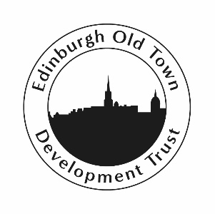
Edinburgh Old Town Development Trust (EOTDT)
Business Development Manager

Duration: Initial 9 month contract – which may be extended
Salary: £30,000 pro-rata, 30 hours a week
Deadline for applications: 5.00pm, Wednesday 21 July

EOTDT aims to foster a vibrant, sustainable community in the Old Town area of Edinburgh through developing enterprising projects to meet local needs; providing tailored educational and training opportunities; and acting to safeguard the area’s built and cultural heritage.

To further these objectives and act as a base for its activities, the Trust recently opened The Crannie, a custom-built community space located in the Canongate area.

EOTDT now seeks to appoint a Business Development Manager with a remit to work towards achieving financial sustainability for The Crannie, and maximising its full potential. The appointment is for an initial nine-month period.

Reporting direct to the Trust Manager, the successful applicant will be responsible for:

- Leading on the development and implementation of a marketing campaign (both traditional and digital approaches).

- Leading on the development and introduction of new social enterprises – exploring their feasibility and securing start-up funding for their development phases.

- Sourcing and securing grant funding for identified immediate and longer-term provision of services and activities for the benefit of the local community.

- Organising fundraising activity with a view to establishing greater levels of unrestricted funds.

- Securing long-term rentals of office space and promoting room hires.

How to apply:
To apply, please email Jackie Cropper at jackie@eotdt.org with a C.V. and a covering letter (no more than two sides of A4) expressing why you believe this post is for you.

Interviews are expected to take place within the following ten days.

Person Specification
Personal Qualities, Skills and Experience
Excellent writing skills | Essential
Excellent negotiating skills | Essential
Knowledge and understanding to work within the key values of Edinburgh Old Town Development Trust | Essential
An inclusive, non-judgemental and positive attitude | Essential
Problem-solving ability | Essential
Self starter – ability to work on own initiative and enthuse others | Essential
Experience working with digital devices and social media | Essential
Good planning and organisational skills | Essential
Previous Experience
Experience of social business | Desirable
Experience in marketing | Desirable

Edinburgh Old Town Development Trust is a company limited by guarantee,
registered in Scotland no. 366198 and is registered as a Scottish Charity no. SC042964

