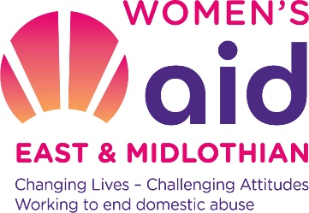

Women’s Aid East & Midlothian Person Specification
Post of Support Worker (Women’s Support Team)

Requirements | Essential | Desirable
- Knowledge  1.1 Knowledge of legislation for protecting vulnerable women | ●
1.2 Understanding issues and support needs of women who are experiencing domestic abuse | ●
- Knowledge of the effects domestic abuse can have on women | ●
- Ability to demonstrate a commitment to feminist values including an understanding of the gender based nature of domestic abuse | ●
- An understanding of additional intersections such as age, race, class, sexuality, mental health, substance misuse etc and how these affect a women’s access to support. |  | ●
- Experience  2.1 Qualified to a minimum standard of SVQ3 Health & Social Care or SVQ3 Community Justice or equivalent | ●
2.3 Experience in working with vulnerable women | ●
2.4 Experience of multi-agency work when providing support to vulnerable women |  | ●
2.5 Experience of providing individual support to vulnerable women | ●
2.6 Minimum of 2 years experience of working with vulnerable women |  | ●
2.7 Experience of delivering and facilitating group work with vulnerable women |  | ●
2.8 Flexible and effective team working | ●

3. Abilities – skills and aptitudes
3.1 Able to work on own initiative or as part of a team | ●
3.2 Ability to priorities work without direct supervision | ●
3.3 Able to work with confidential material appropriately | ●
3.4 Able to communicate effectively both orally and in writing | ●
3.5 Able to assess the needs of vulnerable women | ●
3.6 Able to work in a way that empowers and encourages the participation of vulnerable women | ●
3.7 Able to engage with and develop relationships with women within professional boundaries | ●
3.8 Able to form effective alliances with external and external agencies and practitioners | ●
3.9 Maintain accurate and up to date records | ●
3.10 Highly developed interpersonal skills | ●

