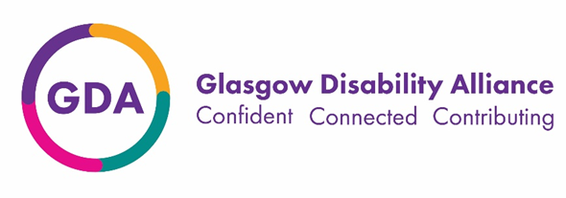

Information for disabled candidates
We are committed to the employment and career development of disabled people. In recognition that disabled people generally face a lot of barriers to participating in work we operate a policy where disabled applicants who meet the minimum criteria for the job will be given the opportunity to demonstrate their abilities at the interview stage. This is permitted by the Equality Act 2010.
You must demonstrate on your application form that you have the minimum level of experience and skills as stated in the person specification before we can interview you. A request under the guaranteed interview policy does not guarantee you a job. At interview, the best candidate will be offered the post.
If you wish to be considered under this policy and/or require any reasonable adjustments at the interview, please complete the declaration below. Any information you give will be treated with the utmost confidence by GDA, will be held separately from your application form and only used for these stated purposes.

Supporting you at interview

Do you require any reasonable adjustments at interview? (delete as appropriate) | Yes/No

If you answered Yes to the previous question, please give details below:

Declaration

I would like to apply under the guaranteed interview policy
Name
Date
Signature

Any false declaration of disability to obtain an interview will subsequently invalidate any contract of employment.

