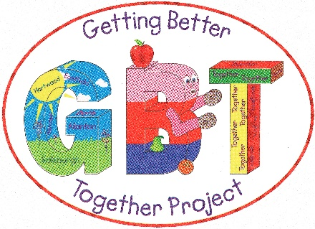

JOB DESCRIPTION
JOB TITLE: Health & Wellbeing Officer
LOCATION: Shotts North Lanarkshire
ACCOUNTABLE TO: Executive Manager
SALARY: £22500.00
Funded initially for 1 year.
MAIN PURPOSE OF THE POST
The main aims of the roles is to support the development of new Healthy Eating Interventions, Physical Activity interventions and to work with the Active Travel Co-ordinator to support Active Travel interventions.
The postholder will support individuals to build personal resilience in self-managing their health and wellbeing through assessment and review of individual needs, development of individual wellbeing plans, and motivating behavioural change.
Work closely with Active Travel coordinator assisting in the promotion of cycling, walking and other physical activity modes.
DUTIES AND RESPONSIBILITIES
Service Operation
- To receive referrals and assess the needs of individuals, facilitating access for them to recommended brief interventions and programmes of activity that benefit their wellbeing.
- To support people to develop and implement wellbeing plans.
- To use health improvement information to help people to self-manage their health and encourage behavioural change, including people with long term conditions.
- To support individuals to recognise and change their current lifestyle and to identify how their way of life might affect their health and wellbeing.
- To help individuals navigate services and activities that are available to them in their community and make informed choices.
- To be respectful and non-judgemental of people's lifestyles, and to be able to encourage them in choices and actions that are acceptable and achievable to them.
- To be aware of and sensitive to barriers to adopting a healthier lifestyle such as affordability, accessibility, and life circumstances
- To enable clients to make choices and develop a wellbeing plan to change behaviour and sustain those changes, leading to more healthy choices and actions.
- To support individual wellbeing plans over an agreed timescale and review and revise wellbeing plans with individuals as appropriate
- To maintain a high level of confidentiality in all aspects of work including clients records and conversations.
- To work to agreed quality and performance framework and the Lanarkshire Weight Management Service Plan.
Development and Promotion
To work with colleagues at Getting Better Together to embed a culture of prevention within the Fortissat area, providing support to other members of the staff team around health improvement activities.
To identify means of development of the service to improve the health and wellbeing of the local community and identify barriers that individuals are experiencing in changing their behaviour.
Administration and Accountability
To ensure the completion and maintenance of all appropriate administrative records
To report as required on activity and outcomes.
To attend individual, team and staff meetings as required
Other
To develop an awareness of local and national developments and best practice in this area of work, and to attend meetings and training events as required.
To ensure that all work is undertaken in accordance with the aims and values of the Weight Strategy Action Plan.
To be able to work flexibly and positively with the various partners who are involved.
To undertake any other relevant duties as required from time to time by Getting Better Together.
- - - - - - - - - - - - - - - - - - - - - - - - - - - - - - - - - - - - - - - - - - - - - - - - - - - - - - - - - - - - - -
PERSON SPECIFICATION
Essential:
- Excellent interpersonal skills
- Good written & verbal communication skills with awareness of the need for confidentiality at all times
- Good listening skills with the ability to adopt appropriate style and method of communication.
- Ability to recognise mental and physical health problems and identify when further advice is required.
- Ability to work to tight deadlines.
- Good organisational skills including information, resources, and time management.
- IT skills, including word processing including excel.
- Understanding of the role preventative services play within Health and Social Care
- Knowledge of the local area and communities
- Knowledge of health improvement interventions including managing long-term conditions.
- Experience of working with communities.
- Confident cyclist.

· A team player able to work well with others within and outside of the team.
· A person-centred approach
Qualifications:
· Qualification relating to the post: Educated to degree level or equivalent.
At least two years’ experience in community development or health improvement initiatives. In particular linked to diet and nutrition.
Knowledge/Expertise:
Experience of working within health, social care, or the voluntary sector.
Experience of working with client groups.
Have knowledge of national policies:
- A More Active Scotland’s physical Activity Delivery Plan.
- A Healthier Future: Scotland’s Diet & Healthy Weight Delivery Plan
- A Healthier Future: Framework for the Prevention, Early Detection & Early Intervention of type 11 diabetes.
Personal Attributes:
- Passionate cyclist/walker
- Enthusiasm and commitment
- Flexibility
- Energetic and Proactive
- Passion for health improvement in weight management

