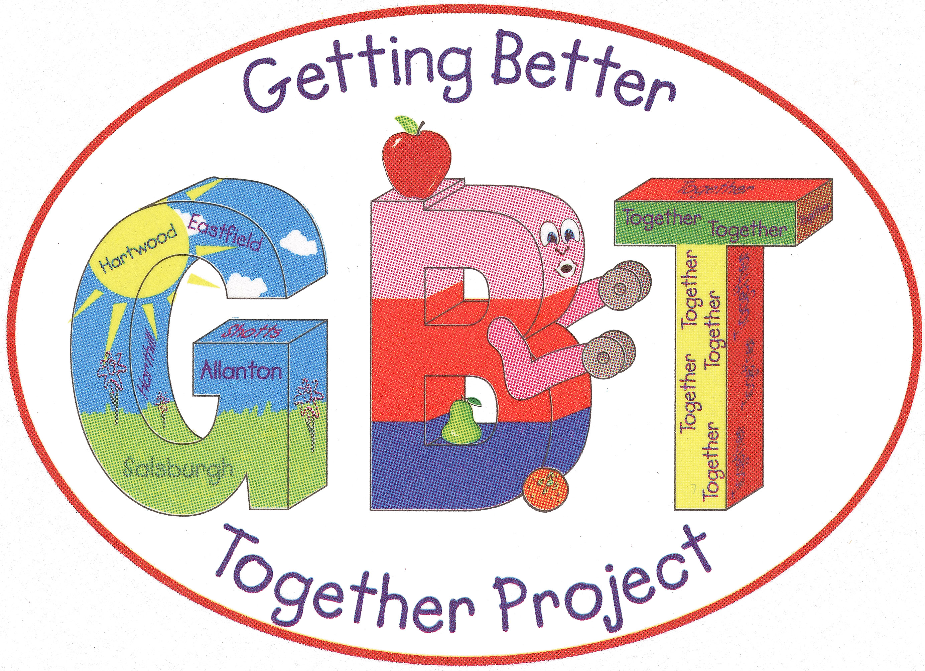

Job Description

Title: Community Liaison Service – Community Liaison Officer

Salary: £26,000 Per Annum + 6% Pension Contribution

Hours: 35 hours per week - Post holder will be required to be flexible in respect of their working pattern and be prepared to work evenings and weekends as the post demands.

Location: Employment will mainly be based in the hospital acute sites, community hospital and rehabilitation units across Lanarkshire, and for administration and employer support at Shotts Healthy Living Centre.

Getting Better Together
Shotts Healthy Living Centre
Kirk Road
Shotts
ML7 5ET

Background:

The Community Liaison Service is funded by the Health and Social Care Partnership North Lanarkshire through the Community Solution Programme (VANL) and is hosted by Getting Better Together (GBT) at Shotts Health Living Centre.

The Community Liaison Service provides a link between the acute settings and the support provided by community and voluntary organisations. The service is available to all North Lanarkshire residents aged 16+ and has a presence in both University Hospital Monklands and Wishaw. The service is also provided to other rehabilitation settings throughout Lanarkshire to support the discharge of North Lanarkshire patients.

The Community Liaison Officers liaise with patients, families, and their carers to offer advice on possible community supports and refer to appropriate organisations when required. The service aim is to encourage clients to engage with additional supports with the anticipated outcomes of reducing loneliness and isolation, improving self-management of conditions, encouraging independence and physical activity. The service offers support throughout the patient’s journey, and this can continue post discharge.
As well as community supports, we also provide information on Local Authority services (such as Social Work, Leisure and Culture) and health promotion literature.

The service receives referrals from all our health & social care colleagues and our community partners. Early links during the discharge planning process allows for the Community Liaison Service Team to build a relationship with the family and we can have an outcome-based conversation. This helps us identify supports available from voluntary organisations and partners within the Community Solutions programme and across the wider community and voluntary sector. The information is tailored to the patient, family and carers individual needs and interests.

The service currently receives funding from the North Lanarkshire Council to extend our support to users of the Community Alarm Network. A member of the Community Liaison Service conducts home visits with individuals identified by the Community Alarms Team with the purpose of facilitating a personal outcomes discussion. The advice and support provided varies depending on the needs and wishes of the individual and their carers. As well as signposting to community support, the Community Liaison Officer also can make direct referrals to a range of key community referral partners.

Purpose(s):

To support the delivery of the Community Liaison Service, taking North Lanarkshire’s preventative approach to improving the wellbeing of North Lanarkshire’s residents. The Community Liaison Officer will liaise with patients, families, and their carers to offer advice on possible community supports and refer to appropriate organisations when required.

The Community Liaison Officer will seek to raise awareness of our service and the wider support and services provided by our community and voluntary sector partners.

Responsible to:

Community Liaison Team Leader – Getting Better Together Shotts Ltd

The post holder will be required to have a UK driving licence.
A PVG will also be required for this post.

Key tasks:

Main Duties and Responsibilities:

- Receive and co-ordinate referrals.
- To provide direct support to service users as per the service specification
- Ensure that the support provided is person centered, promoting informed choice and decision making.
- Undertake a programme of awareness raising amongst staff working within the hospital acute sites, community hospitals and rehabilitation settings.
- Provision of information to our Health and Social Care colleagues on the range of community and voluntary sector supports and services.
- Monitoring and recording of outcomes and maintaining accurate records.
- Maintain effective and positive working relationships within health care/community settings and with all stakeholders and partners to support the delivery of the service.

Further Responsibilities:

- Will participate within the network of locally based key stakeholders including Health and Social Care Partnerships, Community and Voluntary sector representatives.
- To identify and engage local services and agencies in response to needs and wishes identified during personal outcomes discussion.
- To participate in the promotion of the service and effective communication with all stakeholders.
- Responsible for the organisation and delivery of own workload.
- Other duties as specified and agreed with the Getting Better Together Ltd Board of Trustees.
- Maintain up to date knowledge of the (North Lanarkshire) operating landscape.
- Maintain up to date knowledge of best practice in Health Improvement Activity.

Person Specification:

Qualifications:

Qualified to SVQ Level 3 in Social Services and Health Care or Community Development or equivalent. | Essential
Driving License and own vehicle. | Essential

Knowledge/Experience:

Good understanding of the culture, politics, structures, and policy landscape in Lanarkshire. | Essential
Good knowledge of the community and voluntary sector in Lanarkshire | Essential
Experience of effective partnership working. | Essential
Experience of providing support and advice to service users | Essential
Knowledge of community development/Health Promotion principles and practices. | Essential
Experience of Multi Agency working | Essential
Have good knowledge and experience of monitoring and evaluation practice | Essential

Skills:

Ability to use common Microsoft Office products effectively | Essential
Ability to work well individually and as part of a team | Essential
Good personal presentation and verbal/written communication skills | Essential
The ability to develop good working relationships with people and partners. | Essential
Be able to demonstrate good project management skills | Essential
Committed to best practice and with a drive for continual improvement. | Essential

.

Operating Principles:

Getting Better Together Shotts Health Living is an organisation committed to delivering a range of services predicated upon identified need and quality. The organisation is committed to Partnership and effective joint working. Our aim is to promote Community health improvement opportunities to the communities of North Lanarkshire and expect all our staff to act in a manner that positively promotes the company (GBT). The organisation is well recognised locally, nationally, and UK Wide.

Signed (postholder): Signed (GBT):
Date: Date:

