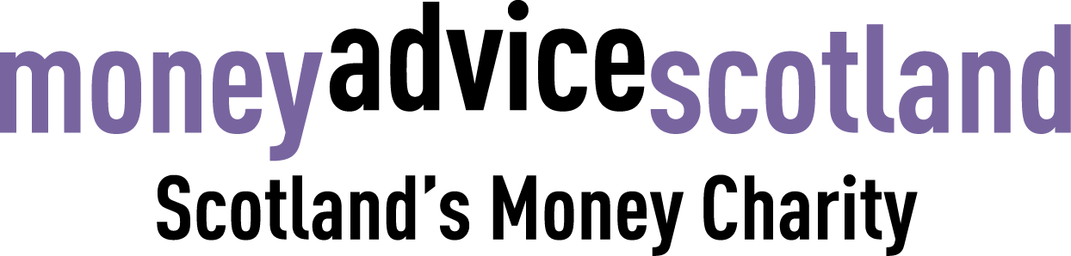

Role: Communications Officer
Responsible to: Policy and Communications Lead
Salary: £26,000 - £29,000
Hours: Full time (36 hours a week). We are a flexible working employer.
Location: Mainly working from home, but some travel to Glasgow for meetings will be required.

About MAS
The times we live through are frequently described as unprecedented.
A century pandemic has magnified and entrenched inequality.
But it has also shown that change can happen rapidly and can make a real difference.
We need change. We need new ideas when old solutions cannot solve new problems.
Our plan sets out our approach towards securing a new different at a time when our purpose is more essential than ever.

Money Advice Scotland is Scotland’s money charity. We believe that people in debt deserve to be treated fairly and with dignity.
And we believe we will achieve that by supporting the advice workforce, empowering citizens to get help and support, and advocating for fairer policy.

Role profile
We’re looking for a communications officer to join our team to support with implementing our communications strategy and building new campaigns. This role is focused on further expanding our communications reach and connecting with the public, money advisers, and policy makers by creating and sharing useful and engaging content and resources.

Job description and key responsibilities

- Create engaging social media content and monitor our channels
- Conduct content-scoping research and liaise with colleagues to source interesting and relevant material for our newsletter and website
- Create and edit content (e.g. blogs, newsletters, press releases) on a range of debt and financial wellbeing subjects
- Update and maintain our website
- Support with the creation and management of digital ads
- Work according to and further develop our dedicated communications toolkit
- Liaise with publications and media outlets to raise Money Advice Scotland’s profile
- Produce reports
- Work with the Policy and Communications Lead to plan campaigns
- Other relevant tasks as required

 | Essential | Desirable
Qualifications and experience | - Degree or equivalent professional experience  - Experience of working in a communications role/setting
Knowledge and understanding | - Ability to create high-quality, engaging content  - Willingness to learn about new subjects  - Ability to write content for different audiences | - Photography/graphic design skills  - Video editing skills  - Interest in financial wellbeing topics
Communication and IT skills | - Proficient with Microsoft Office products  - Experience with social media management platforms  - Experience managing paid ads
Evaluation and analysis | - Strong attention to detail  - Strong analytical skills
Autonomy and accountability | - Ability to work using own initiative  - Comfortable working to deadlines  - Ability to work in a team as well as individually
Values and attitudes | - A commitment to our purpose

What you will get from the role
You’ll be part of a progressive organisation and your work will help to challenge the stigma around debt through evidence-led content.
You’ll create a range of different content, engage with key audiences, and be an important part of ensuring the voices of people in debt are heard.

Application process
Please submit a CV and cover letter (no more than one page) by email to abbey@moneyadvicescotland.org.uk by Monday 16 August. Shortlisted candidates will be invited to attend an online interview w/c 30 August.

