

Role Profile – Residential Care Worker

Reports to:
Senior Residential Care Worker

Role Purpose:
As part of the residential staff team, the Care worker is required to care for and support individual and small groups of adults working shifts which cover the 24-hour period.
You will work collaboratively with the multi-professional team within our care provision and colleagues across Sight Scotland and Sight Scotland Veterans.
All roles within Sight Scotland and Sight Scotland Veterans are expected to work to our values and Our Ways of Working framework:
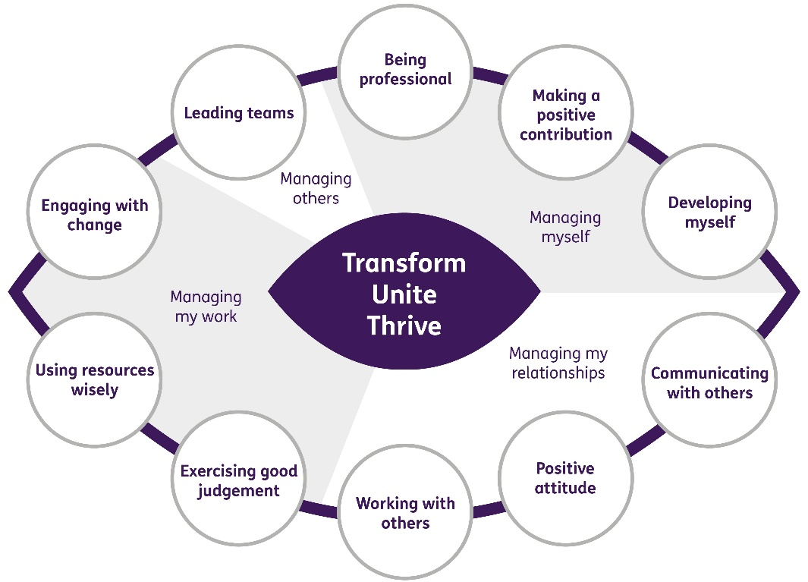

Our Ways of Working - Managing my Work

The main responsibilities and accountabilities of this role are that you will:
- Ensure that the welfare needs of all adults are met, in accordance with the Safeguarding Policy and Guidance
- Create and implement electronic Individualised Care plans
- Attend changeover and other relevant meetings
- Create regular reports and record information as required
- Attend reviews and create relevant reports
- Liaise with parents and carers
- Liaise with other relevant staff and professionals
- Participate in staff/adults/family meetings
- Support our residents to attend work, college, other training and leisure activities
- Support our residents in developing and maintaining appropriate social networks
- Support our residents to make independent choices and manage their finances while helping them maintain a level of independence and autonomy
- Advise the appropriate senior staff member of any concerns in relation to Health & Safety and Security issues
- Advise the appropriate senior staff member of any concerns in relation to Adult Protection issues
- Develop and maintain an awareness of the individual medical conditions of the adults in your care
- Administer medication
- Undertake such other duties as may reasonably be required by the Senior Residential Care Worker or the Residential and Care Services Manager.

Our Ways of Working – Managing Myself and Managing my Relationships

To do this role, you will:

- Have an HNC in Social Care and SVQ 3, all eight units, or equivalent qualification suitable for registration with the SSSC/appropriate professional body. Or a qualification in nursing
- Have demonstrable experience of working in a residential care setting.
- Have demonstrable knowledge and an understanding of people with Vision Impairment, Additional Support Needs (ASN), various disabilities and/or medical conditions.
- Have experience of working within a multi-disciplinary team/environment.
- Have experience of liaising with families.
- Undertake training in and carry out procedures essential to the wellbeing of the adults (this may include gastrostomy feeding, administration of rectal medication etc)
- Have experience of administering medications
- Maintain confidentiality of information regarding adults, families and friends at all times.
- Be willing to develop skills in working with visually impaired people and with adults who have a range of special needs
- Have excellent communication & interpersonal skills and the ability to build positive professional relationships
- Support and mentor students and volunteers
- Have the ability to work on your own initiative and be able to adapt to change and respond positively to non-routine situations
- Have strong organisational skills and the ability to prioritise work
- Have good problem-solving skills and active listening skills
- Have the ability to maintain clear & accurate records
- Have experience of creating reports
- Undertake such other duties as may reasonably be required by the Head of Care (Children, Young People and Adult Services)

It would be desirable for this role if you:

- Have demonstrable experience of communicating effectively with and supporting adults, parents, staff and outside agencies in a range of formats and situations
- Have experience of supporting and formally assessing colleagues through the SVQ process
- Have experience of working with individuals with visual impairments (VI).
- Have demonstrable experience of the ability to carry out personal care in a sensitive and empathetic manner.
- Have experience of working in a non-profit sector
- Have evidence of professional development beyond initial training.
- Have a full drivers licence
- Have a willingness to undertake training to drive the organisations vehicles

On a day to day basis you will work with different people and teams, these could be:
- Families
- Colleagues
- External agencies
- GP’s and medical professionals
- Therapists
- Social Workers
- Senior staff
- Other Sight Scotland and Sight Scotland Veterans colleagues

Requirements of this role are:
- You are a member of the PVG scheme (paid for by Sight Scotland)
- You will have a 6 month probation period
- You must register with the SSSC within 6 months of your start date
- That you participate in all staff training and development and maintain your own professional development
- You will wear the appropriate PPE in accordance with current guidance for the role, including wearing of face masks, gloves and aprons.
- You will follow Sight Scotland’s guidance, policies and procedures relating to your own health and safety and that of colleagues and service users at all times
- You will uphold the principles of Sight Scotland’s Dignity at Work and Equal Opportunities policies at all times, working in a way which supports an inclusive work environment that is respectful of differences.

What we can offer you:
- Generous annual leave entitlement which increases after 4 years’ service
- Generous pension scheme
- Discounts for Carers
- Access to learning and development opportunities
- Employee Perks through the Employee Assistance Programme
- Cycle to Work scheme
- And many more, please visit our website for more information

Special Conditions
- Shift patterns are in operation and may be changed at short notice
- Work pattern is variable and because of the client group there may be exposure to distressing circumstances
- The role can be physically demanding due to the nature of the disabilities our residents have. Adherence to our Health & Safety policies is essential

This job profile is not exhaustive. The duties of the post holder may be reviewed from time to time and the employee may be called upon to work in other locations within Sight Scotland.

