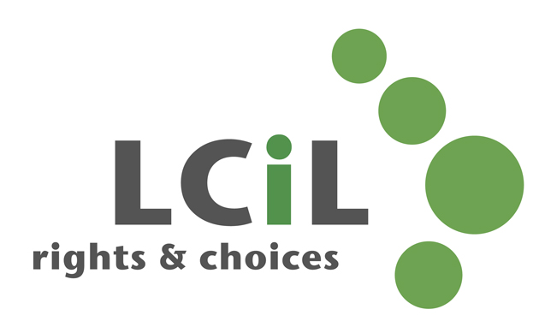

Lothian Centre for Inclusive Living

Job Description

Post Title: Office Manager – 18 hours per week

Post Salary: £26,000 per annum (FTE 35.75hrs)

Responsible to: Chief Executive Officer

Responsible for: LCiL Office management and HR support
LCiL Administrator

Purpose of Post: Ensure that all LCiL administration processes and activities facilitate the smooth running of the office
Ensure that HR related activities enable the organisation to carry out its employer’s responsibilities
Working closely with Chief Executive to assist in the achievement of organisational goals, including project work

Post Objective: Manage the overall administration and operations of LCiL
Support operational HR task for the organisation and its staff in accordance with the policy objectives of the Board and employment law, advice and support available from our legal team

Main Tasks and Duties

- Coordination of LCiL administrative tasks, supporting LCiL administrator as required.
- Ensure LCiL complies with all aspects of GDPR.
- Coordination of office space in relation to hybrid working.
- Manage and negotiate supplier contracts e.g. IT, Photocopier etc, in conjunction with CEO
- IT - Liaising with IT Support, Installing programmes and support staff with IT issues.
- Payroll processing for organisation staff, including expenses
- Cover for invoice payments and bank authorisations for payroll/finance functions when necessary.
- Ensure that LCiL office premises meet Health & Safety requirements, including taking the lead role of Fire Warden for LCIL and appointing deputies from staff group
- Liaise with Albion Trust (Landlord) in relation to building maintenance, security etc.
- Act as first point of contact to provide HR support across the organisation and with key stakeholders.
- Support the life cycle of employment (recruitment, induction, engagement and development) ensuring our approach aligns with LCiL’s mission and values and working closely with managers to ensure processes, documentation and changes are implemented.
- Oversee the HR system and supporting records to maintain employee information including updates for other departments e.g. payroll changes.
- Ensure all staff policies and procedures are regularly reviewed and updated where necessary, including the updating of staff/ policy handbook.

Other
- Undertaking other appropriate duties from time to time as determined by the Chief Executive Officer

Contacts (when relevant)
- Disabled people, their staff and their families
- LCiL’s Board of Directors, staff and members
- Local and national disability organisations
- Voluntary and charitable organisations
- Statutory bodies
- Local Authority and Health Board officials and representatives
- Government Departmental officials
- Suppliers of goods, services or equipment
- Private sector organisations.

Supervision and Support Received
The post holder will receive regular supervision with the Chief Executive Officer in accordance with the Terms and Conditions of service. The post holder will be expected to attend staff meetings, training courses, LCiL events or other meetings deemed appropriate to the function of the organisation.

Complexity and Creativity
The Lothian Centre for Inclusive Living is an innovative and demanding initiative which has had a significant impact on the lives of disabled people, their families and the statutory authorities in the Lothian area.

The provision of support which enables disabled people to increase their level of self control in all aspects of their lives is highly complex. It requires sensitivity, an extensive knowledge of services which are available to disabled people and a wide knowledge of the concerns of disabled people.

The post holder would need to maintain an up to date knowledge of all relevant legislation. They would be required to use ingenuity and imagination to find the most appropriate solutions to individual situations.

They would be required to take initiative on a wide range of tasks and work as part of a team to ensure the Centre maintains an inclusive approach.

It is essential that the post holder is able to work within an organisation which is led and managed by disabled people.

July 2021

Personal Specification

 | Essential | Desirable
Knowledge of:
The role of LCiL and independent support |  | x
Payroll calculation and processing |  | x
Good practice in staff management | x
Independent living philosophy and the social  model of disability |  | x
Experience of:
Working in a busy office environment | x
Generalist knowledge of HR practices |  | x
Working effectively as part of a leadership team | x
Proficiency in relevant payroll  software(eg Sage) |  | x
Managing, supporting and developing staff | x
An ability to contribute to effective planning and to implement resulting activities effectively | x
Excellent analytical and problem-solving skills |  | x
Developing, managing and maintaining monitoring and evaluation systems | x
Working in a disabled people’s organisation |  | x
Direct personal experience of impairment |  | x
Abilities – both aptitudes and skills
Ability to communicate with and provide information to non-admin colleagues | x
Ability to be self-administering in terms of IT | x
A ‘can do’, collaborative, tactful and helpful manner | x
attention to detail and accuracy | x
Other requirements
Non judgmental and interested in people | x
A commitment to equality and diversity | x
Flexibility and ability to adapt to changing circumstances | x
An ability to work under pressure, deal with a fast and varied workload, and prioritise activities | x

