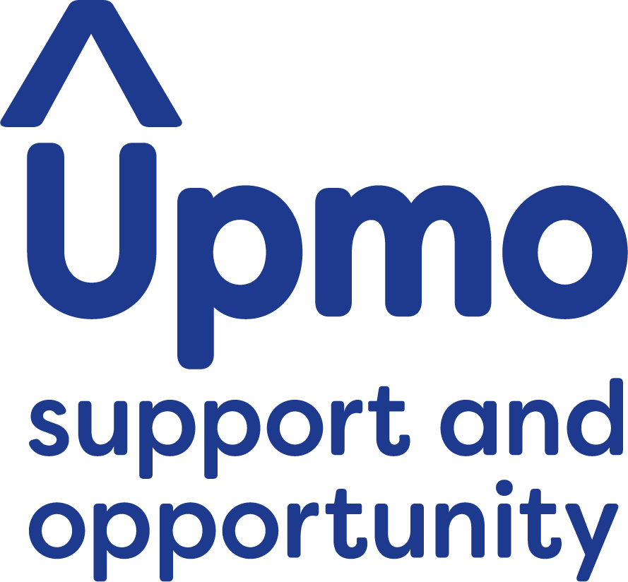**EQUAL OPPORTUNITIES FORM**

**For Monitoring Purposes Only**

m

n  
*Double clicking grey boxes will allow you to change the default value to ‘checked’ or to enter information. If you are using a word processing application that does not support this feature please delete the relevant grey box and replace it with a capital X.*

**Where did you see this post advertised?**

Job Centre:  Local Paper:  Internet:  Notice Board: Word of Mouth:

|  |  |
| --- | --- |
| Other (please specify): |  |

***The information gathered is for statistical reasons only and will not be used for any other purpose.***

**Your ethnic origin**

These categories are based on the Census 2011 categories and recommended by the Commission for Racial Equality.

m

|  |  |
| --- | --- |
| **Asian, Asian British, Asian English, Asian Scottish,  or Asian Welsh**  Asian / Asian British  Bangladeshi  Chinese  Indian  Pakistani  Other Asian background | **White**  British  English  Gypsy or Irish Traveller  Irish  Scottish  Welsh  Other White background |
| **Black, Black British, Black English, Black Scottish,  or Black Welsh**  African  Caribbean  Other Black background | **Mixed**  White and Asian  White and Black African  White and Black Caribbean  White and Chinese  Other mixed background |
| **Other ethnic group**  Arab  Other ethnic group   (specify if you wish): | **Prefer not to say** |

**Your gender**

Male  Female  Other  Prefer not to say

**m  
Have you ever identified as transgender?**

Yes  No  Prefer not to say

**Your age**

Date of Birth:      

16-24  25-34  35-44  45-54  55-64  65+  Prefer not to say

**Your sexual orientation**

Bisexual

Gay man

Gay woman/lesbian

Heterosexual/straight

Other (specify if you wish):

Prefer not to say

**Marriage and civil partnership**

Single

Married/in a registered same-sex civil partnership

Separated, but still legally married/in a registered same-sex civil partnership

Divorced/formerly in a same-sex civil partnership which is now legally dissolved

Widowed/Surviving partner from a same-sex civil partnership

Prefer not to say

Your religion or belief

|  |  |
| --- | --- |
| **No religion**  **Buddhist**  **Christian**  **Hindu**  **Other (specify if you wish):** | **Jewish**  **Muslim**  **Sikh**  **Prefer not to say** |
|  |  |

Disability

The Equality Act 2010 defines a disabled person as someone who has a physical or mental impairment which has a substantial and long-term adverse effect on their ability to carry out normal day-to-day activities.

,

**Do you consider yourself to be disabled?**

Yes **If yes, please specify:**       No  Prefer not to say

Please return a completed copy of this form along with your application.