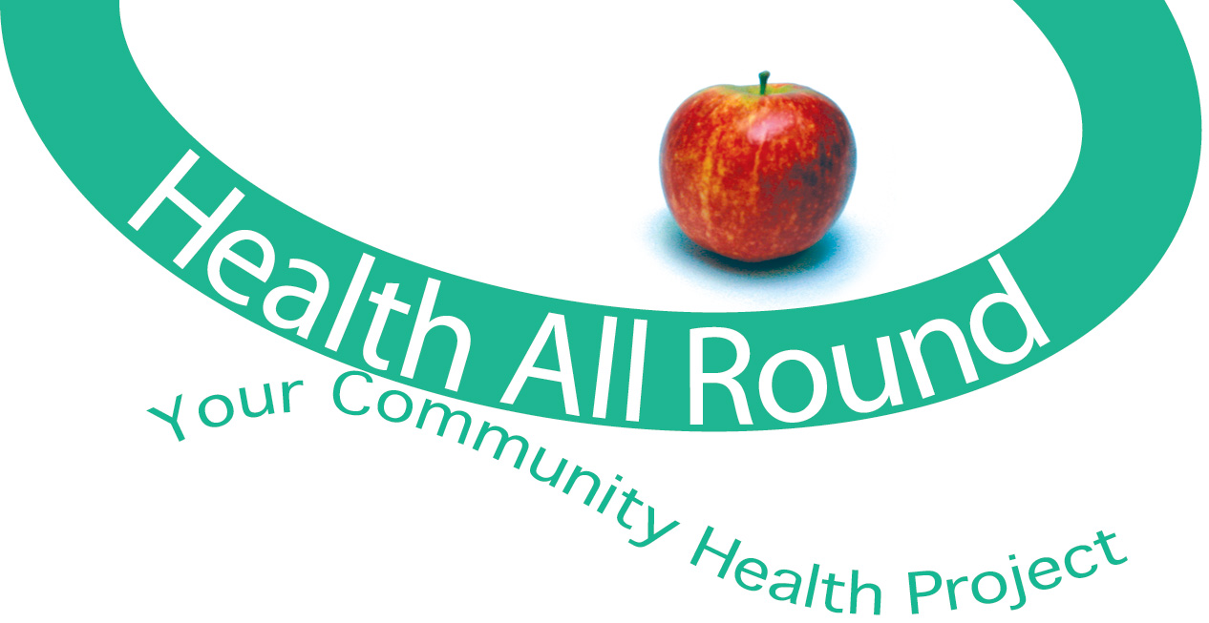

**Health All Round**   
**Community Link Worker**

**Job Description**

* Post title: Community Link Worker
* Salary: £29,210 – £30,996 pro rata
* Hours: 21 per week
* Contract: Fixed term until March ‘23
* Responsible to: Health All Round (HAR) Manager

**Overall purpose of the job:**

The Community Link Worker programme is funded by EVOC and Edinburgh Health & Social Care Partnership. The principle aim is to support people to live well through strengthening connections between community resources and primary care.

The Community Link Worker (CLW) will be employed by Health All Round (HAR), a community health initiative which aims to improve health and wellbeing of people living in the South West area of Edinburgh. They will be expected to work alongside the HAR staff, work according to HAR policies and procedures and participate in team meetings, team building etc.

The success of this post is dependent on effective joint work between Edinburgh Health & Social Care Partnership, EVOC and HAR. The post holder will be supervised by the HAR Manager with support from the Community Link Worker Network Area Lead for South Edinburgh, who will work together to ensure that the post holder is on track to meet outcomes prescribed by the Scottish Government and Edinburgh Integrated Joint Board.

The CLW will provide a person-centred service that is responsive to the needs and interests of two differing GP practice populations. They will support patients referred by medical practice staff to: Identify issues affecting their ability to live well; Identify personal outcomes and priorities; Provide support to overcome barriers to achieving personal goals; Link people to local and national services and agencies.

The CLW will support the Springwell Medical Centre and Murrayfield Medical Practice teams to have increased knowledge and understanding of local and national resources available to their patients. ​They will also build relationships and processes between the GP practices and community resources, statutory organisations, other health services and voluntary organisations.

**Main Duties and Responsibilities**

1. Provide, through good conversations, a specialist and professional service to GP patients who may benefit from services based on a social model of health, and build non-dependant relationships and trust with them.
2. Enable people to identify personal outcomes and priorities to improve their health and well-being, to overcome any barriers to addressing these and, where appropriate, to link people to relevant local and national support services and activities.
3. Implement effective pathways for accessing the Community Link Worker service to ensure people face minimal barriers and are offered a 1:1 appointment within an appropriate timescale.
4. Build excellent working relationships and develop effective pathways to a range of service providers within the statutory/public and 3​rd​ sector.
5. Develop and maintain knowledge of other local and national service providers, sharing this information with practice staff and other colleagues.
6. Develop excellent working relationships with all staff within Springwell Medical Centre and Murrayfield Medical Practice and become embedded within the practice teams, ensuring that the service takes account of local demographics and particular circumstances of each practice.
7. Attend regular practice meetings to discuss and negotiate caseloads & issues of concern.
8. To work with the Community Link Worker Network Area Lead for South Edinburgh to ensure that agreed operational procedures and guidelines are adhered to.
9. Attend CLW network meetings; case review sessions and continued professional development for CLWs as required.
10. Provide appropriate feedback to the medical practices, 3​rd​ sector organisations and other stakeholders on the challenges and achievements of the service, raising awareness of gaps in services and/or excessive demand on services.
11. Enable and support the GP practice teams to build their understanding of community orientated approaches to best support their patients.
12. Maintain accurate and consistent records on each client through a quality assured case management system. This will include recording an agreed minimum core data set required for on-going monitoring and evaluation of the national Community Link Worker programme.
13. Work closely with monitoring and evaluation colleagues to ensure local data is effectively used for on-going monitoring and evaluation of the national Community Link Worker programme.
14. Develop and deliver reports in an agreed timeously manner to enable evaluation and further learning.
15. To participate in the day to day work of HAR as required.
16. To participate in community events run by HAR.
17. To receive supervision by HAR manager, discuss individual client work as required and work in accordance with the HAR policies and procedures for the protection of children/vulnerable adults.

18: To attend HAR team meetings, team building and training as required.

1. Undertake any other duties as deemed appropriate by the HAR line manager. In order to ensure the smooth, safe and effective running of HAR and support people facing complex problems. The post holder will be required to demonstrate a high degree of flexibility and commitment to meeting individual needs of patients referred.