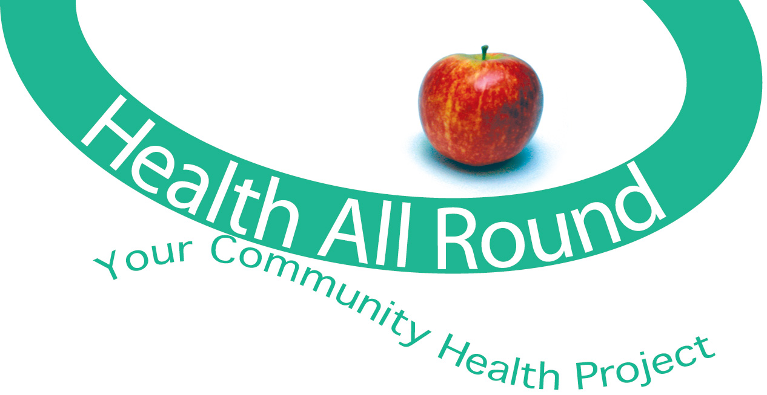

**Health All Round**   
**Community Link Worker**

**Person Specification**

**Essential**

● Extensive experience of working with vulnerable people using a social model of health

● Ability to support individuals in psychological distress calmly, safely and sympathetically

● Understanding of the impact of social and economic inequalities on communities and individuals

● Experience of working with people with complex health and social needs

● Understanding of behaviour change and experience of supporting people to make positive change for health and wellbeing

● Ability to listen, support and motivate individuals

● Understanding of professional boundaries and confidentiality

● IT skills including the use of databases

● Good understanding and creative approach to evaluation

● Ability to work autonomously, plan workloads, meet deadlines etc

● Positive outlook, self motivated and flexible

**Desirable**

● Educated to degree level in a relevant field e.g. health sciences/health & social care/public health

● Understanding/experience of motivational interviewing

● Experience of partnership work across the sectors