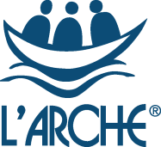

Senior Support Worker
L’Arche Edinburgh

Do you have a passion for ensuring people with learning disabilities live fulfilled lives? Do you want to help lead a community that values people for who they are and what they can do?

L’Arche Edinburgh is a community of more than 80 people with and without learning disabilities. It is a place of belonging where people with learning disabilities can live independent, yet connected lives.

Along with the Support and Care Leader and another Deputy Support and Care leader you will help to lead a team of approximately 15. We aim to provide and develop high quality person-centred care supporting the practical, social and spiritual needs of those who call L’Arche home. We are always looking to increase choice for the people we support as part of shared living at The Skein and in individual supported tenancies and explore ways that we can grow as a Community.

L’Arche Edinburgh is an ecumenical Christian community which welcomes people of all faiths and none. We are part of a global network of communities where people with and without learning disabilities live and share in life together, working for a world where we all belong.

Knowledge and experience in care or supported housing is a key requirement for this role, but we’re also looking for someone with an enthusiasm for our values and the ability to inspire others. You might be looking to step up from a support worker or to use your current management experience in a different way. If you are interested in being part of a mutually supportive and lively community, then we want to hear from you!

Enquiry pack and Application Form available at : www.larche-edinburgh.org.uk
The closing date is Monday 23rd August at 9AM.
Finding out more about L’Arche
L’Arche is more easily experienced than explained. If you would like to find out more about us, we would normally encourage you to visit us, but sadly, these are not normal times. If you are shortlisted, you will be invited to ‘visit’ The Skein in a Covid-compliant way as part of your interview. Interviews will be held via Zoom.

The Assistants Coordinator (HR Manager) or Support and Care Coordinator (Registered Manager) would be very happy to talk informally with you to answer any questions you may have about this position in L’Arche via 0131 553 3478 .
You can find out more about L’Arche Edinburgh at www.larche-edinburgh.org.uk
and L’Arche in the UK at www.larche.org.uk

What qualities those who live in The Skein or their own individual tenancies are looking for in the people who form their leadership team:
- A person who genuinely cares about the core members, and isn’t just taking it as ‘a job’; someone whose heart is really in it.
- A person who is committed to communicating with family members on a regular basis, seeing that their loved one looks well and is taken care of.
- A person who is great at communicating – written and verbal – who knows what’s really going on.
L’Arche: What we do
We believe that people with learning disabilities have much to teach us and contribute to the world. During the last fifty years, we have learnt that one of the best ways to enable this is by creating Communities with a culture of shared lives between people with and without learning disabilities, from which we can work together to build a more human society.
At L’Arche we celebrate people with learning disabilities and build circles of support around them. We go beyond supporting people's basic needs to attend to their emotional and spiritual lives, too. It is this focus on building relationships and cultivating a sense of belonging that makes us different from other service providers.
L’Arche Communities hold in balance four elements: service, community, spirituality & outreach. Experience has shown us that each element has an important role to play and needs to be present - not only for a Community to be healthy - but in order to make us better at each of the other elements.
L’Arche Communities around the world share this common philosophy and approach while reflecting and celebrating the ethnic, cultural and religious composition of the areas in which they exist

Community life
At the heart of L’Arche is the support we provide to people with learning disabilities. As well as providing high quality housing and supported living, we also work with individuals to access employment and voluntary opportunities. In addition, many of our Communities provide day support services. Furthermore, we assist people to access relevant healthcare and, where appropriate, receive therapeutic services. We work hard to ensure that the needs of individuals with learning disabilities are met holistically, and that people are supported to live fully integrated and empowered lives within the wider communities in which they live.
We have a long history of working with social services and social work departments, health authorities, primary care trusts, registration and regulatory authorities, housing associations and others, to provide high quality support that is recognised as being truly responsive to people with learning disabilities.
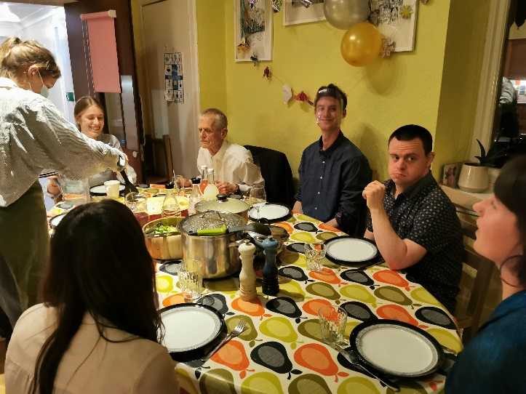
The Skein
L’Arche Edinburgh: Background information
L’Arche Edinburgh is one of ten communities that form L’Arche in the UK and belongs to an International Federation of 153 communities in 38 countries.

L’Arche Edinburgh opened its first house in 1991. It has grown since then and has a network of houses and flats. The community is made up of adults with learning disabilities, more than forty employed assistants, Committee members and many other friends and volunteers.

Our employed assistants are drawn from two sources. Most are local people employed on standard contracts, whom we term “live-out assistants”. But what makes us different is that up to a third of our assistants live in our houses alongside the people with disabilities to whom they provide support. They receive board, lodging and expenses. This experience of living in community alongside people who are different from themselves is a source of huge richness. Many of these live-in assistants are from outside the UK, and Brexit and Covid brings us new challenges in this area.

Our services are registered with the Care Inspectorate under their dual category of Care at home and Housing Support. This vacancy covers The Skein and two people who live independently in their own flats.

Shared Households:
- The Skein: home to four people with learning disabilities today and supported by a team of 14 assistants, up to four of whom live in the house. This was our first house, opened in 1991. Some of the assistants also work shifts in Fox Street.
- David House: a house for four people with more complex support and healthcare needs. 12 assistants support David House, some of whom live in the house
- Creelha: home to four people with disabilities, supported by 10 assistants, some of whom live in the house

Flats for individuals:
- We support four people who live independently in nearby flats, and who choose to live as neighbours

Work and day opportunities:
We do not run centre-based day activities, but instead have been ahead of the time in developing individualised day opportunities in the local community.

Community and spiritual life
L’Arche Edinburgh normally has a rich and vibrant community life involving Community Gatherings, parties, outings, celebrations and meals to bring together large and small groups. Christmas and Easter are celebrated together, and there are other opportunities for prayer, reflection, and quiet time for those who wish to participate. It is hoped that many community activities will become possible again in the near future.

Senior Support Worker – Person Specification

The people with learning disabilities within our service are looking for someone who has the following skills and qualities:
- “They’ve got to get on well with people”
- “They’ve got to be able to sort things out if they go wrong”
- “Be able to answer the telephone, talk to people and make appointments for me”
- “I want them to take their time to get to know me”
- “Make sure people are here when I need them”

Provision of support and care for people with learning disabilities means also supporting some people who have physical disabilities. This could include wheelchair users or people with higher mobility needs and involve lifting and physically supporting people. Therefore, the work may be physically demanding at times.

Leadership and Management – candidates should demonstrate experience and competence in
- Potential or ability to manage and supervise staff within in a social care setting
- Understanding and insight into working with and motivating teams
- Communicate effectively verbally and in writing
- Good organisational and administrative skills
- Ability to delegate effectively

Supporting People – candidates should ideally have
- Experience of support work within a social care setting with adults with learning disabilities
- Experience of support work with adults with learning disabilities who live independently
- Experience of working collaboratively with people with learning disabilities to plan their care and support
- Understanding of the emotional and behavioural support needs of adults with learning disabilities
- Understanding of the principles and practice of supported living
- Understanding of what it means to think and work in a person centred way

Personal Qualities – candidates should demonstrate
- personal authority and potential to lead others
- an openness to the ‘vocational’ aspects of belonging to L’Arche and to becoming a member of the community
- emotional maturity and resilience to deal with situations responsibly, referring more complex situations to the Support and Care Leader
- ability to work with autonomy, initiative and responsibility

Qualifications
- SVQ 2 Health and Social Care and the additional supervisory qualification required by SSSC OR have the ability and commitment to achieve SSSC required qualifications within the required time period (see Terms and Conditions).
- Evidence of openness to continuous professional development
- IT skills
- Full driving license and ability to drive Motability vehicles (desirable)

TERMS AND CONDITIONS:

Full terms and conditions are contained in the L’Arche contract and Employee Handbook
- Total working hours are 40 per week. The hours require shift working involving some evening and weekend work. There will be a typical and predictable pattern of days off, which may vary on occasion if needs arise. Split shifts may be required.
- The salary is on a 2 point scale starting at £21,132
- A satisfactory performance appraisal after 12 months in the post is dependent upon meeting the required standards and completion of the SVQ 2 Health and Social Care.
- Sleepovers are required occasionally. Sleepovers are paid at £85.77 per night in addition to salary.
- The post is subject to a probationary period of 6 months which may be extended if necessary.
- For new employees, during the probationary period sick pay is paid at the statutory rate only. On successful completion of the probationary period and during the subsequent period up to two years of service an employee, sick pay is paid at the full rate for 20 working days in any 12 month period.
- Time off in lieu will be given when circumstances require the post holder to work extra hours.

