RSE APPLICATION PACK

FINANCE ASSISTANT

Thank you for requesting an application pack for the position of Finance Assistant at the Royal Society of Edinburgh.

The Application Pack contains:

- A Job Description including key responsibilities, competencies, skills & experience needed to do the job, salary & hours, a person specification and the RSE expectations of Key Behaviours & skills
- Information about the Royal Society of Edinburgh
- Policy on criminal record disclosure
- A note summarising RSE non-pay benefits

Closing Date for application
The closing date is 5.00pm on Friday 03 September 2021

To apply for the role
Complete the RSE application form as fully as possible demonstrating how you meet the competencies and skills required for the post and the relevant experience you bring to the role, and return it to vacancies@therse.org.uk

Diversity
Completion of the Equal Opportunities Monitoring Form is optional. You should return this form to vacancies@therse.org.uk

Interviews
If you are invited for interview, due to the current situation of COVID 19, this will take place online possibly using ZOOM on Thursday 16 September 2021.

Eligibility
In accordance with the Immigration, Asylum and Nationality Act 2006 The RSE, as an employer, has a legal responsibility to prevent illegal working and therefore must check that all employees are entitled to work in the United Kingdom. To do so we require to see original documents evidencing right to work in the UK before commencement of employment.

Feedback on your application
Please note that feedback will only be provided to candidates after interview.

Job contact
- For an informal discussion about the role, please contact Shazia Siddique, Financial Controller by email ssiddique@therse.org.uk

Recruitment team
- For any queries about the recruitment process, and to apply for the role, please contact our HR department by email vacancies@therse.org.uk

Job Title | Finance Assistant (Part Time)
Grade / Salary / Hours | Grade 1  £10,225  3 days per week (equivalent to 21 hours, 7 hours per day)  Occasional work may be required out-with normal office hours. Finance Team meetings normally take place on Wednesdays. Working remotely due to COVID19 in a first instance
Role | To assist with the day-to-day processes within the finance team, including the financial administration for research awards and enterprise fellowships.
Key Responsibilities | - Processing of enterprise support claims including storing and checking  - Processing research awards acceptance forms including payments  - Reviewing and checking research statements of expenditure & chasing  unspent funds due  - Maintaining the file system for research and enterprise fellowships  - Processing awards claims & grants through purchase ledger and invoices from suppliers as required  - Monitoring the accounts inbox and processing emails appropriately and a timely manner  - To undertake any other finance/research administrative tasks as required by the finance team
Key Competencies /Skills | ESSENTIAL  - Experience in financial procedures within a small organisation, including all the key tasks  - Experience of using SAGE 200  or similar accountancy packages  - Experience in maintaining filing  systems  - Ability to demonstrate excellent  attention to detail & good numerical skills  - Ability to prioritise and organise  own work without supervision, and work as part of a small team  - Good communication skills  - Ability to demonstrate integrity and confidentiality  - Some knowledge of Scottish University Higher Education & Grant Funding | DESIRABLE  - Experience of working with a charitable organisation
Key IT Skills | Word | Excel
Key IT Skills | Intermediate Level | Intermediate Level
Key IT Skills | Outlook | PowerPoint
Key IT Skills | All skills | None
Key IT Skills | CIVI Database | Others
Key IT Skills | Purchase orders  General procedure  Finance procedures | Sage 200  Rendezvous Booking system
Responsible To | Financial Controller
Staff Management Responsibilities | None
Key Customer Groups | External: University and Research Institute administrative & finance staff and awardees, suppliers  Internal: All RSE staff particularly with the awards team and finance team& Fellows

Job Specification

- Processing Enterprise Support Claim forms:
  - Storing electronic claims and receipts;
  - Checking the claim form additions
  - Ensure entries are backed up with relevant receipts in line allowable expenses;
  - Coding the claim forms for entry in purchase ledger;

- Processing research awards acceptance forms:
  - Entering details from research awards grants acceptance forms in the CRM;
  - Preparing payment schedules for each award, including coding;
  - Entering on Finance research awards spreadsheets;

- Review & Checking Statement of Expenditure:
  - Ensure statement of expenditure are received from institutions in a timely fashion;
  - Enter details from statements on Finance research awards spreadsheets;
  - Record any unspent funds due to be returned to RSE;
  - Monitor and chase payment of the unspent funds as required.

- Maintaining the filing system
  - For both Research awards and enterprise fellowships, organise the filing system, including archiving.
  - Processing through Purchase Ledger
  - Entering research awards grant payments and enterprise claims into purchase ledger;
  - Producing suggested payment report for approval;
  - Distributing remittance advices with any additional information required;
  - Supporting the Finance Officer in processing purchase ledger supplier invoices, including coding, distribution for authorisation and entering in purchase ledger.

- Monitoring the Account Inbox
  - In conjunction with other finance team members, monitoring the accounts inbox
  - Printing invoices for processing and storing relevant electronic copy

- Other reasonable tasks / behaviours as required by the RSE, this includes, but is not limited to the following:
  - Apply RSE’s key behaviours and skills (See “Our Expectations” enclosed).
  - Adhere to the RSE vision, mission and values
  - Ensure all processes comply with data protection legislation and are in accordance with RSE record management policy and processes
  - Observe all health and safety requirements
  - Work within and promote policies in relation to the RSE Diversity Policy
  - To undertake any training as required by the job description, in line with the business needs or required by your team leader.
  - To undertake other reasonable tasks as required by RSE

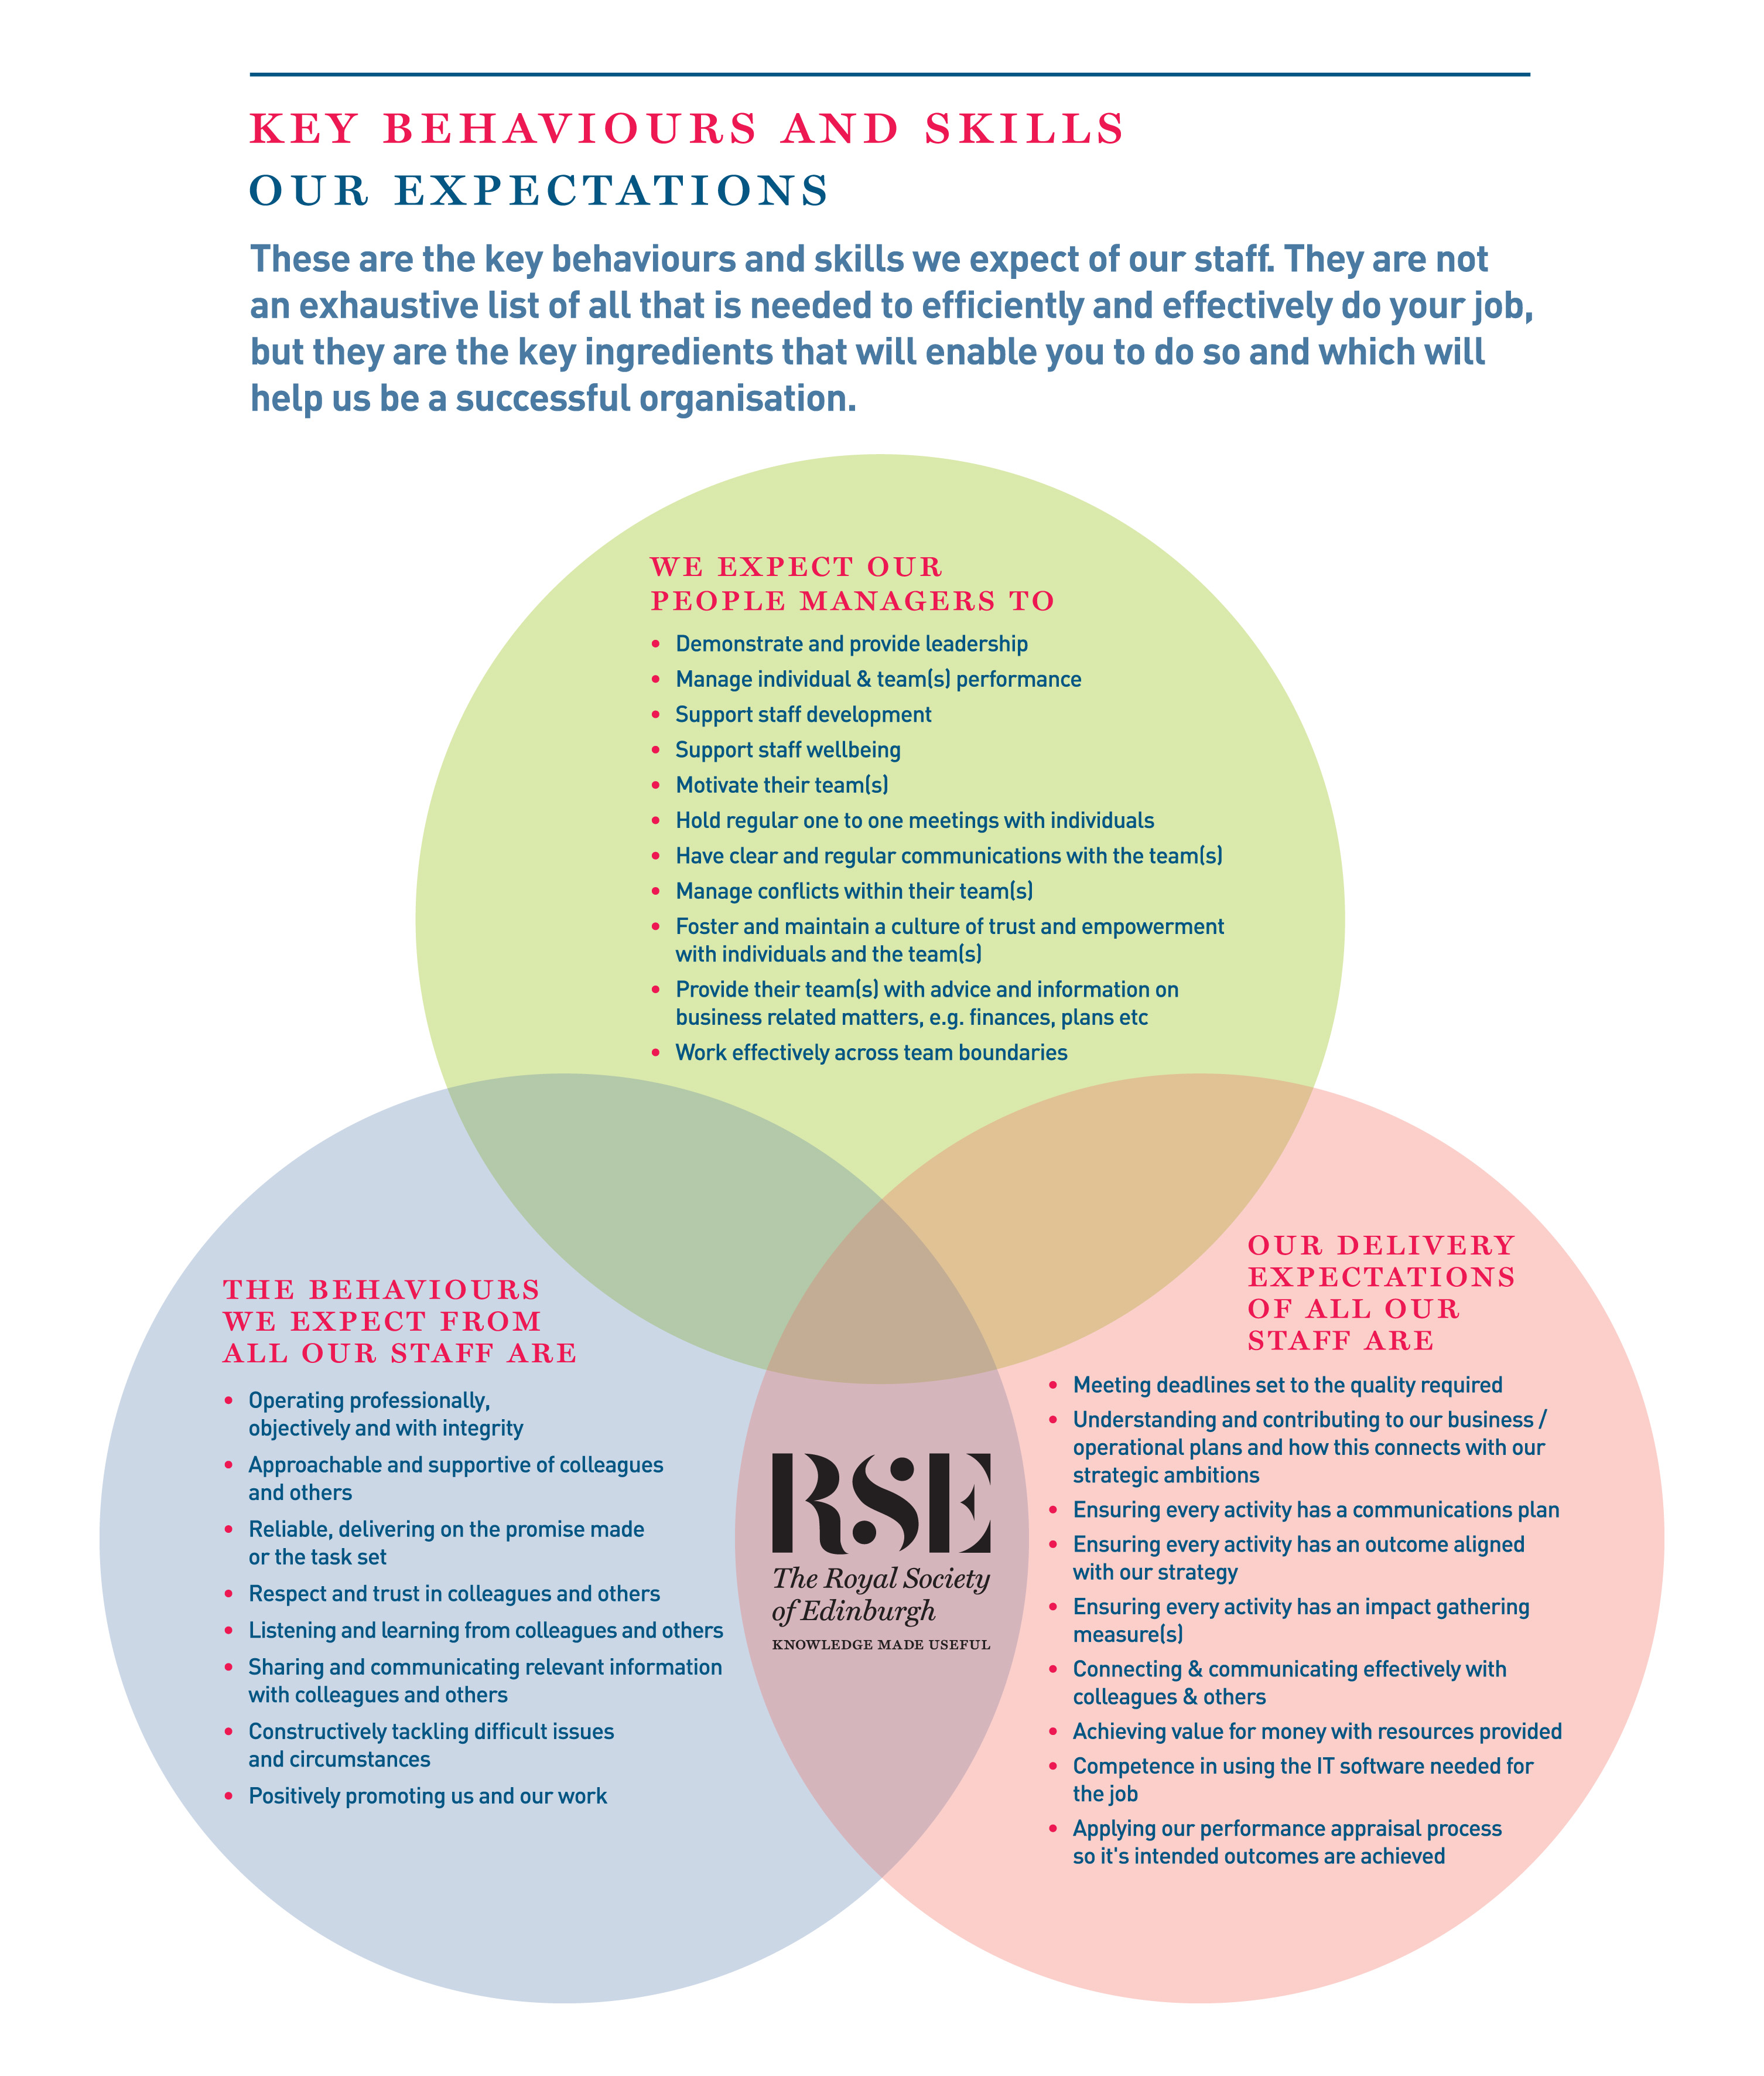

About the RSE
The Royal Society of Edinburgh, Scotland’s National Academy, is an educational charity that provides public benefit throughout Scotland through a diverse range of activity including awarding research funding, informing public policy, and delivering events across Scotland to inspire knowledge and learning.
The RSE’s mission, set out in its Royal Charter of 1783, is “the advancement of learning and useful knowledge”. Its contemporary purpose remains the same – the deployment of knowledge for public good: knowledge that contributes to the social and economic well-being of Scotland and its people and the nation’s wider contribution to the global community.
The RSE draws upon a body of elected fellows who are leaders and experts in their fields. The breadth of expertise and experience within the Fellowship ranges from life sciences, physical sciences, and technology, to arts, humanities, social science, business, public service, and civil society. The multidisciplinary breadth of the RSE – reaching well beyond the academic world – is a distinctive strength and unique within UK national academies.
Our staff group is responsible for executing our programmes of activities and ensuring due governance is followed.

Our Strategic Framework
Published in 2016, our Strategic Framework 2016-2021 sets out the Royal Society of Edinburgh’s vision and strategic objectives to 2021. It identifies the distinctive impact the RSE aims to make nationally and internationally, and the benefits that a vibrant multidisciplinary national academy can bring to Scotland.
The Framework sets out four strategic objectives to:
- Inspire and support Scotland’s most promising young talent across the research, business and public sectors, to create value for the economy and society;
- Engage on key contemporary issues by providing an impartial forum for public debate and discussion;
- Provide expertise to ensure that Scotland’s policy makers and influencers have access to the best national, and indeed global expertise;
- Promote Scotland’s interests and reputation on the global stage.
Alongside these strategic objectives, the Framework identifies four development aims:
- To create an active and more diverse Fellowship;
- To secure increased funding from a diverse range of sources;
- To enhance and widen the RSE’s outreach and impact;
- To redevelop our premises.
In line with the ambitions set out in the Strategic Framework the RSE is embarking on a major programme of change, building on existing strengths, to further enhance the Society’s visibility, reach and impact.

POLICY ON CRIMINAL RECORD DISCLOSURE

In line with its overall recruitment policy, the RSE seeks criminal record information before making an offer of employment to a successful job applicant. The note below describes the process that will be followed and what happens to any information received. Please read it carefully.
The post for which you have applied requires the applicant who is successful at the interview stage to complete a personal disclosure of any unspent convictions, details of any cautions, reprimands and final warnings administered, and details of any charged offences. There will, also, be open and measured discussion about disclosure information at the interview stage. If an applicant fails to disclose relevant information at interview, it may lead to the withdrawal of an offer of employment, or following appointment, disciplinary action being taken, which may include the termination of employment.
If an interview, or subsequent personal disclosure, provide information about a conviction, cautions, reprimands, final warnings administered and charged offences, RSE will assess the relevance of the information by considering:
- The seriousness of the offence and whether it is relevant to the protection and safety of RSE staff, others and RSE property.
- The length of time since the offence took place
- Whether there is a pattern of offending behaviour
- Whether an individual’s circumstances have changed since the offending took place, making re-offending less likely.
- Relevant information offered by an individual about the circumstances which led to the offence being committed
- The country in which the offence was committed; some activities are offences in Scotland and not in England and Wales, and vice versa.
- If the offence has since been decriminalised by Parliament.
- The degree of remorse, or otherwise, expressed by an individual and their motivation to change.
Personal disclosure information provided will only be used for recruitment purposes and will only be shared with those authorised to see it during their duties. No image or photocopy of the information will be made. The Personnel Office will keep all information disclosed in a secure and confidential file for 6 months after the start of employment.


In addition to the basic salary paid, the RSE offers staff a generous package of rewards. The package includes:

Salary | - Subject to what we can afford, you may receive an annual pay award to maintain the real terms value of your pay. There is also discretionary scope for additional consolidated or non-consolidated pay awards
Contributory Pension Scheme | - You can join the RSE AVIVA Group Pension Plan. You contribute 3%. On your behalf, we pay a further contribution of 6% of your annual salary. Further information about the scheme is available here http://www.aviva.co.uk  - There is scope for you to pay a higher employee contribution. If you decide to do so, the RSE will pay double the employee contribution rate up to a maximum employer contribution limit of 12%.  - AVIVA may accept transfers from other schemes so please check with them prior to applying for a transfer.
Annual leave | All employees employed after 1 August 2018 receive the following annual allowances (pro-rata for part time staff):  - 25 days up until completion of 3 years employment  - 27 days following completion of 3 years employment (+ 2 days)  - 30 days following completion of 5 years employment (+ 3 days)
Public Holidays | - You get 9 days public holiday (pro-rata for part time staff). This is built into your total holiday allowance (annual leave + public holidays) each year
Sick Absence | - You receive sick absence pay once you have satisfactorily completed your probation period. The period of paid absence increases progressively according to your length of service and reaches, after 4 years of service, full pay for 26 weeks absence and half pay for a further 26 weeks absence
Family Leave | - We recognise and fully comply with your legal rights in relation to paid (Adoption, Maternity & Paternity leave, Shared Parental Leave) and unpaid time off, and flexible working. Where your contracted salary is greater than the statutory minimum for paid time off, during, or for part of the absence, you will be paid your contracted salary. In addition to these legal rights, you can also, depending on the circumstances, receive paid “Family Responsibility Leave” to cover unforeseen family circumstances.
Performance Management | - We care about your performance and development and assess, manage and support it through our performance review system.
Flexibility with medical appointments | - We are flexible in how we deal with dental and medical appointments. We expect these to be arranged out-with your normal hours of work, but we recognise that for many reasons this might not always be possible. Where that is the case, we exercise discretion and provide reasonable time off during your normal working hours to attend your appointment.
Healthy Working Lives | - We are part of the Healthy Working Lives Award Programme. We obtained our Bronze Award in 2005 and have obtained our Silver Award in July 2011 and since then maintained both Awards. A group of staff volunteers organise events focussing on health promotion, occupational health and safety, health, and the environment, raising awareness about mental health and well-being and we are working towards the Gold Award.  - Types of Events: RSE Wellness Day - Health Checks for staff (diabetes, cholesterol, BMI, Blood Pressure), Big & Healthy breakfast, Running Club at lunchtime (Jog Scotland), Pedometer Competitions, Walking group, Lunchtime Yoga classes, social cycle rides at the weekend, training on First Aid for baby and child for all new parents, event of information on Nutrition, Cancer, Salt Intake, Legal Highs, etc.
Support with VDU | - As part of the Health and Safety at Work legislation, employers are required to designate which staff members are classed as regular users of computers. We have designated that all staff fall into this category.  - Employers also have an obligation to provide eye tests, or a facility, which will allow staff to have their eyes tested so that their ability to see the screen properly can be assessed. We are committed to complying with this obligation by paying for eye tests related to computer usage only.  - Additionally, if a member of staff requires glasses for computer use only, we will contribute to the cost for an amount of up £45  - We organise online DSE checks for all staff and monitor these as part of our wellbeing programme
Occupational Health | - These services include guidance and advice on health-related issues, promotion of health in the workplace, and counselling.  - The service is available to all staff, individually and collectively. Anyone wishing to draw on it should speak to the HR Office, which has the contact details and can advise on appropriate courses of action (Physiotherapy, Counselling, helping with Mental Health issues, etc…)
Learning & Development | - We support your learning and development and have a budget dedicated to these activities as well as an annual Learning & Development programme. You can also apply for up to a 50% contribution towards the costs of maintaining or achieving a professional membership or qualification.
Travel Loans (frozen during COVID) | - You can apply for an interest free loan to cover the cost of a public transport season ticket.
Overtime (Frozen during COVID) | - You will get time off in lieu (TOIL) to compensate for overtime worked out-with normal hours at our request, which is not already compensated through your annual leave entitlement.
Give as you earn | - We are committed to supporting you should you wish to donate to charities directly from your monthly salary. The Direct Donation allows you to personally nominate your own favourite charity or charities to benefit from regular donations straight from your pay. Giving through your pay is tax free and flexible. You can make donations to any charitable or voluntary organisation in the UK. This can include places of worship, schools, scout groups and many other organisations. We pay the administration fee to the scheme and all your donation will therefore go to your nominated charity.
Staff Away Day | - We arrange and pay for a staff away day each year. The purpose of this is to give you an enjoyable, informal day away from your normal workplace, where you can get to know your colleagues better. Due to COVID 19, this event has been postponed

