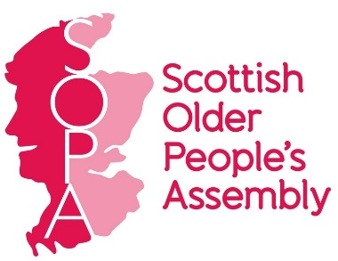
Scottish Older People's Assembly
Trustee Role Description

The Scottish Older People's Assembly (SOPA) exists to give a strong voice to older people about their experience of life in Scotland, and to celebrate the positive contribution that older people make to society.
SOPA engages with older people across Scotland through outreach meetings and its links with member organisations. SOPA participates in national policy forums and events as well as organising its own Assembly and annual Reception. SOPA is currently working to develop digital engagement to extend our reach further. For further information see SOPA’s three year plan.
SOPA is largely a volunteer-led organisation with over 60 member organisations. Its work is overseen by a Board of Trustees (currently 10 Trustees). Staffing comprises of a part-time Co-ordinator, with occasional project work from other freelancers. Following recent securing of additional funds, we will be recruiting a further two part-time Project Workers which will allow us to significantly expand our capacity. SOPA is a Scottish Charitable Incorporated Organisation: Number - SC046520.
Meetings: Board meetings are held between four and six times per year, alternating between Glasgow and Edinburgh, or in recent times meetings have taken place online.
Role: Trustees are responsible for the charity's governance and strategy, and for making sure that the charity is administered effectively. They must account for its activities and outcomes. Further information about the role of a charity trustee in Scotland is available in the OSCR Guidance and Good Practice for Charity Trustees.
Commitment: SOPA Trustees are expected to provide proactive support to SOPA in delivering its aims. This includes:
- Attendance and active participation in quarterly Board and Member meetings
- Attendance and participation at SOPA’s Parliamentary Receptions, Assemblies and out-reach meetings (3-5 per year in total)
- Representing SOPA at consultation events, meetings and working groups (2-3 times per year)
- Attendance at SOPA’s Annual General Meeting
- Contributing to consultation responses, surveys and engagement activity (by email, phone, web and face-to-face meetings)
- Contributing areas of particular expertise e.g. helping to develop funding bids, reviewing policies and political engagement activity to support the work of the Chair and Co-ordinator.
Trustees are not paid but will be reimbursed for reasonable travel expenses related to their role.

