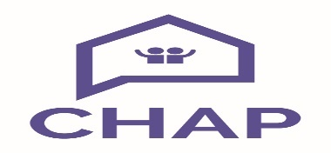

**Job Description**

**Keyworker (Better Off North Ayrshire Project)**

**POST: Keyworker**

**RESPONSIBLE TO: Service Manager**

*The post holder will work with the Better Off North Ayrshire team within CHAP to achieve the project’s key objectives of supporting residents to improve financial resilience and wellbeing.*

The Key deliverables are:

1. Be responsible to the Service Manager and work in partnership with the ‘Better Off North Ayrshire’ partners
2. Sensitively provide clear and accurate information to clients on debt/housing/welfare rights issues up to, and including, Scottish National Standards Type 111 *(development training will be provided where applicable)*
3. Accurately represent in writing/by telephone/in person, clients views and opinions on issues to statutory bodies/other organisations, where they are unable to do so for themselves
4. Ensure that client database is maintained with concise notes on individual cases
5. Maintain a secure and confidential registry of all sensitive information relating to service users
6. To effectively identify wider needs of clients and provide support, including advocacy support, to engage with community services, support resources and other service providers.
7. Contribute to monitoring reports as directed by the Service Manager in regard to activities undertaken with clients and evidence of impact
8. Complete necessary paperwork on time, to enable the project to monitor and collate statistics
9. Adhere strictly to company policies and procedures, including Corporate and Client Confidentiality as outlined in the company Confidentiality Policy
10. Undertake any other reasonable task which may from time to time be delegated by management