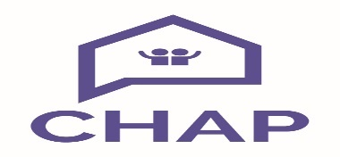

**Person Specification**

**Keyworker (Better Off North Ayrshire Project)**

|  |  |
| --- | --- |
| **Essential** | **Desirable** |
| * Experience of Case working, particularly with vulnerable individuals and using extensive knowledge of the Welfare System * Experience of representing and negotiating on behalf of service users * Experience of completing comprehensive income and expenditures with service users * Experience of multi-agency partnership working * High standard of numeracy and writing skills, with the ability to draft correspondence and reports * Demonstrate an understanding of the ‘whole-person’ approach. * Demonstrate an understanding of confidentiality * A good attendance and timekeeping record | * Ability to identify own training needs * Knowledge of local services * Team player * Pragmatic attitude * Knowledge of housing and homelessness legislation * Knowledge of, and ability to assimilate, the legislative framework informing money and debt advice |