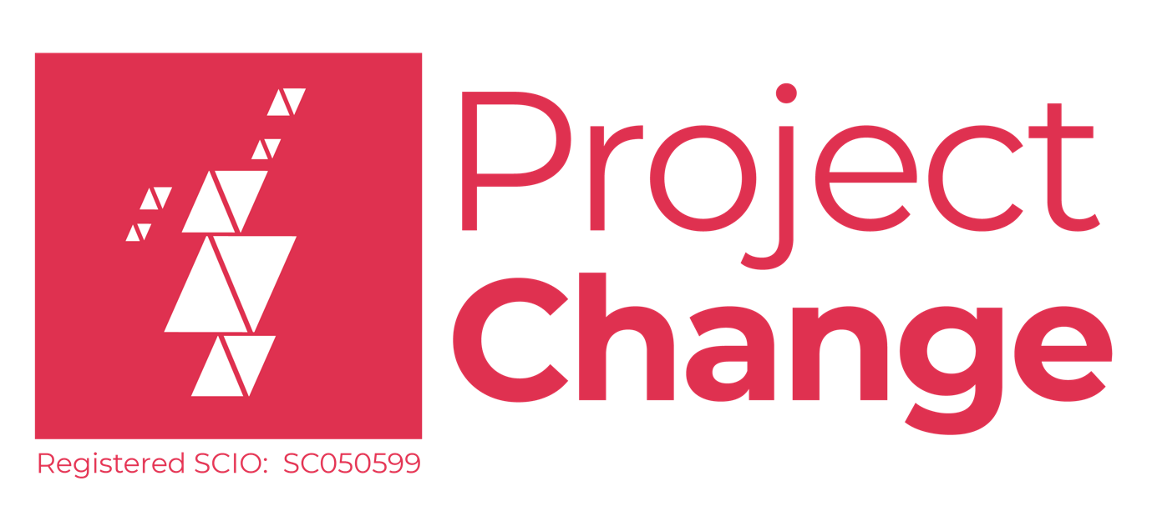

Information Pack

Development Officer

About Us

ProjectChange was founded in February 2020 by members of the care community. Some of the founders had lived experiences of the care system, others worked and lived around the system.

The word ‘care system’ is becoming more and more obsolete. We believe redefining ourselves as a community recognises the 'live, long, belonging' and the impact that belonging to this can have. It’s underpinned by the idea that being connected beyond system labels allows us to be diverse and not uniform. Most importantly, we are human beings connecting and developing with others. By redefining this new community, real change can happen.

This is a new concept. On breaking down the care community, It naturally splits Into three overlapping segments. Generally, the community is made up of those with lived experiences of care; those who interact with people in care (e.g. social workers and teachers); and those interested in care(funders, the wider public and friends).

If all three of these groups worked and grew together, the future could be would make the future more representative, diverse, and inclusive. It would remove old power barriers and would ultimately make people’s lives better.

ProjectChange’s role within the community is not just to champion this new idea and way of working but also how we think we can build our community.

We believe in three simple actions.

- We help people talk,
- We help people listen,
- We help bring people together.

Connecting and developing relationships is at the heart of what we do.

ProjectChange has broken its work into four segments to create a more targeted approach to development and participation.

Friendships:
This involves creating positive relationships across the care community. In doing this, we hope to create belonging and identity; connecting and inspiring each other, create safe and friendly spaces for the care community to come together and enabling people.

Engagements:
By nurturing others, listening and valuing people with a diverse range of lived experiences, we hope to implement change that will make improve people's lives. Change will keep the promise made to Scotland’s children and families.

Changemakers:
We want to support and develop those who are determined to make change and make sure that as many people as possible are involved. We hope to develop a toolkit to allow enable and empower any voice.

Leaders:
We will support innovative new ways of nurturing, finding, and recruiting care experienced leaders from the whole community. Without leadership, change won't happen and we won't be able to support the community of tomorrow. We will also launch a consultancy service, aiming to provide organisations with a direct source of expertise from the care community.

Keeping The Promise:
While not an official pillar of the work ProjectChange does, keeping the promise made to Scotland’s young people by the Independent Care Review’s publication guides everything ProjectChange does and aims to do.
Post Title | Development Officer
Salary Range | £22,129 - £24,697
Hours of Work | 35 Hours (with the offer of Flexible Working)
Base Location | Flexible – Due to ongoing restrictions
Responsible to | Chief Executive

ProjectChange Job Specification

Additional Benefits:
- 35 days annual leave (includes bank holidays)
- 3.5% employer pension contribution

Purpose of the Post

The main role will be to develop and publicise the voices toolkit. This is a series of self-led empowerment resources for individuals. The aim is for people with care experience (and others with different lived experiences) to have the confidence and skills to be part of a community of change-makers. They can then in conversation about language, identity and belonging and ultimately help to reframe the narrative of care.

This will involve working with the steering group, which consist of individuals and organisations Involved In developing the voices toolkit.

You will have to work with the steering group to finalise the toolkit's design. After this, you will be involved in rolling out the toolkit to people with care experience, those interested in care and other organisations within the wider sector (e.g. by delivering training and support sessions for users)

Internally your role will be to nurture and grow ProjectChange by thinking of creative ideas to help us continue creating a new direction for the care community.

Main Duties and Responsibilities

To coordinate and develop, along with the steering group, the final stages of the toolkit.

To ensure people with care experience are at the heart of the final stages of development, and subsequent roll-out.

To develop new partnerships across the sector to ensure a wide reach and embedding of the toolkit.

To assist ProjectChange and our partners keep The Promise we made to children and young people in Scotland.

To coordinate ProjectChange's participation activities which ensure that people with care experience are heard and empowered and inform the development of ProjectChange's strategies and practices.

To build trusting relationships with a variety of people across the care community so they feel comfortable to speak up and be supported, addressing the power dynamics which impact the experiences and effectiveness of this work.

To contribute to monitoring, evaluating, and reporting the impact of our participation work and outcomes for participants and toolkit users.

Communication and Relationships
The successful applicant will have contact with:
- Chief Executive Officer
- The Trustee Board
- Voices Toolkit Steering Group

Essential Experience:

The successful applicant must have the experience listed below:

Working with children, young people and adults, including those with experiences of the care system. Applicants should have at least two years' experience via paid or voluntary roles in a public engagement, youth work, education or other relevant settings.

Planning and delivering (online) workshops and other engagement activities to engage groups of children, young people and adults in delivering creative outputs.

Essential Personal Attributes:

The successful applicant must be able to provide practical examples of how they have demonstrated the attributes below:

Show commitment to improving the lives and opportunities of children and young people in care, care leavers, adults with experience of care and the wider care community.

Have the ability to build respectful relationships with a wide variety of stakeholders.

Emotionally Intelligent and able to be non-judgemental and put aside their views when listening and consulting.

Have self-initiative and can work independently.

Show commitment to principles of equality, diversity, and inclusion, including the ability to actively challenge discrimination.

Essential Skills:

The successful applicant must be able to provide practical examples of how they have demonstrated the skills below:

- Communicate naturally with members of the care community
- Excellent written and verbal communication skills.
- Good IT literacy knowledge, particularly Microsoft Office Suite.
- Strong time management and record-keeping skills.

Essential Knowledge:

The successful applicant must be able to provide practical examples of how they have understanding of the below:

- Understanding of the children's care system and local authority structures.
- Understanding of the emotional and practical issues often faced by children and young people in care, care leavers, adults with experience of care and the wider care community.
- Understanding of the principles of practices of co-design, including mechanisms for involving and empowering communities in decision-making
- Understanding of safeguarding for children and vulnerable adults.

Desirable Criteria:

Desirable Qualifications:
- An HND or higher qualification in a social science.

Desirable Knowledge:
- Understanding of the policy, legislation and guidance underpinning children’s rights and the care system (e.g. UNCRC, Children Act 2020 etc).
- Demonstrate personal understanding of The Promise, including the Independent Care Review Reports and ‘Plan 21-24’.

How to apply
To apply, please download an application form, complete it and send it to jobs@projectchange.scot before the closing date. Please send your application as a Word document or google doc (not a PDF) and please do not include any other documents with your application - they will not be read.

Closing date for applications: 30th September 2021
First interviews will take place on w/c 11th October with second interviews on w/c 18th October

Due to the volume of applications, we usually receive, we regret that we are unable to offer feedback to individual applicants who aren’t selected for interview.

Equal Opportunities
We are committed to providing equal opportunities for everyone, regardless of their background. We believe this is crucial to ensuring the legitimacy and effectiveness of our work. We acknowledge that people from a number of communities are underrepresented in our team and the wider care community and the charity sector in general, and we’re committed to addressing this. If you believe you would bring greater diversity to our team, we’re keen to hear from you.

Get in touch
If you have any questions about the role, or if you feel you could do this role well but don’t have all the characteristics we’re looking for, please contact ProjectChange CEO Adam Bennett at adam@projectchange.scot for an informal conversation.

