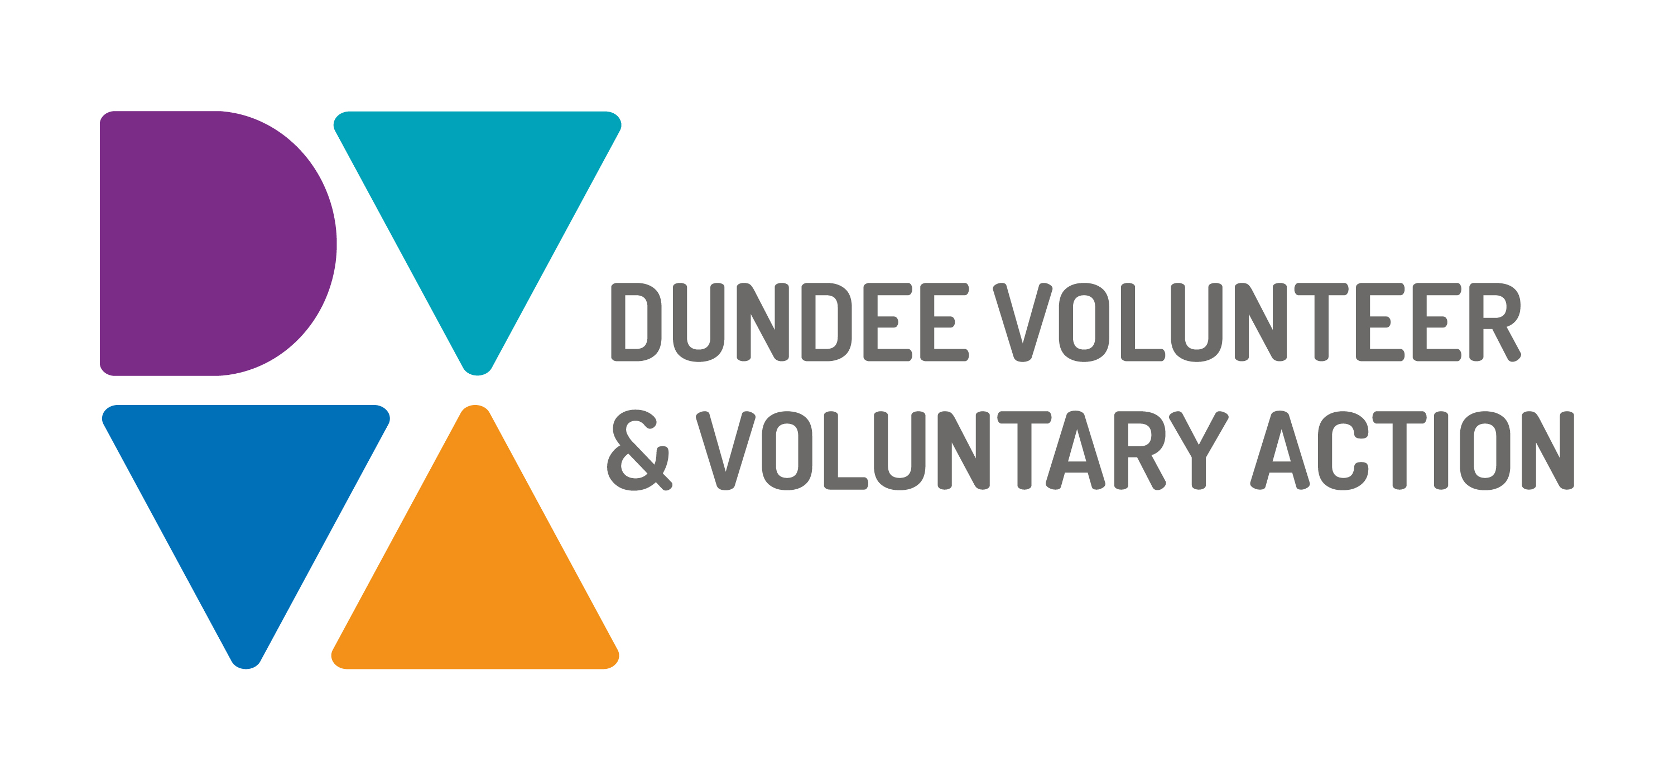
Job Description and
Person Specification

POST TITLE: Operations Manager

RESPONSIBLE TO: Dundee Volunteer and Voluntary Action Board of Management through the Head of Service and Chief Executive

DURATION: This is a permanent post and is subject to an initial 6 months probationary period

HOURS: 35 hours per week, to be worked in accordance with DVVA Conditions of Service

SALARY: Grade 7: £33,750- £37,500

PURPOSE OF POST

The post holder will manage the day to day operations of the Health & Wellbeing and Community Planning Programmes. The Operations Manager has line management responsibility for all staff engaged in the delivery of services and engagement with stakeholders (the operations staff team). This includes Managers in Social Isolation, Mental Health & Alcohol Substance Use, Communities and Community Hub Programmes.

MAIN WORKING CONTACTS

Internal: Chief Executive, DVVA Board, Head of Service, Programme Managers and Programme Staff and Volunteers.

External: Third Sector, Third Sector Interface partners, Community Planning Partners, Health and Social Care Partners

MAIN DUTIES:

- Providing leadership around organisational development needs, direction and motivation for staff team

- Improve operational management systems, process and best practice

- Ensure that each manager has put into place an individual work plan that contributes and aligns to the programme work plan and overall strategic plan of the organisation for each employee within their team.

- Ensure that Individual work plans are monitored and updated on a regular basis by Line Managers.

- Work load is allocated fairly across the operations staff team.

- That interactions with Upshot (Monitoring system) for stakeholders and organisations is kept up to date.

- Support the management of programme budgets and forecasts

- That the operations staff team are provided with appropriate training and personal development plans to meet their personal development needs and the needs of the organisation.
- To ensure third sector organisations are represented and connected with Community Planning and Healthcare & Wellbeing engagement process and influence and contribute effectively to the design and delivery of Dundee’s City Plan and various Strategies in relation to commissioned requirements.
- Facilitating networking and taking joint action to effect changes in service design and delivery.

- Promoting and ensuring communication lines are built between third sector and partner agencies through various partnership forums and networks

- Ensuring the development of effective and innovative strategies to promote the interests of the sector Dundee

- Researching and mapping issues impacting on the sector

- Managing and promoting DVVA services which support third sector organisations to be well governed and managed, strong and resilient with ability to increase capacity and deliver quality services

GENERAL DUTIES

- Contribute to quality assurance which will ensure compliance with existing quality systems such as EFQM and the Good Governance Award.

- To contribute to the promotion of a positive culture of employee engagement, training, development and empowerment to ensure job satisfaction and employee retention.

- To contribute to organisational strategy and growth as part of the leadership team.

- Be aware of any areas of risk and advise on improvements

- Be committed to the work of Dundee Volunteer Voluntary Action and promote team working.

- Be committed to work of the Third Sector Interface and promote partnership working

- Work in accordance with the organisation’s policies and procedures

- To establish a positive, healthy and safe work environment in accordance with all appropriate legislation and regulations.

OTHER DUTIES
The job description is a broad picture of the post at the date of preparation. It is not an exhaustive list of all possible duties as it is recognised that jobs change over time. Should the duties change radically then the post and grading will be reviewed.

CONDITIONS OF SERVICE
- These are set out in the organisation’s staff handbook.
- All staff meeting the qualifying criteria may join a defined contribution pension scheme provided by TPT Retirement Solutions.
- The organisation has an equal opportunities policy and seeks to be an equal opportunities employer.

ANNUAL LEAVE: 21 days per annum on appointment increasing each year by 1 day to a maximum of 25 days, plus 6 public holidays, plus 5 days Christmas closedown.

LOCATION: Initially, the post holder may be required to work from home due to Covid-19 restrictions. There may be an option for the post to be a blend of home and office working in future. Our main office is based in Dundee city centre and we have community locations in Lochee and Whitfield.

TRAINING: Staff may make application to pursue appropriate training.

Person Specification

Operations Manager

 | Essential | Desirable

Professional/Educational Qualifications
Relevant educational qualifications at degree level plus 5 years post graduate experience. | √
Working experience at senior level within the third sector |  | √
Knowledge and Understanding
Knowledge and understanding of the third sector | √
Theoretical, practical, procedural and policy knowledge of at least one of the following areas Children and Families, Community Safety, justice or Building Stronger Communities, mental health, substance use, health & wellbeing | √
5 years advanced practical knowledge |  | √
Understanding of the work of the public sector, particularly local authorities and NHS | √
A broad knowledge of voluntary and statutory sector services. Demonstrable experience of working with a wide range of stakeholders and organisations |  | √
Understanding of the Third Sector and the environment in which it operates | √
Knowledge of charity law and governance |  | √

Skills and abilities
Self-management skills with the ability to work independently and proactively | √
Advanced verbal and written communication skills including ability to influence decision making, win hearts and minds and deal with politically sensitive issues both internally and externally to the organisation | √
Community development and co-production experience |  | √
Analysis, judgement, creativity and development skills | √
Produce policies and input to strategies and business planning |  | √
Excellent organisation skills | √
Demonstrate leadership and management skills | √
Ability to motivate and develop others and manage quality and performance | √
Resilience in reacting to and resolving challenges | √
Ability to multi-task and work to deadlines and under pressure | √
Outcome and quality focussed | √

Experience
Strategic development and innovation | √
Implementing change management | √
Identifying problems and resolving issues | √
Proactively building collaborative relationships with a diverse groups of stakeholders or partners to achieve objectives | √
Successfully managing people and leading teams | √
Experience of dealing with staff performance, carrying out investigations within disciplinary and grievance procedures |  | √
Managing contracts to qualitative, finance and service expectations | √
Managing compliance to contracture and legal standards |  | √
Skilled in the collection of data and impact of services for service users, to provide as evidence for funding applications or monitoring purposes | √
IT literate – particularly use of Microsoft Office, e-mail, the internet and database systems | √
Social media use |  | √
Experience of financial management with budgetary control and reporting | √
Lead on the development of grant applications and tenders for new services |  | √
A personal commitment to equal opportunities displays honesty, integrity and a strong sense of ethics in all actions and decisions | √
Experience of working with core team and volunteers | √

