
Role Profile – Operations Support Manager

Reports to: Director of Services

Role Purpose
You will lead and deliver, a programme of continuous improvement, applying lean process techniques to improve efficiencies, quality and consistency in working practices.

You will manage the charity’s administrative procedures, systems and team, providing the first point of contact for Sight Scotland Veterans staff on GDPR, risk management and data collection and storage issues.
You will oversee the compliance of the Sight Scotland Veterans practices in line with the organisations policies.
You will develop effective business and support responses to aid the successful delivery of the charity’s service strategy, working closely with Sight Scotland Veterans colleagues.

All roles within Sight Scotland and Sight Scotland Veterans are expected to work to our values and Our Ways of Working framework:
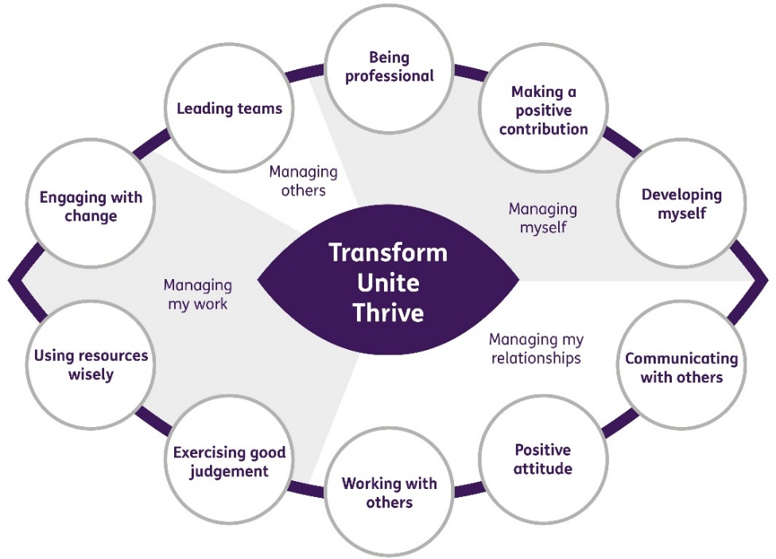
Our Ways of Working - Managing my Work
The main responsibilities and accountabilities of this role are:
- Ensure all business processes and information flows are mapped across the charity’s functions, relevant inter-team dependencies and critical pathways are identified, using consistent techniques and documentation.
- Continually review the quality and delivery of internal processes and systems through the analysis of stakeholder feedback and other appropriate data/information.
- Using lean tools and techniques, work with colleagues and stakeholders to devise ways of streamlining and improving processes and systems, including the introduction of digital solutions to add value.
- Develop and manage a change control process for all system and process changes within Sight Scotland Veterans.
- Support the charity’s senior management team with business planning and reporting, monitoring of KPIs, and the timely delivery of key strategic targets.
- Support managers to develop their business cases by providing input into strategic decisions that require significant central support resource, policy or process changes.
- Implement systems to monitor time spent on activities, to help understand capacity and cost of services being delivered.
- Provide project management support and thinking in the delivery of projects to support the implementation of the strategy and improvements in service delivery, ensuring a consistent approach throughout.
- Manage the charity’s CRM system, working alongside the charity’s IT team in managing and planning upgrades, and translating business requirements into technical requirements.
- Provide key data and business insights and other key performance metrics to support monitoring and to help inform continuous improvement and decision making.
- Oversee offline data management processes to ensure a smooth workflow into the CRM system.
- Have responsibility for the effective management of the charity’s central admin team and provide support to other admin staff within the charity, ensuring a consistent joined up approach to admin provision and cover.
- Lead on the design and implementing a document management and control system for the charity including storage, version control and retention; working closely with the Quality and Compliance Officer.
- Manage data quality within the charity including accuracy, completeness, consistency, reliability and the applicable lawful bases for processing.
- Working closely with the finance department, monitor financial spend via the charity’s credit, expenses and financial systems, introducing central purchasing solutions to streamline and lower costs.
- Support managers in the procurement, storage, distribution and collection of sight loss equipment.
- Manage the charity’s allowance policy and verification policy’s and oversee the administration relating to the implementation of both policies.
- Work alongside the Marketing and Comms team in organising events and in the distribution of marketing materials to staff and veterans and third parties.
- Working closely with the Quality and Compliance Officer, co-ordinate the use of service level and partnership agreements and contracts with third parties, including an ongoing monitoring and review process and maintenance of a 3rd party log.
- Working closely with the Quality and Compliance Officer, oversee the implementation of GDPR processes including data protection impact assessments and data sharing agreements with third parties and use of data statements and consent maintaining a charity data breach issue log.
- Manage the charity’s data audit log, documenting data capture and the lawful bases for processing each type of data, and requirements for the storage and retention of information.
- Working closely with the Quality and Compliance Officer, support the implementation of Health and Safety Risk Management practice across the charities activities, oversee the appropriate use and storage of local risk assessments.
- Liaise closely with Sight Scotland Corporate Resources departments (People, Finance, IT and Estates) to aid the delivery of enabling support services.
- Set up and implement a programme for the regular monitoring and reviewing of all charity processes, to ensure ongoing compliance in key policy areas, providing additional support where required.

Our Ways of Working – Managing Myself and Managing my Relationships

To do this role, you will have:

- Educated to degree level or equivalent level of competency/experience.
- Significant knowledge of improvement approaches and application of lean tools and techniques to add value.
- Strong project management skills, with the ability to deliver multiple initiatives to deadlines and to prioritise effectively, with strong planning and organisational skills.
- Operational management experience and resolving first-line daily operational challenges.
- People management experience, with proven ability to motivate, inspire and develop teams to deliver excellent performance and customer service.
- Knowledge of GDPR legislation and its implementation into day-to-day practice.
- Knowledge of health and safety legislation and risk management practice, with practical experience of completing risk assessments.
- Experience of providing advice and support to colleagues on a range of compliance issues.
- Experience of managing CRM systems and implementation of digital solutions.
- Ability to gather, analyse and interpret information with excellent attention to detail.
- Excellent report writing skills and ability to present information and data and reports in a simple, clear and visual way.
- Ability to present cogent arguments in support of a proposed course of action.
- Experience of working in partnership with a diverse range of stakeholders.
- High level of digital proficiency and technical ability
- Strong interpersonal skills with ability to build positive relationships
- Excellent verbal and written communication skills
- Effective analytical and problem-solving skills
- Ability to respond positively to a variety of situations and people to meet changing priorities.
- Flexibility and adaptability
- Confidence, enthusiasm and ambition
- Demonstrable commitment to quality, promoting high standards and continuous improvement

On a day to day basis you will work with different people and teams from Sight Scotland Veterans, these could be:
- Colleagues (staff and volunteers)
- Managers and Senior Staff
- External stakeholders

Requirements of this role are:

- You are a member of the PVG scheme (paid for by Sight Scotland)
- You will have a 6 month probation period
- That you participate in all staff training and development and maintain your own professional development
- Ability to build positive professional relationships at all levels
- You will wear the appropriate PPE in accordance with current guidance for the role.
- You will follow Sight Scotland’s guidance, policies and procedures relating to your own health and safety and that of colleagues and service users at all times
- You will uphold the principles of Sight Scotland’s Dignity at Work and Equal Opportunities policies at all times, working in a way which supports an inclusive work environment that is respectful of differences.

What we can offer you:
- Generous annual leave entitlement
- Generous pension scheme
- Access to learning and development opportunities
- Employee Perks through the Employee Assistance Programme
- Cycle to Work scheme
- And many more, please visit our website for more information

This job profile is not exhaustive. The duties of the post holder may be reviewed from time to time and the employee may be called upon to work in other locations within Sight Scotland or Sight Scotland Veterans.

