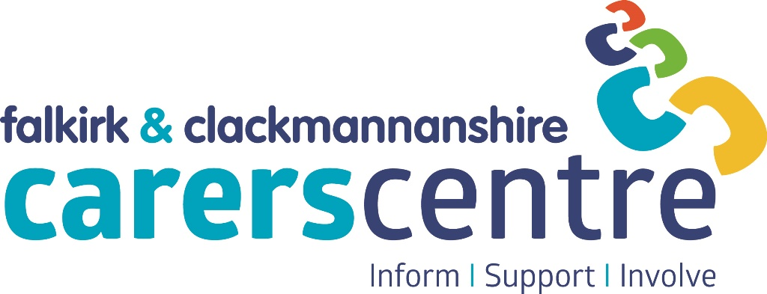
Clackmannanshire
Ludgate House
Mar Place
ALLOA
FK10 2AD

01259 226839
Falkirk
Bank Chambers
1a Bank Street
FALKIRK
FK1 1NB

01324 611510

Application Pack
www.centre@centralcarers.org

Principal Funders of Central Carers Association






Managed by Central Carers Association (Falkirk & Clackmannan) | Company Limited by Guarantee | Company No SC184443 | Scottish Charity No SC023658

Central Carers Association


Is the local voluntary organisation that supports carers in Falkirk district and Clackmannanshire and is the managing body of the Falkirk & Clackmannanshire Carers Centre. The organisation, which is a registered charity and limited company, is managed by a voluntary Board of Trustees who are elected from the membership of the organisation.

Mission Statement

To ensure that carers of all ages are recognised, valued, receive the information and support they need to allow them to care with confidence and in good health, and are empowered to have a life of their own outside caring.

Values
Central Carers Association aims to provide quality, confidential services that are sensitive to the needs and wishes of local carers and provide opportunities to allow carers to participate in the development of local health and community care services to improve the quality of life for carers and those they care for.

Aims of the Association

- To identify carers and encourage mutual support
- To raise awareness of the needs of carers and establish carers support groups
- To co-ordinate views of carers within the Association's area by identifying and raising carers' concerns with policy makers and service providers
- To assist carers to liaise with all relevant agencies
- To promote services which help carers
- To collate and disseminate information relevant to carers within the Association's area
- To recognise and work with former carers within the Association's area as appropriate to their circumstances and experiences
- To promote the principle and practice of equal opportunities for all carers
- To promote good communication, collaborative working and partnerships between statutory, voluntary and community organisations which provide services to carers, in order to ensure better co-ordinated and more effective support to carers and respective service users

Privacy Notice

In accordance with the General Data Protection Regulation, Central Carers Association has developed a Privacy Notice for Job Applicants to inform prospective employees about the types of data we process, the reasons for processing this data, the lawful basis that permits us to process the data, how long we keep the data, and the rights of applicants regarding their data. This document can be viewed on our website: www.centralcarers.org.

The Carers Centre

The Carers Centre is a growing and forward-thinking organisation with ambition to support an increasing number of children, young people and adults who provide unpaid care for a family member or friend due to disability, illness, addiction or frailty.

To achieve this, the Carers Centre provides information, support and involvement opportunities for carers, of all ages, across Falkirk district and Clackmannanshire.

Organisation Structure

The day to day management of the Carers Centre is delegated by the Trustees to the Carers Centre Manager. We currently have 28 members of staff who are based in various locations, including the Carers Centres in Falkirk and Alloa, Forth Valley Royal Hospital, Falkirk Community Hospital and Clackmannanshire Community Healthcare Centre.

Working for Central Carers Association

Staff benefits include:

- Competitive salary scales, with annual increments until top of scale is reached
- 8% contribution to Legal & General Workplace Pension Plan
- 20 days annual leave plus 14 days public holidays
- Support for employees with a caring role
- Flexibility around starting and finishing times and length of lunch breaks
- Regular supervision and support

Application Process

Details about the post are contained in the job description and person specification.

To apply to work for Central Carers Association you need to fully complete our Application Form - CVs will not be accepted. Shortlisting is dependent on applicants being able to demonstrate how their knowledge, skills and experience relate to the post applied for, which are detailed in the Person Specification.

If you are completing and returning the form electronically you will be required to sign your application form if you are appointed to the post.

The deadline for applications and interview dates are included in the advert for the post – please let us know as soon as possible if you would be unavailable on this date.

We will endeavour to let all applicants know the outcome of their application however, we will not provide feedback on unsuccessful applications.

You should return your completed Application Form, together with completed Equal Opportunities Monitoring and Criminal Convictions Declaration forms to:

recruitment@centralcarers.co.uk

Thank you for your interest in working at the Carers Centre - we look forward to receiving your completed application.

Central Carers Association
Job Description

Job Title Telephone Support Worker
Salary £21452
Hours 35 hours
Responsible for providing, over the telephone, preventative, emotional support for carers and reviewing their progress in achieving the outcomes recorded in their Adult Carer Support Plan

Aims of post
To sustain or improve the impact of the caring role on carers health and wellbeing through the provision, over the telephone, of:
- Emotional support
- Information that assists carers to access appropriate supports in their local community
- Reviews of Adult Carer Support Plans to ascertain if the support provided is making the required difference

Main duties
Information and support
- To provide emotional support to new carers who will be referred for telephone support by a Carer Support Worker if this is identified as a need when developing their Adult Carer Support Plan.
- To contact existing carers who haven’t been in contact with the Carers Centre for a while to ascertain their support needs, if any.
- To liaise with the Adult Carer Support Team regarding individual Adult Carer Support Plans prior to review.
- To inform the Adult Carer Support Team about any significant changes or developments in the caring role that may require the Adult Carer Support Plan to be updated.

Awareness raising and networking
- To signpost and refer carers to relevant sources of information and support within their local community.
- To liaise and work in partnership with carers, statutory and voluntary agencies.

Development
- Contribute to the development of the service – referral process, recording, evaluation and monitoring.
- To participate in all aspects of publicity, contributing to promotions and events and raising awareness of the service and what it offers.

Involvement
To encourage and support carers to participate in involvement opportunities to allow them to have their say and influence the development of services to support carers and those they care for.
Recording and monitoring
- To record information and activity on the Carers Centre Information Management Systems.
- To prepare regular reports on work undertaken.

Accountability
- Accountable in the first instance to the Centre Manager and ultimately to the Board of Trustees.
- Prepare regular work plans in agreement with the Centre Manager or another senior member of staff.
- Participate in staff meetings.
- Co-operate with the Board of Trustees in quality assurance exercises.
- Work as part of an effective staff team to ensure the Centre functions efficiently and professionally.
- Undertake any other duties relevant to the post, as reasonably required from time to time by the Centre Manager.

Confidentiality
The post-holder is expected to adhere to high standards of confidentiality and data-protection at all times.
Personal Development
The post-holder is expected to participate in staff development and use all relevant learning opportunities to improve their personal skills.
Supervisory Relations
The post-holder will receive regular support and supervision from the Centre Manager or another senior member of staff.

Equal Opportunities
Central Carers Association (Falkirk & Clackmannan) is committed to being an equal opportunities employer. The post-holder will therefore be required to carry out their duties with due regard to Equal Opportunities legislation.
Quality Statement
The Association is committed to running an organisation with high standards of organisational and operational practice. To that end, the Carers Centre operates a continuous programme addressing quality issues.

Location

The post will be home-based with some attendance at meetings and training required at the Falkirk & Clackmannanshire Carers Centre, 1a Bank Street, Falkirk, FK1 1NB.

Candidates will be required to demonstrate that they can work from home in a way that complies with health and safety and confidentiality requirements.

Person Specification

Skills and experience required for this post | Essential | Desirable
Relevant qualification in social care, healthcare or community work or considerable previous experience in a related field | x
An appreciation of, and sensitive approach towards, the needs and difficulties faced by carers | x
Good telephone, listening, verbal and written skills and the ability to write reports | x
Ability to use own initiative and organise own work in consultation with line manager | x
Ability to develop and maintain effective working relationships | x
Sound IT skills and experience in the use of all Microsoft Office applications | x
Personal experience of caring or of working with carers |  | x
An understanding of current legislation and policy relating to carers |  | x
Experience of multi-agency working |  | x

