 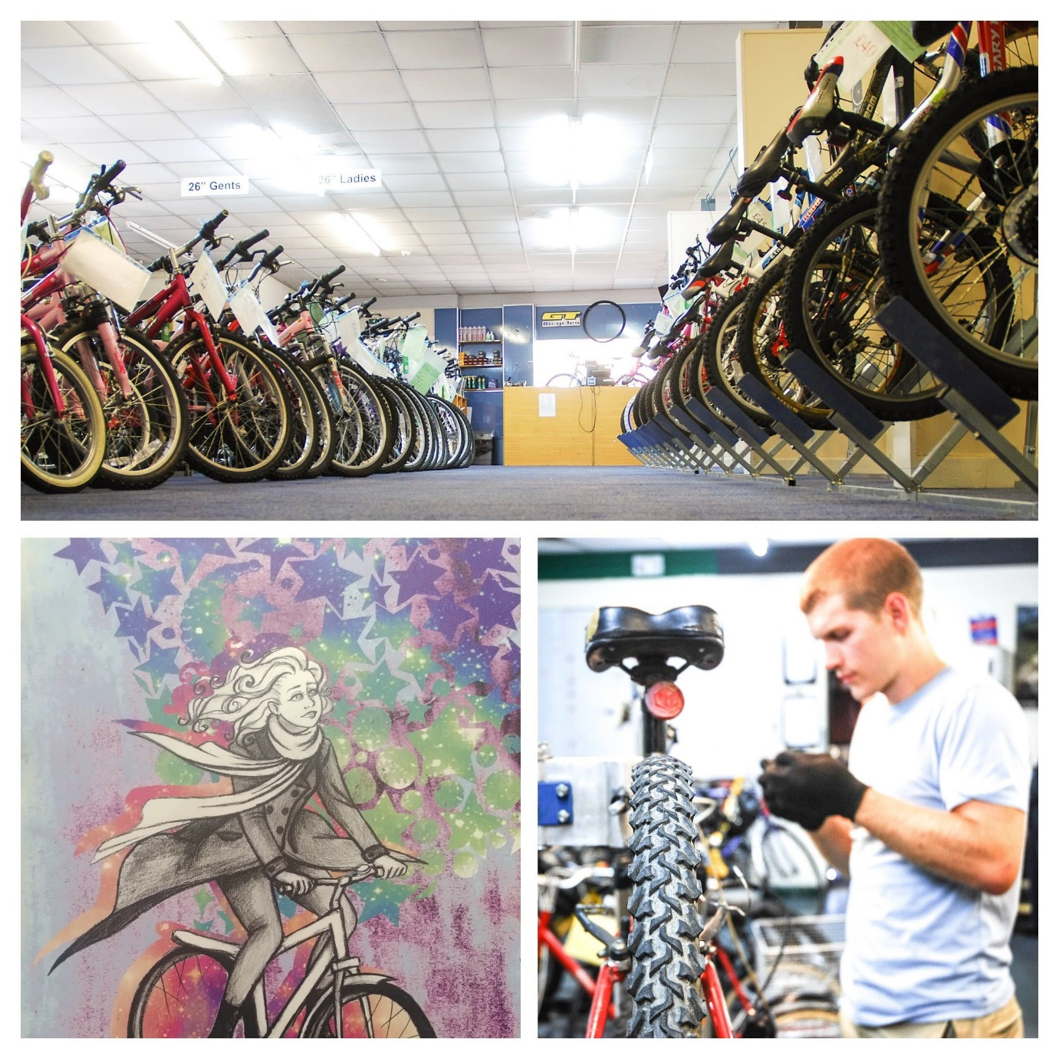

Operations Manager

September 2021

Recyke-a-bike | Alloa Road |Causewayhead- Stirling| Tel 01786 447559

admin@recyke-a-bike.co.uk|www.recyke-a-bike.co.uk

**Join us**

**Welcome and how to apply**

**About Recyke-a-bike**

**Role specification**

**Non-discrimination statement**

**Welcome**

***“****Thank you for helping me find my feet, get back on the bike and for giving me the confidence to meet new people, try new things and move forward with my life.****”***

***“****Working at Recyke-a-bike is the best thing I’ve ever done.****”***

***“****My favourite part of my job is working on the second-hand bikes in the warehouse and getting them ready to be sold in the shop. It's great because I know that my work means that the bike will be going to someone who will enjoy cycling on it again.****”***

Dear Prospective Candidate

If the statements above from some of our Recyke-a-bike participants inspire you to help make a difference then please read on.

I am proud to be the Chair of an organisation, which works to end cycles of disadvantage and adversity for individuals, their families and our communities whilst positively impacting our environment. Our professional team supports people who are outside mainstream services, unemployed or who have never been in employment, who are struggling with many and complex issues. We focus on an individual’s strengths, equipping them with essential life-skills and building confidence. We do this by offering intensive learning and development in communities, providing employment programmes, which help them on their journey to a more positive destination. Our programmes contribute to the Climate Change plan through contributions to active travel and the circular economy.

The Recyke-a-bike Board is seeking to appoint a new Operations Manager to take on the daily operation and staff leadership for the organisation. We are looking for an experienced operations lead; someone with strong leadership skills, the practical skills to run Recyke-a-bike’s day-to-day operations. It is a challenging time for the third sector with huge demand and competition for funds and many competing social, economic and environmental priorities throughout Scotland, and so the post demands an experienced manager who can run a tight ship and deliver top quality services with limited budgets. As a senior manager within a small organisation the postholder will have the opportunity to develop strategic leadership skills by working with the board on the ongoing development of the strategic plan and its execution.

If you believe you have the vision, skills and your values align with the organisation’s, please submit an application in the form of your CV, and supporting statement of no more than two sides of A4 outlining your suitability for the role. Please send your completed application to [admin@recyke-a-bike.co.uk](mailto:admin@recyke-a-bike.co.uk) prior to 5pm on the closing date of 8th October 2021.

We look forward to hearing from you

Ros Griffith

Chair of Recyke-a-bike

**About Recyke-a-bike**

**Vision and mission**

**Our vision** is a healthy, economically and environmentally sustainable Scotland where vibrant communities work together making them great places to live, work and relax.

**Our mission** is to use cycling, bikes and social inclusion to change and improve lives across Scotland. We will reduce poverty and social isolation; and improve sustainability, health and wellbeing, employability and access to cycling.

**Our values:**

* **People** are our greatest asset, everyone is part of the team, valued and respected whether paid, placement, volunteer, or customer.
* Anyone who wants to **cycle** should have access to a bike, cycle training and safe cycle infrastructure
* **Equality** of opportunity should be a human right and we will work to improve people’s opportunities for work, life and cycling
* **Vocational** jobs and qualifications are just as important to individuals and society and we will support their achievement
* We only have one planet and our work must be done in an **environmentally responsible** manner

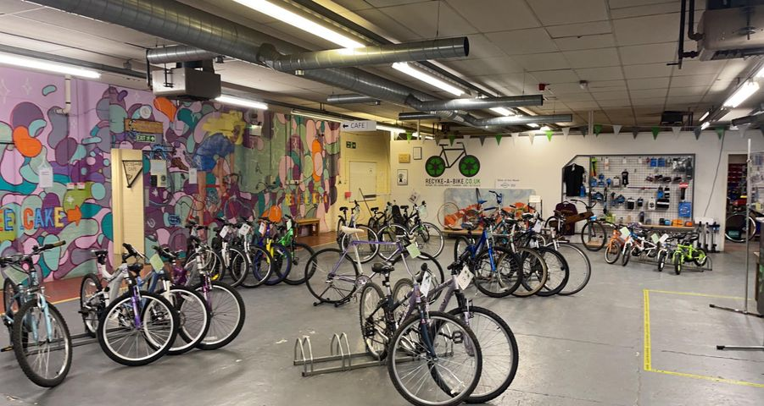

**Role description**

Job title: Operations Manager

Salary range: £30,000 p.a.

Hours: 35 hours per week

Job Purpose: To ensure the smooth running of daily operations delivering excellent quality of services, leadership and motivation of the staff team, organisational development in line with strategic plan.

Responsible to: Recyke-a-bike Board of Directors

Responsible for: Recyke-a-bike Team with direct line management of departmental managers.

Location: Stirling with some travel throughout Scotland

**Role purpose**

You are responsible to the Recyke-a-bike Board for providing the operational leadership to deliver the organisation’s vision, strategic plans, and impact and sustainability goals as agreed with the Recyke-a-bike Board of Trustees.

You will ensure that the charity is managed effectively, demonstrating sound governance, financially and HR leadership and compliance with relevant legislation. You will put your operational experience to good use by regularly reviewing, revising and improving the organisation’s processes and procedures. You will ensure that Recyke-a-bike develops its position and reputation as a sector leader in delivering services across Scotland.

It is important that you naturally lead with a style that reflects our Charity’s values.

**Specific Demands:** Educated to degree level or with relevant equivalent experience, the ideal candidate will have the enthusiasm and commitment, together with the interpersonal skills, to lead the organisation’s operations successfully. The operation currently includes the (used) bicycle shop and workshop, community outreach activities and cycle training services, employability programmes and cycle mechanic training, the operation of bike share schemes across Scotland, and ad hoc community projects supporting the local community through Covid. The community café closed due to Covid but an excellent kitchen remains in place.

**Specific responsibilities**

**Strategic leadership and governance**

* Support the development of a longer term (5 years) strategy for Board review and approval.
* Lead the preparation of a 3-year operational business plan including the forecasts on resources required to meet the targets and risks to delivery.
* Maintain a positive, open and honest relationship with the Board
* Commit to participating in on-going professional development opportunities within the sector
* Ensure that Recyke-a-bike meets its legal and contractual obligations.
* Provide insights and timely, well-informed information on the opportunities and risks facing the Charity to help inform the Board’s decision-making
* Working with the Chair ensuring there is a succession plan in operation
* Work with the Board on regular reviews of the organisational risk register
* Keep abreast of economic, policy and practice developments relevant to the business of Recyke-a-bike
* Production of bi-monthly board papers
* Support the delivery of the annual report and AGM

**Partnerships, stakeholders and relationship management**

* Maintain Recyke-a-bike’s position as a highly respected Scottish charity and, where appropriate, develop our excellent reputation as a local delivery partner for UK and international stakeholders.
* Create and foster positive relationships, partnerships and networks, which are appropriate to our Charity’s objects, strategic plan and beneficiaries.
* Attract and maintain positive relationships with funders and supporters
* Communicate Recyke-a-bike’s positive social impact to help further its activities, including representation to external stakeholders, partners, funders and the media.
* Identify and agree with the Board the key alliances to support the development and delivery of our services
* Establishes and maintains positive working relationships, with key stakeholders and commercial enterprises.

**Leadership and management**

* Lead the Management Team and ensure a performance and improvement culture is embedded throughout the organisation.
* Lead on process and procedural improvements across all Recyke-a-bike’s operations.
* Ensure the organisation secures the resources to deliver its plans in a way that achieves both value for money and impact.
* Ensure effective engagement and communication with staff on the implementation of projects and their associated budgets.
* Ensure the Charity’s financial policies and procedures are appropriately managed through a financial delegation framework.
* Support the development of impact-focused monitoring and reporting for the organisation.
* Maintain a positive health, safety and well-being culture, embedded within the organisation and ensure all legal and best practice requirements are met.
* Work with the Board and Management Team to implement a full organisational review and establish updated job descriptions, KPIs and annual appraisal system.
* Lead, inspire and empower others towards high levels of performance
* Maintain a respectful dignity-based work environment, where all voices and diverse opinions are valued.

**Financial management**

* Exercises sound financial management decisions and controls.
* Commercial contract negotiation and preparation of tenders
* Overseeing all aspects of financial performance, systems and reporting including the quarterly VAT returns and the annual accounts
* Implementing our income generation plan and achieving targets
* Managing funding agreements against which we will deliver agreed services
* Ensure financially responsible and ethical procurement processes

**Personal Attributes**

* **Communication –**
* Ability to communicate effectively at all levels and engage with different types of audience
* Able to express a professional informed opinion
* Can communicate using different types of media and methods of communication
* Can express themselves in a clear and concise manner
* Is an active listener
* **Co-operation –**
* Understand the importance of developing positive working relationships
* Able to appropriately convey instructions across all levels
* Promotes an open working environment
* Encourages two-way dialogue and sharing of ideas
* **Decision Making**
* Is able to make informed decisions based on evidence
* Ability to delegate decisions appropriately
* Makes recommendations based on reliable evidence

* **Problem Solving** –
* Has a solutions focused approach
* Able to see the bigger picture
* Ability to adapt and respond to challenges
* Develops new methods and ways of improving processes and procedures
* Escalates issues in a reasonable timescale

**Non-discrimination Statement**

##### "Recyke-a-bike commits to providing equality of services and care to everyone, regardless of people’s age, disability, gender, gender identity, race, religion or belief, or sexual orientation."

##### ​

##### Sounds very official, doesn't it? It's more or less copied and pasted from a 'how to' guide. What we mean is... Just be you - we'll welcome, respect, value, support and encourage you for who you are. The world would be very boring if everyone was the same, we believe diversity is cause for celebration and we hope that everyone feels welcome at Recyke-a-bike. All we ask is that you extend the same courtesy to our staff, volunteers and customers too – thank you.