JOB TITLE: Service Manager
LOCATION: Dundee
SALARY: £27,000 (pro rata £19285)
HOURS: 25 hours per week
TERMS: This is a permanent post – with a 6-month probationary period.
28 Days Holiday pro-rata
Employers Pension Scheme
The post will be subject to a satisfactory PVG Membership
Closing Date for applications is 15th October 2021
Interviews will take place on 29th October 2021 (tbc)

We have a fantastic opportunity to help make a positive difference in our community by joining Dundee Independent Advocacy Support. We are looking for an organised and motivated person to take on the role of Service Manager.
This is an exciting post, created due to internal growth and demand for our services and the running of our company.
The Service Manager will be part of a staff team that strives hard to support others, sees the benefit of multi partnership agency working yet maintaining the independence we have built up when delivering a range of advocacy services?
For an informal chat, please contact Mary Sneddon, Manager on 07901838060

Purpose of Post
The purpose of the Service Manager’s post is to ensure that the service provided by DIAS is independent, professional, in line with the principles of the organisation and meets the needs of the people who access it. As an integral member of a Senior Management Team, the Service Manager will lead and direct areas of the service.

This will be achieved by:
1. Taking a lead in the case management and review process for the advocacy provision across identified services.
2. Leading and managing the governance and risk management of the service and for the staff team by ensuring efficient and effective monitoring and evaluation procedures are in place.
3. Complete and coordinating operational actions from Board Meetings.
4. Promoting and raising awareness of the organisation and its services.
5. Promoting knowledge and good practice and excellence within the team by ensuring that DIAS learning and development plans are in place.
6. Carry out any other duties as directed by the Manager

DETAILED RESPONSIBILITIES:
- Responsible for advocates case load reviews/ meetings along with allocation of cases.
- Responsible for approving and monitoring travel expenses, holiday request forms and the accuracy of timesheets.
- Responsible for the management of risk and governance arrangements for DIAS. Including advice and support to the Board
- Analyse data and prepare statistics to meet the requirements of DIAS Service Specification and prepare reports on a quarterly and annual basis as required.
- Take the lead in dealing with, investigating, and responding to complaints about the service.
- To ensure there is a continuous improvement of risk management & governance framework for DIAS
- Support the Manager in all HR matters including all relevant human resource policies and procedure and where necessary seek support from external HR Consultants.
- Be involved in recruitment and selection processes as required
- Support the Manager to develop and manage DIAS learning and development plan for staff and volunteers by identifying areas of training needs and supporting the Manager in sourcing and/or delivering this.
- Responsible for the management of contracts for premises and other services and suppliers
- Responsible for health and safety and ensure day to day management of health and safety within DIAS is provided
- Support the Manager to manage and update DIAS GDPR Plan as required and directed
- Complete and coordinating operational actions from Board Meetings as directed by the Manager
- Managing a small team of staff as delegated by the Manager
- Represent DIAS at internal and external meetings by liaising with appropriate services and existing networks to promote advocacy and highlight issues affecting the individuals DIAS supports.
- Deputise for their line manager as required.

Other Duties
This job description is a broad picture of the post at the date of presentation. It is not an exhaustive list of possible duties, and it is recognised that posts change and evolve over time. Consequently, this is not a contractual document, and the post holder will be required to carry out any other duties to the equivalent level that are necessary to fulfil the purpose of the post.

PERSON SPECIFICATION

Professional qualification and experience
You will hold a management qualification with at least 2 years post qualifying experience or Proven Management experience: preferably in a voluntary sector or health or social care organisation
Knowledge and Experience - Essential
Proven recent (within last 18 months) experience of staff management, including personal development and objective setting
Proven experience in working with, and implementing, quality systems to ensure high quality services are delivered.
Proven ability to liaise with statutory agencies e.g., OSCR.
Proven experience of meeting organisational deadlines
Experience of liaising with auditors, business advisers and board members.

Desirable
Experience of working with volunteers.
Knowledge and understanding of working in the charity sector
Also, a knowledge of independent advocacy

Skills, Abilities and Competencies - Essential
Extensive computer literacy in dealing with standard MS Office packages, including spreadsheets.
Technology savvy with experience in selecting and overseeing software installations and managing relationships with software vendors
Ability to work under pressure, managing competing priorities, and ensuring deadlines are met.
Particularly good organisational, administrative, and time-management skills.
Committed and highly self-motivated with ability to enthuse, inspire and motivate others, to ensure the objectives of the Charity are achieved.
Strong sense of accountability and responsibility to Manager of DIAS.
The ability to work in a self-directed manner, and as part of a team, including ability to develop and build good working relationships with all stakeholders and partners.
The ability to network and communicate with a wide range of personnel including healthcare professionals, commissioners, charity representatives and fundraisers.
Personal qualities of integrity, credibility, and dedication to the mission of DIAS
A multitasker with the ability to wear many hats in a fast-paced working environment.
Excellent communication and relationship building skills with an ability to prioritise and work with a variety of internal and external stakeholders.

Other Duties
This job description is broad based and is not intended to be an exhaustive list of all possible duties as it is recognised that jobs change over time.

CONTEXT OF THE ROLE:
This post is responsible for the following key areas: responsible for day-to-day case management and allocation of advocacy cases, risk and governance management, contracts management and actions from the Board Meetings.

INTRODUCTION TO DIAS:

Dundee Independent Advocacy Support (DIAS) was constituted as a charity (SC027180) on 30 December 1998. It was incorporated as a Limited Company (SC419193) on 12 March 2012.

OUR VISION
To provide quality independent support for people to have a voice on issues that affect them.
OUR PROMISE
We promise to promote social inclusion, equality, and social justice by supporting individuals to say what they want, to secure their rights and to represent their interests when they are unable to do so themselves.
To ensure we provide a fair and quality service to the most vulnerable groups in our communities, we operate within a defined set of Standards and Principles that form our Code of Practice.
We are members of the Scottish Independent Advocacy Alliance (SIAA), which promotes, supports, and defends the principles and practice of Independent Advocacy across Scotland.

OUR MISSION STATEMENT
Dundee Independent Advocacy Support endeavours to provide the highest standard of independent advocacy support and information by ensuring that the interests of the service users are central to the decision which affect their well-being and that they are treated with dignity and respect.
The main beneficiaries (from the list provided by the Charities Regulator) are older people, people with disabilities and people with health problems.
Consistent with its registration with the Charities Regulator, the main aims of DIAS are to provide independent advocacy for people in the City of Dundee who:
- have mental health issues
- are over the age of 65
- have dementia
- have learning disabilities
- have physical disabilities
and who
- are unable to support themselves
- have no one independent to support them

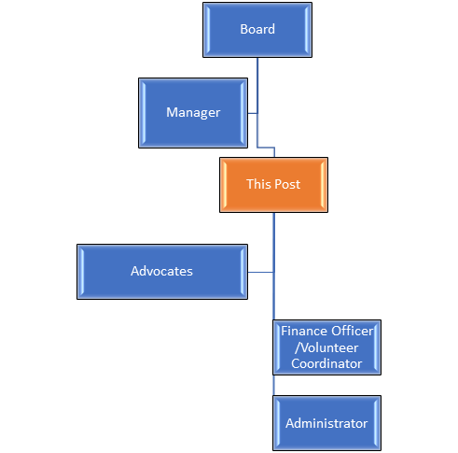

This is a small charity with a current £260,000 turn over annually.

.

