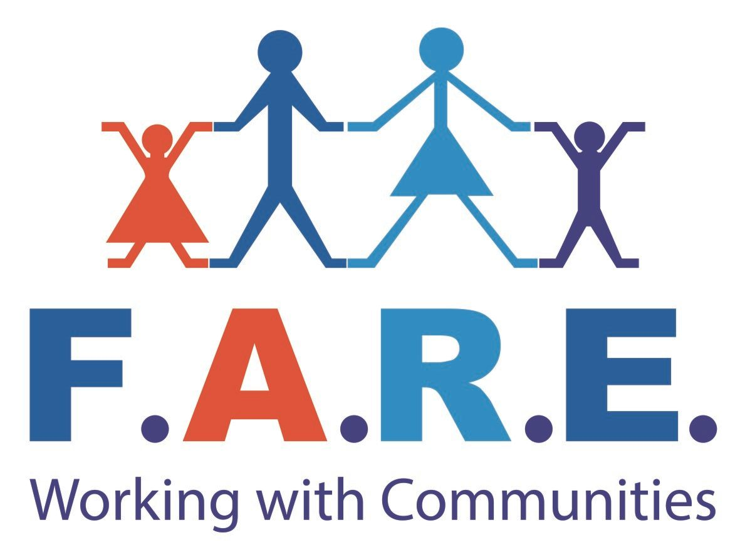
f.a.r.e Scotland
Bannatyne House,
31 Drumlanrig Avenue,
Glasgow, G34 0JF

Tel no. 0141 771 9151

Email: recruitment@fare-scotland.org
Website: www.fare-scotland.org

Position: Family Support Practitioner:

Reporting to: Community Support & Development Manager

Contractual status: Full Time, 38 hours per week (Including occasional evening & weekends)

Salary: £22,000 - £24,000

Annual Leave: 25 days & 9 Public holidays

FARE’s
Mission ‘To improve the lives of the people in the communities we serve’
Vision ‘People and communities thrive and are free from the effects of poverty’
What does the Service provide?
Glasgow Health and Social Care Partnership have commissioned an exciting new service in the North East of the City to work alongside families in a flexible and strengths based way to help them achieve positive outcomes.
As part of a city-wide strategy, the service will promote the wellbeing of children and young people and to support them to stay at home and thrive with their families within their local communities by offering the right support at the right time.

Job Description
Our shared vision is to support children and young people to live with their parents and brothers and sisters, or where this is in the best interest of children, with their extended family, enabling them to grow up in their community with their friends, and attend their local school. The Family Support Practitioner will be part of a multi-disciplinary team with families to support and enable positive change and to improve outcomes. You'll join a team with an opportunity to work supporting and empowering families to achieve positive outcomes.
An assessment of need will be undertaken to identify needs, strengths and challenges that each family faces, the interventions will be based on expressed family needs and goals and will include advice, guidance, parenting support, 1:1 work with children and liaising with partner agencies. The post holder will carry out assessments, planned support and reviews and support families to overcome barriers. Working as part of a team, you will attend meetings and work alongside partner agencies, advocating on behalf of children and families.

Key Responsibilities
- Be effective in assessing the needs of families and responding to them.
- Working collaboratively with families to achieve positive outcomes.
- Listening to children, young people and families.
- Working in an integrated way as part of a dynamic multidisciplinary team.
- To promote activities which will promote the personal, social, educational and material welfare of young people and their families.
- Ensure the collection and collation of vital information as required to evaluate the projects impact and for progress reports.
- Establish and maintain contact with relevant outside agencies.
- Comply with all relevant legislation and FARE policies.
- Promote the objectives of FARE as stated in its constitution.
- Write reports, as requested.
- Attend training opportunities.
- Attend meetings, as requested.
- Undertake any other duties as specified by the SMT

Person Specification
- SVQ 3 in social care or equivalent.
- Post qualification experience of working with children, young people and families and achieving positive outcomes through direct contribution with support activities and intervention.
- Outreach working experience.
- Experience of working with vulnerable families and a broad understanding of their barriers.
- Knowledge and experience of implementing methods of assessment and interventions.
- Understanding of safeguarding.
- Ability to communicate effectively verbally, in writing and through presentations.
- Experience of developing multidisciplinary support plans.
- Organised and systematic approach to monitoring and reporting
- Ability to work with people at all levels internally and externally
- The drive and initiative to work independently
- Ability to share learning and develop practice through feedback
- Ability to challenge, in a constructive manner, negative attitudes
- Driving License (Maximum 6 penalty points)
- Good knowledge of CSD/Family Support initiatives
- Knowledge of statutory organisations

