Application Form

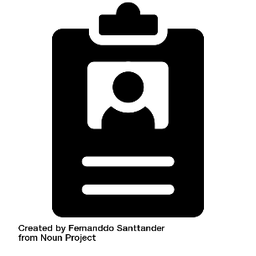
Personal Details

Name:
Address:
Postcode:
Phone Number:
Email:

Please tell us about yourself by answering the next 7 questions

1. Tell us about a time when you gave your time freely to something you cared about. Or tell us what you care about? (300 words maximum)

2. What kind of world do you want to live in? What kind of things are you doing to make that happen? (300 words maximum)

3.Why do you want to be a Guide for the Social Action Inquiry? (300 words maximum)

4.What experiences can you bring? In the future, how might social action help your community? (300 words maximum)

5. Have you experienced or seen someone else not be included in decisions that affected them? What could be done differently? (300 words maximum)

6. If you are invited to an interview is there any support you would need?

7. Is there anything else you would like to tell us?

References
Please give details of 2 people who will be your references

These could be:
- People who know you professionally (for example from work or volunteering).
- A non-family member that knows you well.
1 (please give name, email, and phone number)

2 (please give name, email, and phone number)
Please sign the form on the next page. Return the completed form to:

hello@socialaction.scot

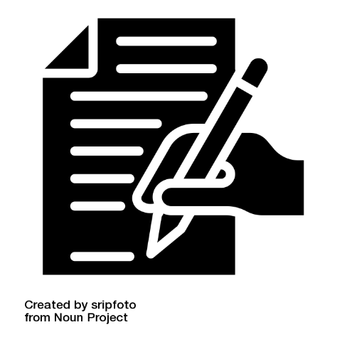
Signed Confirmation

- I confirm that to the best of my knowledge the information I have provided on this form is correct.

- I accept that providing deliberately false information could result in my offer being cancelled.

Name:
Signature:

Date:

Privacy Statement
We will only use the information on this form to:
- Consider your application.
- Produce anonymized recruitment statistics.

Personal information about unsuccessful applications will be held for 6 months. Then it will be destroyed.

If you are successful in your application:

We will contact your references using the details you gave us on this application form.
We will create a file linked to your role.

The information contained in this will be:
- kept secure
- only used for purposes relevant to your role.

Once your role, which is hosted by SCVO, has ended, we will keep the file in accordance with the requirements of our retention policy and then delete it.

