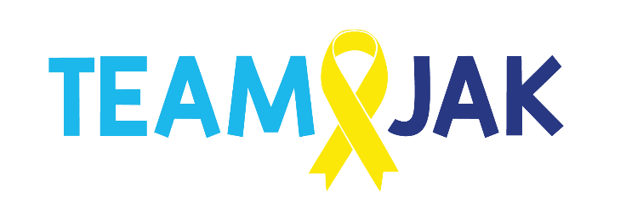
Job Description - Wellbeing Coordinator

Job Purpose:

To plan, prepare and deliver the co-ordination, provision and evaluation of a bespoke wellbeing service that ensures children and young people, families and professionals can access high quality emotional, social and practical support in situations where a young person or child has been diagnosed with cancer or related illness or is in remission and needs support, or sadly has died; and assessing and responding to the needs of siblings.
To contribute to the training and support of professionals across Scotland whose roles bring them into contact with warrior or bereaved families.

Key Working Relationships:

Team Jak – Employees and Board members;
Education Staff • Young Lives Vs Cancer Social Work Staff and WL Steering Group & Lothian Bereavement Network • Statutory and Voluntary service providers in health, social care and education.

Principal Responsibilities:

- To help plan, prepare and lead the co-ordination, provision and evaluation of a children and young people’s counselling and support service from Jak’s Den HQ Livingston, via outreach to hospitals and homes and or via phone or online as required throughout Scotland.

- To develop our bespoke wellbeing programme for Team Jak in relation to our children and young people’s cancer journey focusing on resilience, coping strategies, emotional wellbeing and bereavement support.

Our bespoke Wellbeing Programme will encompass the following:

- 121 Support - age related Wellbeing Programme with resources and discussion and Jak’s Sack;
- Age related Mindfulness/Wellbeing/ Positive Post Packs;
- Group Support- age related and peer related where possible i.e. warriors, siblings, bereaved;
- Bag of Worries and TJ’s Worries programme & Teen resources;
- Befriending- 121 time with trained adult- story time discussion and play with emotions resources to encourage discussion and strategies to help on journey;
- Play Therapy/Child Counselling/Music Therapy - Structured sessions with more in depth support required.
- Seasons for Growth programme
- Adult Counselling & Support Groups
- Mindfulness resources and sessions- 1 x monthly and courses on specific subjects;
- Leading, providing and evaluating a support service to support children and young people age 0-25, their families and friends whilst in hospital or at home and working with other agencies to provide support as required.
- To provide support for parents and carers through group sessions, drop-ins. 121 befriending and counselling provision.
- To uphold the ethos of Team Jak’s service in what is offered to families
- To work within national guidelines and Team Jak policies, ensuring that practice is standardised, ethical and safe for families, staff and volunteers. This includes child protection, equal opportunities, complaints and grievance procedures.
- To support the Team Jak CE and work with staff in developing and establishing Team Jak’s services as a source of advice and support for families and professionals throughout Scotland where a young person or child has cancer, is in remission is dying or has died.
- To allocate referrals ensuring timely and appropriate support.
- To work with CYP & Family and Creative Coordinators to provide a programme of individual support sessions, and to develop and provide facilitated peer groups for young people, siblings, grandparents and friends throughout their journey or sadly if bereaved.
- To assess the needs of siblings, cousins and friends, giving initial guidance and support and signpost to the most appropriate long-term support if required.
- To support the provision of our online and telephone support service for families struggling with diagnosis or treatment or those bereaved, who live in more remote locations.
- To empower other professionals offering advice, resources and support through joint working, when working with warriors their families and friends and those bereaved.
- To provide support as is required to families and hospital staff, outside office hours.
- To participate in supervision, both individually and as part of the team.
- To maintain and improve own professional competence and accountability.
- To assist Team Jak in the strategic and operational development of the service in Jak’s Den and throughout Scotland, in response to identified need.

Training& Experience:

- Recognised health, educational, social care-eg Play Therapy, Psychology or/ and counselling qualification (BACP/COSCA)
- Training in working with children, young people, adults and families
- Relevant trauma and bereavement training across the lifespan
- Relevant experience of working with children, adults and families, individually and in groups
- Experience of supporting bereaved families and families suffering trauma
- Understanding of peer group work/facilitation
- Experience of delivering training in loss and grief
- Knowledge of support services available for children and families
- Experience of supervision of others
- Knowledge of education, social services and primary care services
- Experience of working with traumatic grief
- Ethnic and cultural awareness
- Experience of telephone support and information provision
- Experience of service evaluation

Skills and Abilities:

- The ability to work alone and within a multidisciplinary team
- Excellent communication skills
- The ability to communicate clearly and sensitively in writing
- Computer and database skills
- Excellent communication skills
- Highly motivated and able to motivate others
- Relates well to children and adults
- Positive attitude, energy and drive
- Passionate about the support needs of bereaved families
- Ability to work under pressure

Other Requirements

- Available to provide support outside of office hours if required
- Flexible working hours and willingness ability to work evenings and weekends as required
- Driving Licence and ability to travel if required
- Occasional need for unsociable hours - e.g. attendance at fund-raising events, meetings, conferences, training and presentations (time off in lieu will be given).

