

Role Profile – Senior Relationship Fundraiser
Reports To: Head of Fundraising

Role Purpose:
The Senior Relationship Fundraiser will play a key role in working with the Head of Fundraising to deliver the fundraising strategy across a mix of income generation priorities. The role is responsible for maximising income predominantly from high value donors, legacies, large trusts and grants and managing corporate relationships. You will be responsible for leading the development, implementation and growth of our legacy fundraising.

You will also be responsible for managing relationships with trusts, who share our passion for transforming the lives of those with visual impairment and their families, to maximise their support and funding. It is expected that the role will involve line managing and working closely with the Trust and Corporate Fundraiser.
All roles within Sight Scotland and Sight Scotland Veterans are expected to work to our values and Our Ways of Working framework:
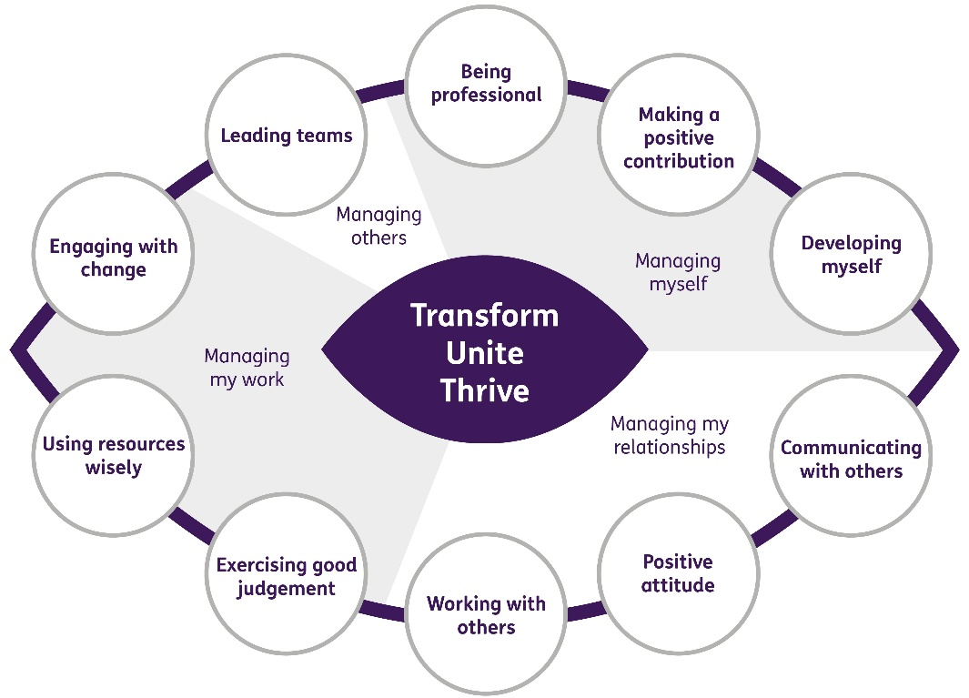
Our Ways of Working - Managing my Work
The main responsibilities and accountabilities of this role are:
Trusts
- To develop, write and deliver creative large funding proposals in line with the organisation’s strategic aims
- To ensure that all reporting requirements are met, and reports submitted according to agreed schedules and in line with funders’ criteria
- Produce information for relevant KPI reports and provide detailed analysis where relevant on the outcome of applications
- To line manage the Trusts and Corporate Fundraiser and oversee funding applications
- To work closely with finance and operational staff to ensure all funds are correctly used, correctly allocated and conditions and targets are met
- Manage and coordinate funders’ events as part of a stewardship programme
- Build relationships with our major funders and key individual donors ensuring that they clearly understand both what we do and how we make use of their funds.

Legacies
- Work with the Head of Fundraising to deliver a legacy strategy and where appropriate liaise with external suppliers
- Provide reports and analysis on all elements of the legacy pipeline, including the cultivation of donors towards legators, successes of marketing campaigns and constant analysis of legators that will enable us to target future campaigns
- Manage the delivery of legacy marketing projects from conception to delivery and evaluation
- Plan and implement legacy recruitment activities appropriate to pre-determined target market in order to increase income
- Be the first point of contact for legacy enquiries
- Ensure the management of Raiser’s Edge NXT for all legacies and potential legacy donors
- Coordinate any legator or potential legator events
- Develop relationships both internally and externally to expand and maintain a robust pipeline of legacy pledgers, intenders and enquirers
- Develop our relationship with solicitors and liaise with marketing and fundraising colleagues to promote their free will service
- Liaise with the Executive Support Manager on the administration of legacies.

Corporate
- Oversee corporate fundraising
- Identify a corporate pipeline in order to solicit funds from and report on pipeline development
- Generate and grow income from corporate partnerships (including but not limited to, donations, gifts in kind, sponsorship, employee fundraising and payroll giving), in order to meet corporate fundraising income targets
- Lead on the development of corporate relationships to develop partnerships
- Manage applications to corporate foundations to secure funding for services.

High Value Donor and Major Gifts
- Work with Head of Fundraising to devise and implement a major donor strategy to engage senior supporters more fully
- Work with the Planned Giving Officer to undertake database analysis and data mining to establish a high value and major donor stewardship programme in order to fully capitalise on supporter goodwill
- Work with the Head of Fundraising and Director of Marketing and Communications to produce reports and analysis of donors within the pipeline and financial projections
- Lead on major donor engagement events.

Other
- Adhere to the highest standards of fundraising practice
- Ensure that all activities comply fully with the relevant Data Protection obligations and any other legislation.
- Work with colleagues to use data segmentation to develop and adapt supporter journeys in order to maximise retention and optimise lifetime value.
- Build relationships with internal stakeholders and help foster a fundraising culture
- Contribute to the Board report three times a year
- Ensure relevant records on the database are kept up to date and accurate
- Keep up to date with changes in legislation, tax implications for charitable giving and Institute of Fundraising policies

Contribute to the work of the Marketing and Communications department
- Support cross team projects and events
- Work effectively and collaboratively with colleagues across the department
- Proof read brochures, magazines and leaflets written by other colleagues
- Represent the organisation at conferences, exhibition stands and events

Our Ways of Working – Managing Myself and Managing my Relationships

To do this role, you will have:
- A proven track record of raising funds from written applications (eg. trusts, foundations, corporates or tenders)
- Experience of working for a charity or third sector organisation
- Strong and accurate writing skills with excellent grammar and the ability to write persuasively
- Strong relationship building skills and the confidence to speak to donors in person and by phone / online to pitch funding proposals
- Strong interpersonal skills, with the ability to collaborate effectively with staff at all levels across a diverse organisation
- Effective planning and organisational skills and the ability to maintain accurate records
- Project management skills
- Budget planning skills
- Ability to work independently to tight deadlines
- Experience of using CRM systems, preferably Raiser’s Edge NXT or 7

Knowledge of:
- The charity sector
- Scottish and UK wide trusts

Other:
- Ability to work flexibly including evenings and at weekends

It is desirable that you will have:
- Membership of the Institute of Fundraising
- Qualification in fundraising
- Experience or understanding of other areas of fundraising (eg. community, individual giving, legacies, events)

On a day to day basis you will work with different people and teams, these could be:
- Heads of Service
- Directors
- Senior Leadership and Management Teams
- Service Users
- Families
- Colleagues
- Other Sight Scotland services
- Senior Staff

Requirements of this role are:
- You are a member of the PVG scheme (paid for by Sight Scotland)
- You will have a 6 month probation period
- That you participate in all staff training and development and maintain your own professional development
- You will wear the appropriate PPE in accordance with current guidance for the role.
- You will follow Sight Scotland’s guidance, policies and procedures relating to your own health and safety and that of colleagues and service users at all times
- You will uphold the principles of Sight Scotland’s Dignity at Work and Equal Opportunities policies at all times, working in a way which supports an inclusive work environment that is respectful of differences.

What we can offer you:
- Generous pension scheme
- Discounts for Carers
- Access to learning and development opportunities
- Employee Perks through the Employee Assistance Programme
- Cycle to Work scheme
- And many more, please visit our website for more information

This job profile is not exhaustive. The duties of the post holder may be reviewed from time to time and the employee may be called upon to work in other locations within Sight Scotland or Sight Scotland Veterans.

