

Development Officer
(Database & Fundraising Support)
(Maternity Cover)



THE ROLE
Fettes College is seeking a professional with experience in database management to join their busy and friendly Development Team on a temporary basis, to cover maternity leave in the existing team. Reporting to the Director of Development and working alongside three other members of the Development Team, the successful candidate will hit the ground running to manage the Team’s database, The Raiser’s Edge. Applications would be particularly welcome from candidates who have worked in a fundraising environment and who also have some experience of annual giving and stewardship, as the responsibilities of this role include supporting the delivery of the Fettes Foundation’s annual appeal and carefully looking after donors.

KEY DUTIES AND RESPONSIBILITIES

- Managing the Fettes College Development Team database (The Raiser’s Edge).
- Producing data to support Development Team priorities eg mailings, campaigns and events.
- Ensuring GDPR compliance for the Development Team (including the Fettes Foundation and the Old Fettesian Association).
- Preparing prospect management, activity updates and financial reports, as necessary, for the Director of Development, Senior staff, Foundation Trustees and Governors.
- Supporting the delivery of the Fettes Foundation’s annual appeal including direct mail materials, e-mail and web copy and fulfilment materials.
- Providing a high standard of stewardship and supporter care to Fettes Foundation donors, including effective verbal and written communications and events.
- Managing our processes for thanking, renewals and upgrades and on an ongoing basis, ensuring these are the best they can be.
- Managing budgets aligned to key responsibilities.

PERSON SPECIFICATION

The successful applicant will require to have a broad range of knowledge, experience, skills and attributes to ensure that they make the maximum impact throughout this temporary contract. The following person specification has been put together to help potential candidates assess their suitability for the role.

Knowledge and Experience | Essential or desirable | Evidence assessed by
Extensive knowledge of managing a CRM database | Essential | Application / Selection Event
Experience of using Raiser’s Edge | Desirable | Application/ Selection Event
Relevant and proven experience in a comparable environment | Essential | Application / Selection Event
Well-developed ICT knowledge, including ability to import, export, manipulate and present data from a database using Microsoft packages, especially Microsoft Excel | Essential | Application / Selection Event
Understanding of data protection regulatory and legal requirements | Essential | Application / Selection Event
Working with, organising and providing summaries of financial information | Essential | Application / Selection Event
Knowledge of mass e-mailing packages | Essential | Application / Selection Event
Managing and reconciling budgets | Desirable | Application / Selection Event
Producing, editing and proofreading content for print publications and online channels | Desirable | Application / Selection Event
Managing design and print processes | Desirable | Application / Selection Event
Event management experience | Desirable | Application / Selection Event
Working within an education environment | Desirable | Application / Selection Event

Essential Skills and Attributes:

Attention to detail
Creative and flexible approach to work challenges, demonstrating vision, innovation and personal resilience
Strong planning and project management skills
Excellent interpersonal skills to manage, build and develop relationships with members of the Fettes community
Excellent verbal and written communication, with fluency in the English language
Self-motivation and the ability to work under pressure
Good general knowledge
Team-player
Tact, diplomacy and empathy
Energy and enthusiasm for the job and a good sense of humour

BENEFITS

This position is a full-time position for circa 10 months, commencing as soon as possible. The hours of work are 9.00 am to 5.00 pm Monday to Friday. The remuneration package will be competitive and will, to an extent, depend on the experience of the successful candidate.

You will be opted into the Fettes Trust Operational Staff Pension Scheme after 3 months service. This scheme is a money purchase one and full details of it and your options will be made available to you prior to your opt-in date. The Fettes Trust will contribute to the scheme and your contribution will be subject to the minimum overall combined employer and employee contribution limits set by the Pensions Regulator. The College also operates contribution matching up to a maximum of 10% of gross salary.

Lunchtime meals may be taken in the Dining Hall free of charge during term time and when catering is provided and at other times, when catering is provided and you are on duty. Parking is free of charge within the campus grounds. Gym membership at Westwoods Health Club is also available.

New staff at Fettes join a friendly and supportive team with a vibrant mixture of age and experience. We value every member of staff’s contribution to the life of the school.

APPLICATION PROCESS

Applicants should complete an Application Form, which can be accessed directly from our website following the link below:

https://www.fettes.com/about-us/vacancies

Completed applications together with a CV and covering letter outlining your suitability for the post should be returned via email to recruitment@fettes.com

If you would like to discuss your application in advance, please do not hesitate to contact Nicola Pickavance, Director of Development, by emailing n.pickavance@fettes.com

Fettes College is committed to the safeguarding of children. An offer of employment will be subject to two satisfactory references being obtained from your referees and a clean report being obtained on you from the Disclosure Scotland PVG Scheme in view of the contact you will have with children during your normal duties.

Closing date for applications is Monday, 8th November 2021.

Fettes College aims to provide a workplace in which all staff are treated in a fair and consistent manner. We will ensure, to the best of our ability, that staff and all others who have contact with the College are not discriminated against, either directly or indirectly.

We are committed to providing equality of opportunity in all areas of dealing with staff, whether in recruitment and selection, promotion or training and development.

We are keen to welcome applicants from diverse backgrounds into our staff body. If you would like a friendly conversation with an employee who identifies as an ethnic minority, please feel free to contact Sara Medel Jiménez (s.medeljimenez@fettes.com) who will be happy to share her experience of Fettes College.

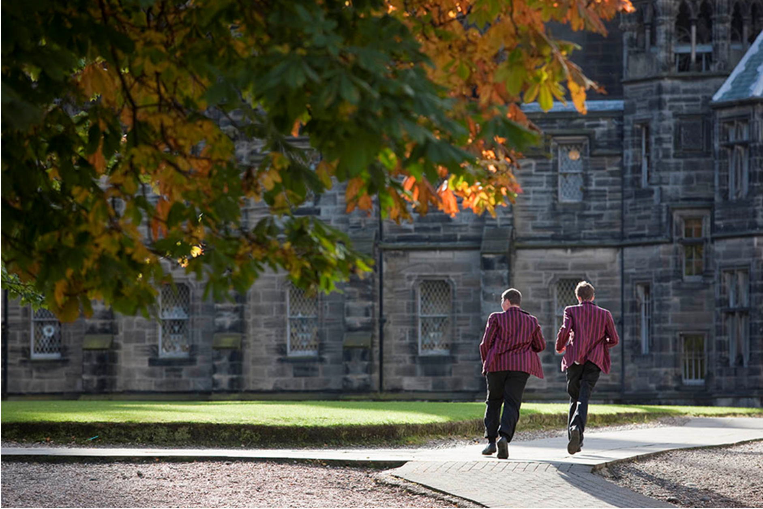

ABOUT FETTES

Fettes College is a leading HMC co-educational boarding and day school close to the heart of Edinburgh. It has a strong tradition of academic, sporting and cultural excellence underpinned by outstanding pastoral care. Fettes opened its doors in 1870 and became fully co-educational in 1980: it is now an independent school of some 800 students. There are 598 students in the Senior School (13-18 years) and 202 students in the Preparatory School (7-13 years). The academic staff in the College consists of the Head and 90 full-time members of the Common Room. Our Prep School shares the same site and consists of a further 29 full-time teaching staff.

The school stands on a magnificent site of approximately 100 acres, but still within walking distance of Edinburgh’s city centre. The historic main building holds the Chapel, Library, the English, Classics and History Departments as well as the Medical Centre and two boarding houses. A large newly built teaching block (the Spens Building) houses Art, Modern Languages, Mathematics, Economics, Geography, and Music. The Theatre, Science Laboratories and Dining Hall are adjacent. The Preparatory School and seven further boarding houses (including a purpose-built U6th House) are also on the campus. Our sports facilities (including extensive playing fields, two all-weather pitches and a private Health Club) are excellent.

As well as our teaching staff we employ over 220 Non-Teaching Staff across the many departments, including; Estates, Security, Housekeeping, Finance, Admissions and Marketing with a pervading sense of community amongst staff, students and parents alike.

THE AIMS OF THE COLLEGE

Fettes College aims to nurture the individual while fostering a happy well-ordered and caring environment with strong community values at its core.

To this end, we will do our utmost to ensure our students:

- Receive the highest possible quality of education within a boarding environment.
- Feel safe, valued, have a sense of personal worth, are thoughtful and considerate of the needs of others, possessing a willingness to take on responsibility.
- Develop their self-confidence, integrity, emotional resilience, loyalty, good manners and humour, leadership skills and teamwork.
- Value a sense of community and service, and develop a clear sense of right and wrong, equipping them for life beyond Fettes.
- Are provided with equal opportunities regardless of gender & identity, sexual orientation, disability, ethnicity or religion.
- Are encouraged to stretch and challenge themselves in everything they undertake.

