

**Role Profile – Driver**

**Reports To:**

Centres Manager

**Role Purpose:**

You will be responsible for safely transporting our members to and from the Day Centre, or as otherwise required.

All roles within Sight Scotland and Sight Scotland Veterans are expected to work to our values and Our Ways of Working framework:

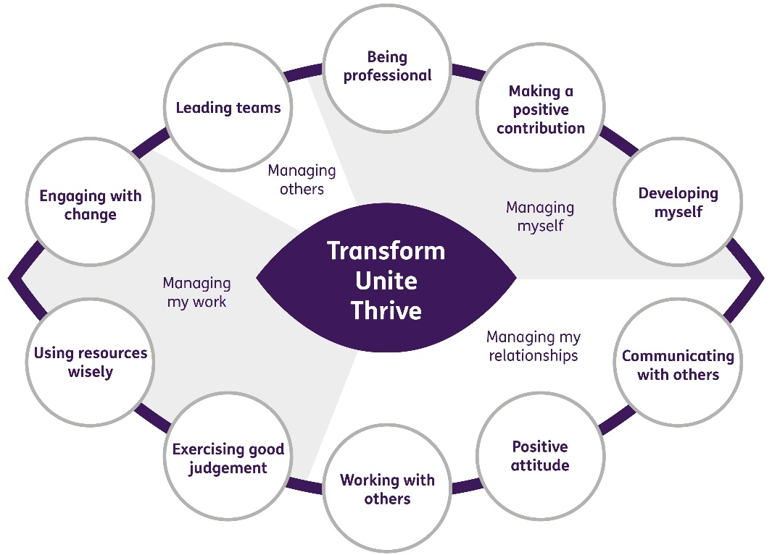

**Our Ways of Working - Managing my Work**

**The main responsibilities and accountabilities of this role are:**

* Be responsible for safely transporting adults in the minibus or car to and from the Centre or other locations, as required.
* Undertake any driving duties necessary to the functioning of the organisation as agreed with the Centre Manager and Deputy.
* Take responsibility for Health & Safety in relation to the minibus or car including ensuring, through close working with the escorts, that all passengers use appropriate seatbelts / restraints during all journeys and that all passengers are assisted in a safe fashion when boarding / exiting the minibus or car.
* Ensure that the minibus or car is driven with due care and attention in accordance with current road traffic legislation.
* Take responsibility for the routine maintenance of the minibus or car, including cleaning the vehicles and ensuring the Centre Manager or Deputy is informed as soon as possible of any problems in relation to the vehicles.
* Ensure all wheelchair clamps are present and functioning in the minibus.
* Any other reasonable driving or ancillary duties that may be required.

**Our Ways of Working – Managing Myself and Managing my Relationships**

**To do this role, you will:**

* Be eligible to drive a minibus (hold a D1 Licence if applicable)
* Hold a clean current driving licence
* Be a good listener, courteous, tactful.
* Have the ability to work with and support colleagues.
* Have the ability to build positive professional relationships at all levels
* Have the ability to adapt to change and respond positively to non-routine situations
* Have the ability to work on own initiative
* Demonstrate Strong organisational skills
* Have the ability to prioritise work
* Demonstrate good problem-solving skills
* Be flexible and have a patient approach to changing circumstances on a daily basis

**On a day to day basis you will work with different people and teams, these could be:**

* Members
* Families / Carers
* Colleagues
* Other Sight Scotland services
* Senior Staff

**Requirements of this role are:**

* You are a member of the PVG scheme (paid for by Sight Scotland Veterans)
* You will have a 6 month probation period
* That you participate in all staff training and development and maintain your own professional development
* You have demonstrable knowledge of relevant Health and Safety regulations
* You have a clear understanding of the Highway Code
* An understanding of the need to maintain confidentiality in relation to all information relating to members
* You will wear the appropriate PPE in accordance with current guidance for the role.
* You will follow Sight Scotland’s guidance, policies and procedures relating to your own health and safety and that of colleagues and service users at all times
* You will uphold the principles of Sight Scotland’s Dignity at Work and Equal Opportunities policies at all times, working in a way which supports an inclusive work environment that is respectful of differences.

**What we can offer you:**

* Generous annual leave entitlement which increases after 4 years’ service
* Generous pension scheme
* Discounts for Carers
* Access to learning and development opportunities
* Employee Perks through the Employee Assistance Programme
* Cycle to Work scheme
* And many more, please visit our website for more information

This job profile is not exhaustive. The duties of the post holder may be reviewed from time to time and the employee may be called upon to work in other locations within Sight Scotland Veterans.