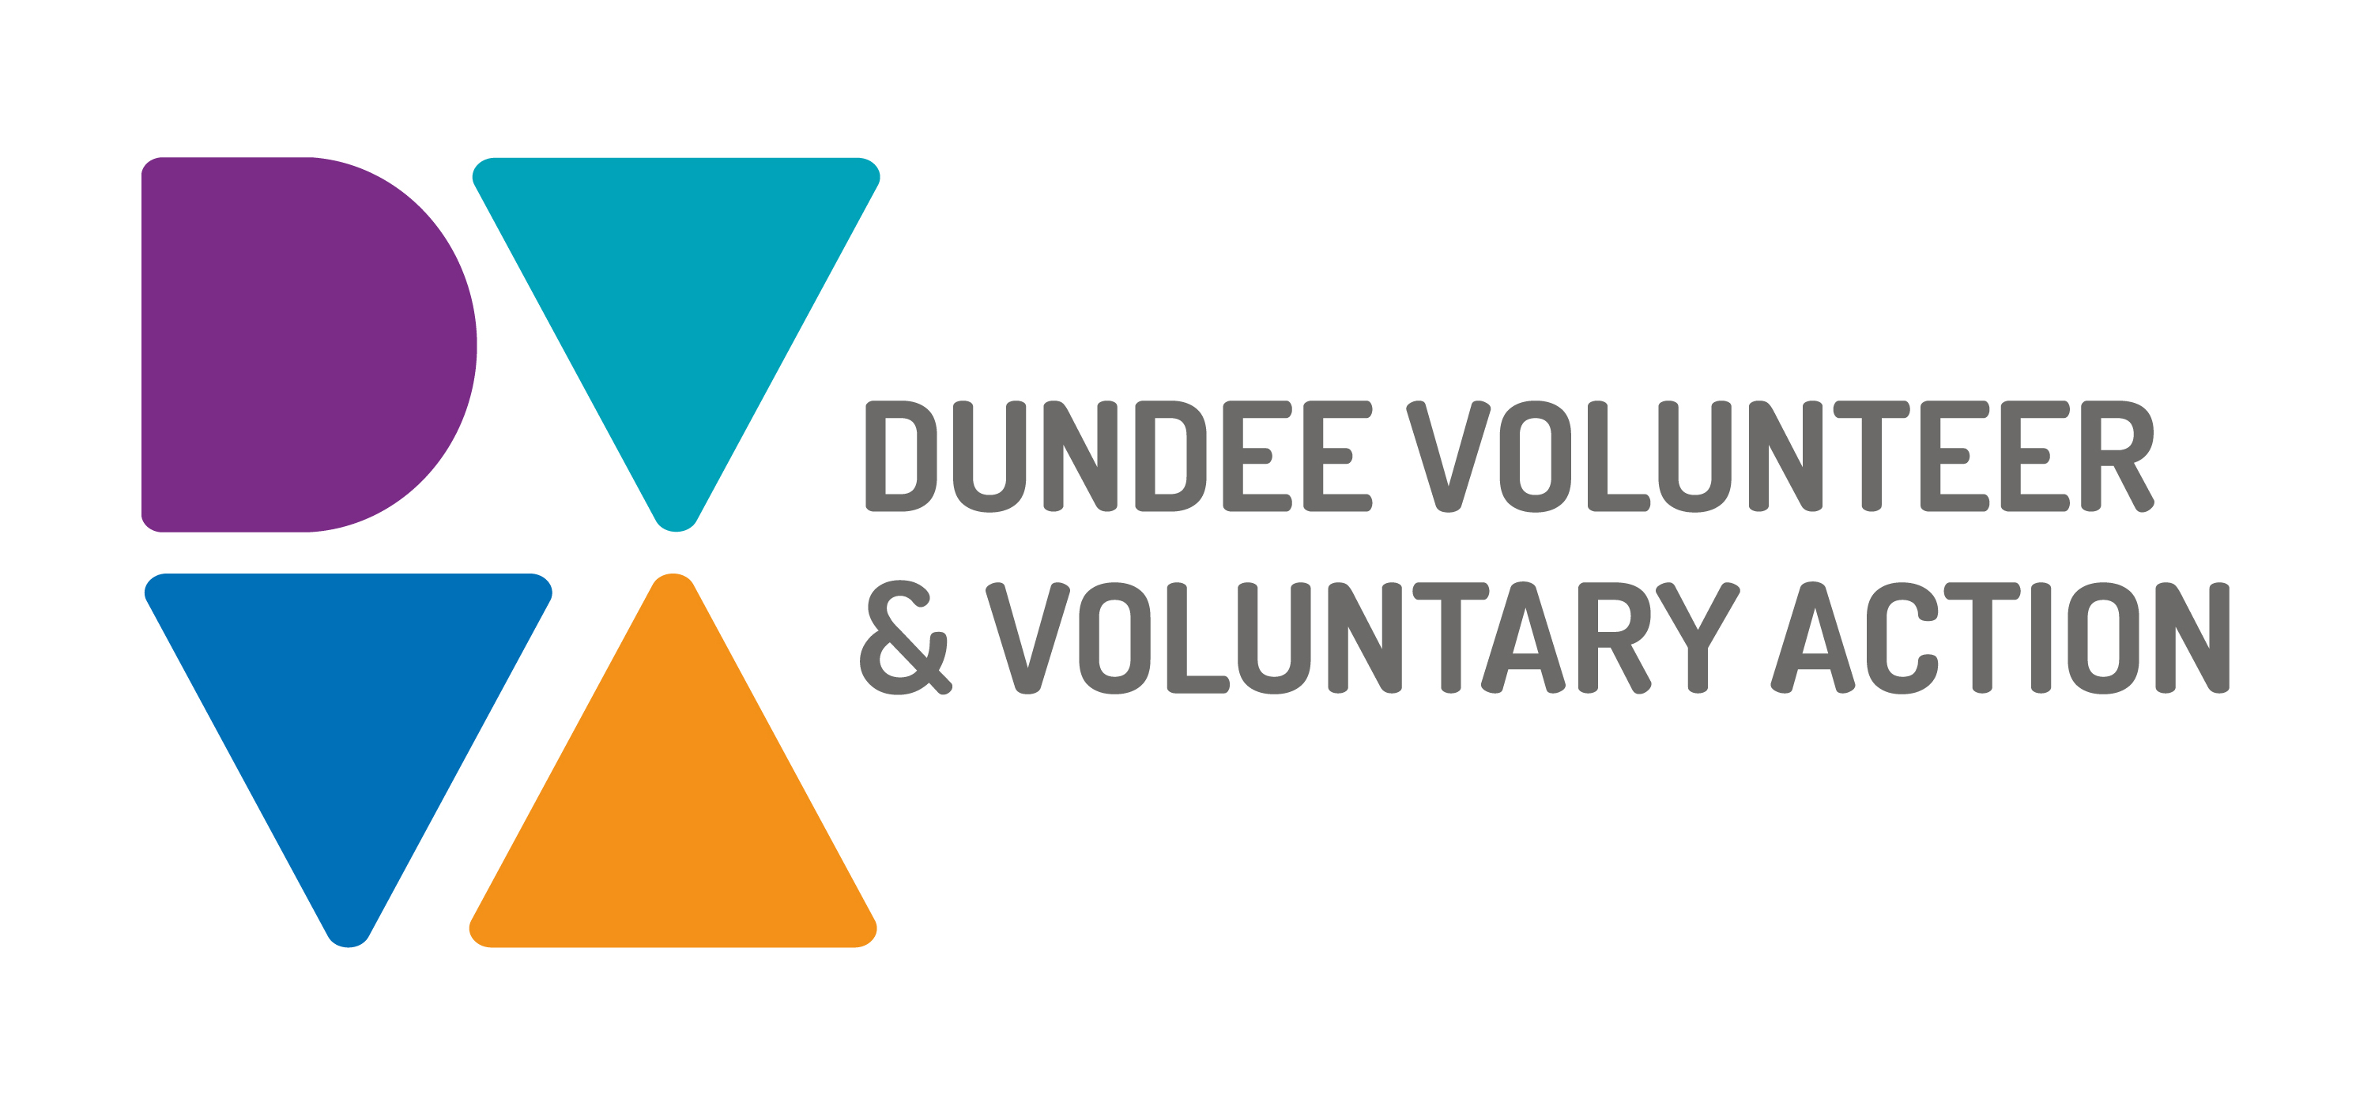
Job Description and
Person Specification

POST TITLE: Funding Co-ordinator

PURPOSE OF POST: The postholder will be responsible for implementing and managing a funding strategy for DVVA. They will co-ordinate the funding bid process to maintain existing funding streams from funders as well as explore and develop new funding opportunities.

RESPONSIBLE TO: Dundee Volunteer and Voluntary Action Board of Management through the Corporate Services Manager

MAIN DUTIES:

- To implement and review a funding strategy for DVVA
- To identify, develop and manage existing and prospective sources of funding from individuals, trusts and foundations, companies, local and central government, and other external agencies as agreed by the senior management team
- To identify potential sources of external funding which link to DVVA strategic priorities
- To prepare detailed funding applications for approval
- To co-ordinate the funding application process for existing and new projects, giving support and advice to managers preparing funding applications
- To build and nurture relationships with key funders and prospective funders
- To manage the application, distribution and monitoring of external funds held by DVVA
- To provide appropriate support and advice to the Senior Management Team in regards to the funding position of the organisation

OTHER DUTIES

The job description is a broad picture of the post at the date of preparation. It is not an exhaustive list of all possible duties as it is recognised that jobs change over time. Should the duties change radically then the post and grading will be reviewed.

CONDITIONS OF SERVICE
- These are set out in the organisation’s staff handbook.
- All staff meeting the qualifying criteria may join a defined contribution pension scheme provided by TPT Retirement Solutions.
- The organisation has an equal opportunities policy and seeks to be an equal opportunities employer.

SALARY: £25,470 - £28,300

HOURS OF WORK: 35 hours per week, to be worked in accordance with DVVA Conditions of Service.

ANNUAL LEAVE: 21 days per annum on appointment increasing each year by 1 day to a maximum of 25 days, plus 6 public holidays, plus 5 days Christmas closedown.

LOCATION: Initially, the post holder may be required to work from home due to Covid-19 restrictions. There may be an option for the post to be a blend of home and office working in future. Our main office is based in Dundee city centre and we have community locations in Lochee and Whitfield.

TRAINING: Staff may make application to pursue appropriate training.

JOB DESCRIPTIONS are reviewed from time to time.

Person Specification

 | Essential | Desirable

Professional/Educational Qualifications
Qualified to degree level or equivalent relevant experience | √
Knowledge and Experience
A minimum of 3 years’ experience managing income streams | √
Proven experience in reaching set targets | √
Experience in an income generation role |  | √
Experience of work within the Voluntary Sector |  | √

Skills and abilities
Excellent communication skills, both oral and written | √
Excellent organisational skills with the ability to handle multiple tasks simultaneously | √
Strong interpersonal skills, with the ability to manage internal and external relationships effectively | √
Strategic financial planning skills | √
Team working skills | √

Personal Qualities
Evidence of the ability to work in a demanding environment with minimal supervision | √
Ability to prioritise and cope with changing demands | √

