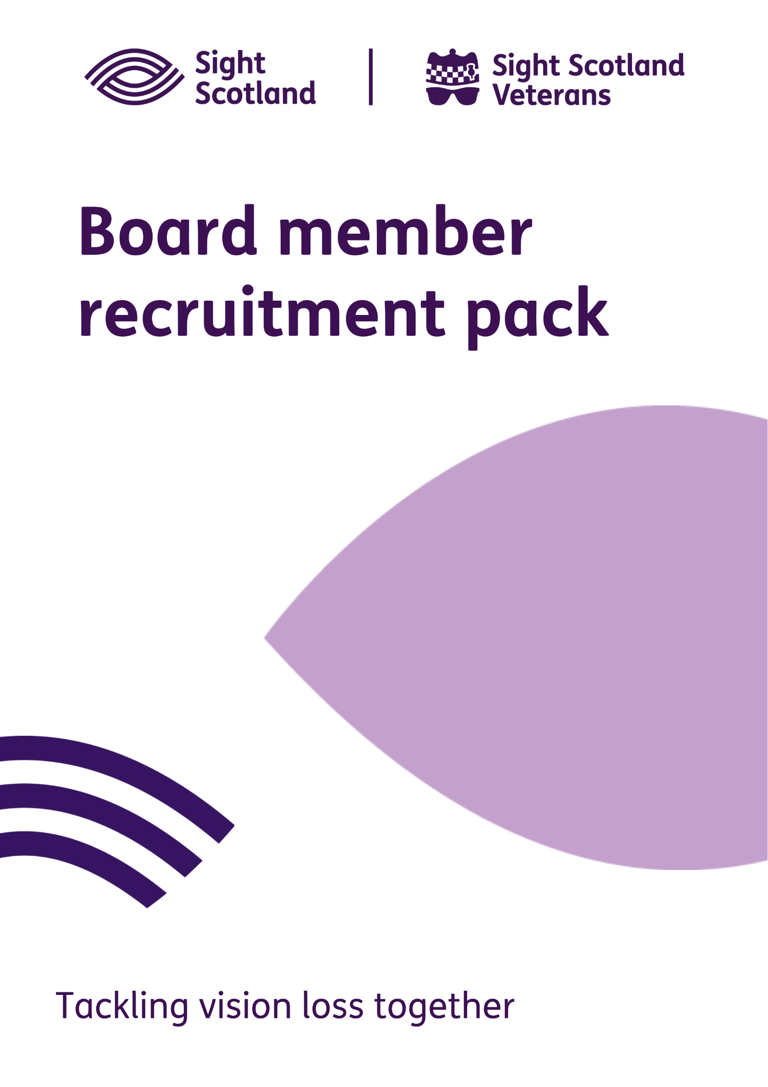
Board Member Recruitment Pack

Thank you for your interest in the role of Board Member with Sight Scotland and Sight Scotland Veterans.

We are looking for two outstanding candidates to join our Board. An interest in better outcomes for people with sight loss is essential. Lived experience of sight loss, either directly or perhaps through a family member is not essential, but such candidates would be welcome. A wide variety of skills and experiences are required on a modern charity Board. Again, whilst not essential, we would also be particularly keen to see applications from those with strategic level experience in one or more of the following areas:

  - Business Development, including Fundraising
  - Digital Transformation
  - Property and Estates Management
  - Medical Research

Trustees are automatically appointed as Trustees of both charities, which are separate legal entities. The Chief Executive is the accountable officer for both charities which have their own staff and resources. A number of corporate support functions are shared across both charities, such as human resources, IT, finance, estates and buildings, marketing and communications and policy and campaigning.

The positions are voluntary and not remunerated.

This pack includes:

- An introduction to Sight Scotland and Sight Scotland Veterans
- Board Member Role Description
- Code of Conduct for Board Members
- Information about our current Board Members

Closing date for applications is Monday 22nd November.

Interviews will take place on Thursday 2nd December – please specify in your application if you’re not available on this day.

If you have any questions or would like to arrange an informal conversation about the role, please contact Pamela Gaiter, Executive Support Manager, at pamela.gaiter@sightscotland.org.uk.

Successful applicants will be expected to:
- pass a Police Act Disclosure check
- sign up to the Code of Conduct for Board Members
- complete the Declaration of Eligibility for Charity Trustees
- complete the Care Inspectorate’s Fitness Declaration.

We look forward to receiving your application.

An introduction to Sight Scotland and Sight Scotland Veterans

Our ambition
We are determined that no-one should face sight loss alone. That’s why at Sight Scotland and Sight Scotland Veterans we have set the ambitious target of reaching as many people as possible who need us.
There are more than 175,000 people living in Scotland today with significant sight loss. The number of people living with sight loss is set to increase by 30,000 over the next 10 years.
Sight loss causes isolation and significantly alters lives yet, less than 1 in 3 adults get help within the first year of their diagnosis. People with sight loss are at a higher risk of poor education, unemployment, mental health problems, loneliness and financial challenges for the rest of their lives.
We want to reach significantly more people with sight loss across Scotland and to help people tackle these challenges.
How are we doing this at Sight Scotland?
At Sight Scotland, we are here for people with sight loss no matter what their age and stage of visual impairment. We already offer expert care, education, support and help but we want to do more by reaching out in new ways across all of Scotland to many more communities and people with sight loss.
We will work together to help people with visual impairment get the support they need in:
- Providing Care wherever it’s needed
- Supporting Learning across all life stages
- Embedding ourselves in the Community
- Exploring Enterprise opportunities
- Growing our Fundraising.
How are we doing this at Sight Scotland Veterans?
Supporting around 1,400 veterans, we provide innovative and valuable support to keep them independent through our outreach service, rehabilitation and two activity centres: Hawkhead Centre in Paisley and the Linburn Centre in West Lothian.
Over the next five years we are developing ambitious plans to increase the number of veterans with sight loss that we support and explore innovative new ways of providing person-centred support and advice.
Making a difference together through Policy and Research
Across both charities we want to strengthen our focus on research and development through medical research, social research, impact evaluation and through new forms of technology and innovative models of support.
We will continue to support people with sight loss through advocacy and campaigning, making sure that the voices of those with sight loss and their families and carers are heard at the highest level.

Our Values:
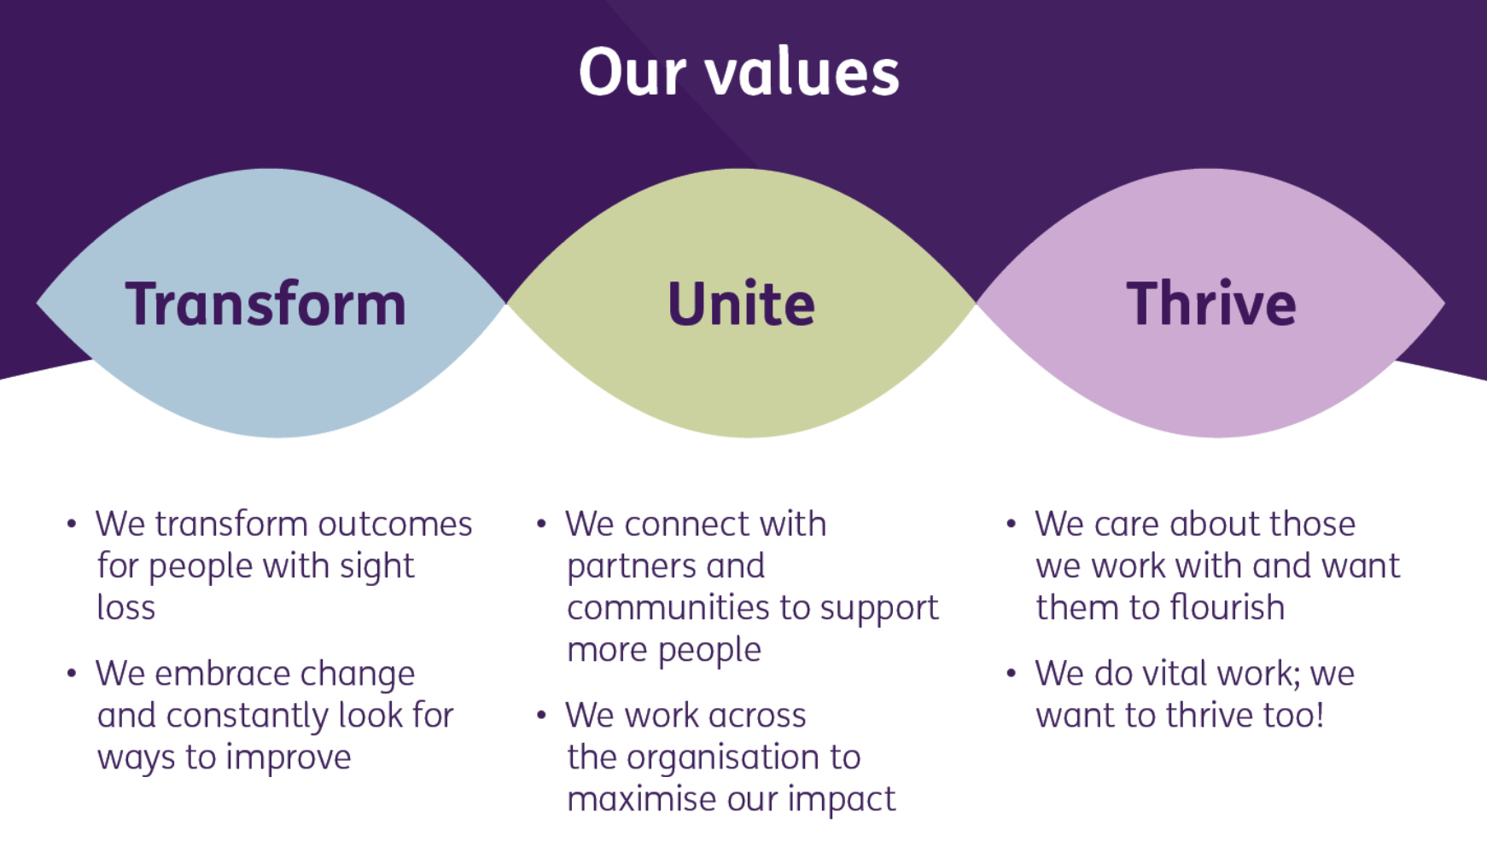

Our Ways of Working:
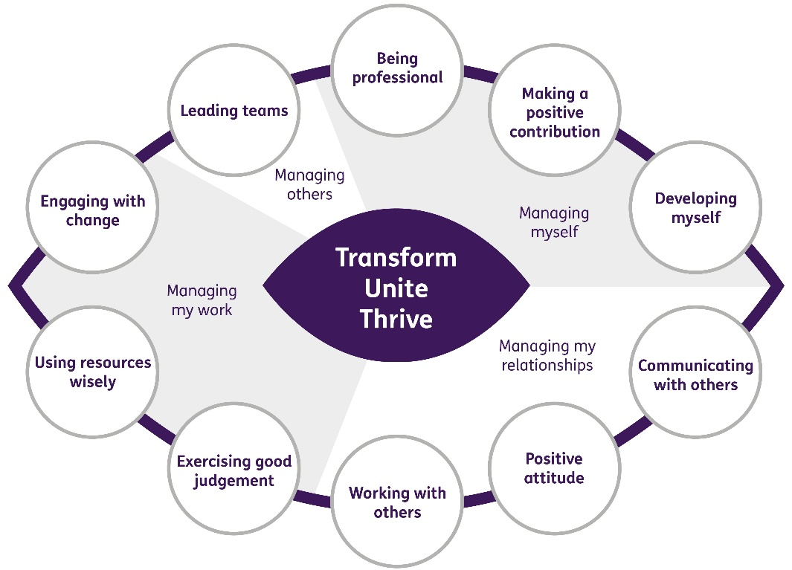

For further information, including an overview of our services, our governance and management, please visit our website: https://sightscotland.org.uk/
Board Member Role Description

Role purpose

The Board are responsible for the overall governance and strategic direction of Sight Scotland and Sight Scotland Veterans, ensuring that they are well-managed and abide by their charitable aims. Board Members must at all times, individually and collectively, act in the best interests of Sight Scotland and Sight Scotland Veterans.

Key duties
- Ensure that Sight Scotland and Sight Scotland Veterans comply with their governing documents (the Royal Charter for Sight Scotland and Sight Scotland Veterans Constitution), charity law, company law and other relevant legislation.
- Ensure that Sight Scotland and Sight Scotland Veterans pursue their objectives as defined in their governing documents.
- Ensure that Sight Scotland and Sight Scotland Veterans apply their resources exclusively in pursuance of their objectives.
- Contribute actively to the Board’s role in giving firm strategic direction to the organisation, setting overall policy, defining goals and setting targets, and evaluating performance against agreed targets.
- Safeguard the good name and values of Sight Scotland and Sight Scotland Veterans, promote a positive public profile and reputation of the organisation, and represent it as required.
- Ensure financial viability and sustainability of Sight Scotland and Sight Scotland Veterans.
- Approve and oversee frameworks of delegation, internal control and risk management.
- Protect and manage the property of Sight Scotland and Sight Scotland Veterans and ensure proper investment of the charities’ funds.
- Be an active member of the Board, providing organisational oversight and engaging in participative decision making to ensure Sight Scotland and Sight Scotland Veterans exemplify their mission, vision and values.
- Ensure that Sight Scotland and Sight Scotland Veterans are well-managed, accountable, and strive to achieve best practice in all that they do.
- Appoint and support the Chief Executive and manage their performance
- Use personal skills, knowledge or experience to help the Board of Trustees reach sound decisions. This may involve leading discussions, identifying key issues, providing advice and guidance on new initiatives, and evaluating or offering advice on other areas in which the Trustee has particular expertise.

Person specification:
- Commitment to the mission, vision and values of Sight Scotland and Sight Scotland Veterans.
- Understanding and acceptance of the legal duties, responsibilities and liabilities of trusteeship.
- Clear understanding of the principles of effective governance of organisations.
- Good understanding of the voluntary sector.
- Sound judgement and strategic vision.
- Ability to think creatively, a “can do” attitude to problem solving and willingness to speak their mind.
- Ability to analyse information and, when necessary, challenge constructively.
- Demonstrable experience of building and sustaining relationships with key stakeholders and colleagues to achieve organisational objectives.
- Commitment to Nolan’s principles of public life: selflessness, openness, integrity, honesty, objectivity, leadership, accountability.
- Willingness to devote necessary time and effort for effective contribution.
- Strategic level experience in one of the following areas is desirable:
  - Business Development, including Fundraising
  - Digital Transformation
  - Property and Estates Management
  - Medical Research

Time Commitment
Our Board meets four times a year, normally on Wednesday afternoons. We have six Committees of the Board, which normally meet three times a year:
- Care and Learning Committee
- Community Committee
- Corporate Committee
- Enterprise and Engagement Committee
- Audit Committee
- Remuneration Committee

We expect Board Members to join and participate in at least one, preferably two, Committees.

Additional communication may be required between meetings via email. Board Members will also be required to set time aside in advance of meetings to read all papers relating to meetings – packs are normally distributed a week in advance.

Meetings have been held by video-conferencing during the Covid-19 pandemic and a degree of flexibility is expected to remain in the future, including hybrid in person/virtual meetings.

Terms of Office
Board Members are appointed for a three-year term, and may be re-appointed for a second three-year term.

Board Structure
The Board can have thirteen Members.

Remuneration
The positions are voluntary and not remunerated. Out of pocket expenses will be paid in line with our policies.

Eligibility
Applicants must satisfy statutory requirements in order to be eligible to become a Charity Trustee. The Charities and Trustee Investment (Scotland) Act 2005 (“the 2005 Act”) disqualifies anyone who:

- Has an unspent conviction for an offence involving dishonesty or an offense under the 2005 Act
- Is an undischarged bankrupt
- Has been removed from trusteeship of a charity by the Courts, OSCR or Charity Commission for misconduct of mismanagement
- Is disqualified from serving as a company director.

Appointed Board Members will be expected to sign a declaration to confirm that they are not disqualified from acting as a charity trustee.

Training
Board members will receive full induction, along with access to further training / learning.

Equal Opportunities
We are committed to creating an inclusive environment where all people can contribute to reach their full potential, regardless of individual characteristics or circumstances.

We welcome Board Member applications from all suitable candidates regardless of gender, race, disability, age, sexual orientation, gender reassignment, religion or belief, marital status, or pregnancy and maternity. Groups currently under-represented on our Board include people under 40 and those from BAME backgrounds.

CODE OF CONDUCT FOR BOARD MEMBERS

- Each member of the Board must act in the interests of the two Charities.
- Where a decision action or statement affects both charities, a Board member must not take action that benefits one of the charities to the detriment of the interests of the other charity.
- Board members must seek, in good faith, to ensure that the two charities operate in a manner that is consistent each with its legal objects and purposes.
- Board members must act with the care and diligence that it is reasonable to expect of a person who is managing the affairs of another person.
- Board members must ensure that both charities comply with the provisions of the Charities and Trustee Investment (Scotland) Act 2005 and other relevant legislation.
- Individual Board members should avoid circumstances in which there is a conflict between their personal interests and those of either charity. The member must make the conflict of interest known to the other members and not take part in decision making on the matter.
- There may be a conflict of interest between one of these charities and another to which the individual is affiliated, such as both applying for funding from the same limited source. This should be disclosed and no further part taken in relevant decisions, discussions or actions.
- Other Board members must take reasonable steps and make sufficiently full disclosure to ensure that a member’s conflict of interest is declared and dealt with appropriately.
- All Board members have a duty of care to paid staff and volunteers and to service users and customers.
- Board members are expected to uphold and to speak and act consistently with the policies of the charities at all times, and refrain from criticism of the organisation and of its services outwith meetings.
- Board members should uphold the principles of equality and have regard to the requirements of the Equalities Act.
- All Board members must be subject to criminal record disclosure through Police Act Disclosure checks.
- Board members when present in the charities’ services and activities must adhere to a high standard of behaviour, and must guard against any situation where a person may feel vulnerable or in a way which puts vulnerable people at risk. Board members must disclose to the Chair or the Chief Executive any instance in which they felt uneasy or had any reason for doubt as to the welfare of any vulnerable individual in the organisation’s care.
- Board and committee members are welcome by prior arrangement to visit all the offices, facilities and services of the two organisations. When doing so they must have regard to the privacy and interests of service users and staff, and observe all instructions regarding health and safety and the protection of children and vulnerable adults.
- All information held by a Board member or a member of a committee which is not in the public domain will be strictly confidential and must not be divulged to the Press or to other parties, including the member’s nominating body where applicable.
- Board members exercise their powers as a corporate body through attendance at Board and Committee meetings. Appointment as a Board member does not confer any executive power on the individual to instruct officers of the two organisations or to commit the organisations to any action, grant or contract, other than where exercised by virtue of an office or specific delegation conferred by the Board.

Our Current Board

Michael Craig

Michael chairs the boards of the charities, and is a member of the Corporate and Audit Committees.

Michael is an experienced business leader and non-executive director who works collaboratively with Board and Executive teams to shape, communicate and implement strategic change within an organisation.

Results-oriented with a strong track record of delivery and proven communication, strategic and inter-personal skills. A team player who seeks to nurture and encourage others in the achievement of a common goal.

Aidan McCorry

In addition to serving on the Board, Aidan serves on the Corporate Committee and is Convener of the Community Committee.

Aidan has extensive knowledge of both the public and third sectors, having worked as Chief Executive at Deaf Action, as Project Manager at Scottish Enterprise and as Director of Corporate Services at Apex Scotland.

His work has focused on supporting a wide range of disadvantaged people to achieve equality of access to education, housing, training and employment opportunities.

Aidan has been a member of SCVO’s Policy Committee, an Investors in People Panel Member, a founder member of the Links Foundation, a member of the Scottish Parliament’s Cross Party Group on Deafness and a Board member of the social enterprise All Cleaned Up.

Graeme Bold

Graeme serves on the Board, as the Convenor of the Corporate Committee and on the Remuneration Committee.

He is a qualified Actuary and is currently Director of Workplace Pensions at Scottish Widows.

He brings a wide range of experience with previous roles as Strategy Director, Proposition & Commercial Director, Operations Director as well as in Transformation and Finance during his 20-year career at Standard Life.

Graeme also works with West College Scotland as a member of the Audit Committee.

He lives in Edinburgh with his family and enjoys travelling, music, and playing and watching sports.

Liz Porterfield

Liz is Vice Chair of the Board and serves as Vice Convenor on the Care and Learning Committee and as a member of the Community Committee.

Liz worked for the Scottish Government Health & Social Care Directorates as Head of Strategic Planning and Clinical Priorities until her retirement in 2017. Since then she has remained active in health and social care as a Trustee Board member, then Vice Chair of Genetic Alliance UK. In 2020 she took over as Chair of the Board and in short-term targeted project roles with, among others, NHS Greater Glasgow and Clyde where she was the Transformation Policy Lead for their Moving Forward Together innovation and change programme.

In Scottish Government Liz was responsible for a wide range of national clinical priorities and other policy developments, including the National Clinical Strategy, the Cancer Strategy, Diabetes strategy, neurological and long-term conditions, chronic pain and the Scottish Rare Disease Plan. She was a member of the SG implementation group and of the UK Government’s Rare Disease Forum and NHS England Rare Disease Advisory Group. She was the Government sponsor of Scotland’s National Services Division which commissions all national (including across the UK) specialist and screening services.

Liz contributed to the establishment of the Innovative Healthcare Delivery Programme (IHDP) based at the Farr Institute in Edinburgh and the Scottish Genomes Partnership. She chaired the implementation group that saw the introduction of robotic surgery in Scotland, and was a member of several other policy and implementation groups such as the development of the now established major trauma service/network, which was, in turn, a part of the work of the National Planning Forum of which she was also a member and policy lead. She was also responsible for the SG’s Armed Forces and Veterans Health Care policy, including overseeing the fulfilment of the UK Armed Forces Covenant and the SG’s Commitments for veterans. Among other developments, this involved leading the work to establish Scotland’s state of the art prosthetics service which was set up in response to the Murrison Report. She was also the SG policy representative on the MoD’s UK Committee led by the Surgeon General to oversee the implementation of the UK Covenant.

In her personal life, Liz is a grandmother to three granddaughters, all growing up too fast! She enjoys reading, particularly history, and is working her way through various Open University modules in the social sciences field, the most recent on Criminology, results awaited. She plans to study public law and criminal law.

Michelle McWilliams

Michelle is Vice Chair of the Board and serves as the Convenor of the Enterprise and Engagement Committee and on the Corporate and Remuneration Committees.

Michelle’s early communications career was in Whitehall, working at the Home Office for Ministers such as Michael Howard and Jack Straw and latterly as Head of PR with the Central Office of Information, advising government departments on PR and communications strategies.

On returning to Scotland Michelle worked in higher education, firstly as Deputy Director of Communications & Public Affairs at the University of Edinburgh and then as a consultant for Edinburgh Napier University.

After a career break, a move to the private sector saw time spent as an Account Director with a PR agency and then in-house with a tech start up. Michelle is currently an independent communications consultant with clients in the cultural, heritage and tourism and tech sectors.

Michelle is a co-founder and director of the annual Outwith Music and Arts Festival.

Mike Donnelly

Mike serves on the Board, on the Care and Learning Committee, and on the Enterprise and Engagement Committee.

Mike is a retired academic and adviser to senior politicians in the UK. He was Head of School and Dean of Faculty in UK and Australian University Business Schools over a 35 year academic career. He served as chief of staff to the First Minister of Scotland and as an adviser to the Secretary of State for Scotland and the UK Home Secretary.

Mike is an Honorary Professor of Management at both Heriot-Watt University and the Victoria Institute of Technology in Melbourne. He is an Honorary Fellow of the Strategic Management Institute of Australia.

Mike’s research and teaching has been in the area of Strategic and Operations Management. His expertise has been made available to public services both as consultancy and in academic publications.

Mike was a volunteer Board member on Linthouse Housing Association, Quarriers, The Star Project in Paisley, Govan Law Centre and the Institute of Public Administration Australia. He volunteered as a “foster-grandad” with Extended Families Australia and as a barista at Yorkhill Hospital’s tea bar.

Mike Martin

Mike is Convenor of the Care and Learning Committee and also serves on the Audit and Remuneration Committees.

He is a social worker to trade. Following a career in local authority criminal justice work he spent over 20 years with Capability Scotland, latterly as one of their directors.

He has worked independently for the past 12 years as a consultant, researcher, trainer and practitioner, combining these activities with part-time work as a co-ordinator of out of hours social work, and a number of teaching engagements for the Open University.

Mike's hobbies include natural history interests, he rings birds to study their movements, and until last year was the Secretary of the Scottish Ornithologists Club.

Stephanie Phillips

Stephanie serves on the Board and on Care and Learning and Remuneration Committees, and as the Convenor of the Audit Committee.

Stephanie has a background in strategic planning, quality improvement and performance management.

Stephanie has spent most of her career working in the public sector, including the Scottish Children’s Reporter Administration and Northern Constabulary.
Having joined NHS Scotland in 2006, Steph worked for the Scottish Ambulance Service for 10 years. In 2017, Stephanie moved to NHS 24 where she is currently the Director of Service Delivery.

Catherine Topley

Catherine serves on the Board, and on the Corporate and Audit Committees

Catherine joined Scottish Canals as CEO in June 2018. She has worked in a variety of sectors, from financial services and manufacturing to retail and is a respected and competent leader with a wide range of relevant commercial and public sector experience.
Catherine has extensive experience of working in public and third sectors, having worked as the Director of Corporate Services in Scotland’s Prisons, working closely with third parties and communities. She joined at an important time in Scottish Canals' journey as they become one of the nation's leading tourism and regeneration organisations, delivering diverse public value to the people of Scotland.
Her work has focused on supporting a wide range of people and sectors in Scotland to achieve equality of access to education, housing, training and employment opportunities.

David McArthur

David serves on the Board, and on the Care and Learning and Community Committees

David is the Director of Nursing, Midwifery and Allied Health Professions for NHS Orkney. He is also NHS Orkneys Veterans Champion and works with the Scottish Government advising on priority care for Veterans.

As health care professional his area of specialisms are an eclectic mix including Psychiatry, Operating Theatres and Intensive Care. He was the Executive Nurse Director for the Louisa Jordan Hospital which formed part of the Scottish Government Covid response.

He has a varied experience between the Third Sector, Army Medical Services Reserve and the NHS. His Third Sector experience includes roles within Erskine Hospital and a Chief Executive appointment with Trefoil House in Edinburgh.

David was a long-term Reservist with extensive operational experience in Iraq and Afghanistan where he held clinical and staff appointments including Command of the Camp Bastion Field Hospital. He retired from the Reserves in 2019 as the Brigadier, Head of the Army Medical Services Reserves.

He was awarded an OBE in 2011, he holds a Masters Degree from Kings College London and is an Honorary Fellow of the Royal College of Physicians and Surgeons Glasgow.

Dianne-Dominique Theakstone

Dianne serves on the Board and on the Enterprise and Engagement and Audit Committees

Dr Dianne-Dominique Theakstone is currently studying towards a master’s in social work at Strathclyde University. Her lived experience of visual impairment due to Retinoblastoma has driven her passion for disabled people’s rights. In 2018, for example, she attained her PhD in Applied Social Sciences which examined disabled peoples’ access to independent living in Scotland and Norway. Alongside this, she has gained over 5 years’ experience of conducting co-production research with disabled people. These projects include the 2020 ‘My Support My Choice: service user’s experiences of Self-directed Support across Scotland’, 2019 ‘Match Me: what works for effective allocations of adapted/accessible social housing in Scotland’ and 2018 Equality and Human Rights Commission report ‘Housing experiences of disabled people living in Great Britain’.

In her spare time Dianne enjoys long dog walks with her black lab guide dog Merlin, reading and creative writing.

