

**Role Profile – Fundraising Manager**

**Reports To:** Head of Fundraising

**Role Purpose:**

The Fundraising Manager will play a key role in working with the Head of Fundraising to deliver the fundraising strategy across a mix of income generation priorities. The role is responsible for generating income predominantly from trusts and corporates and working with the Head of Fundraising to implement and grow our legacy fundraising.

You will be responsible for managing relationships with trusts, who share our passion for transforming the lives of those with visual impairment and their families, to maximise their support and funding. The role will also have responsibility for corporate fundraising.

This role has the potential to include line management in the future depending on growth of the team and funding streams as we work towards our goal of transformational fundraising.

All roles within Sight Scotland and Sight Scotland Veterans are expected to work to our values and Our Ways of Working framework:

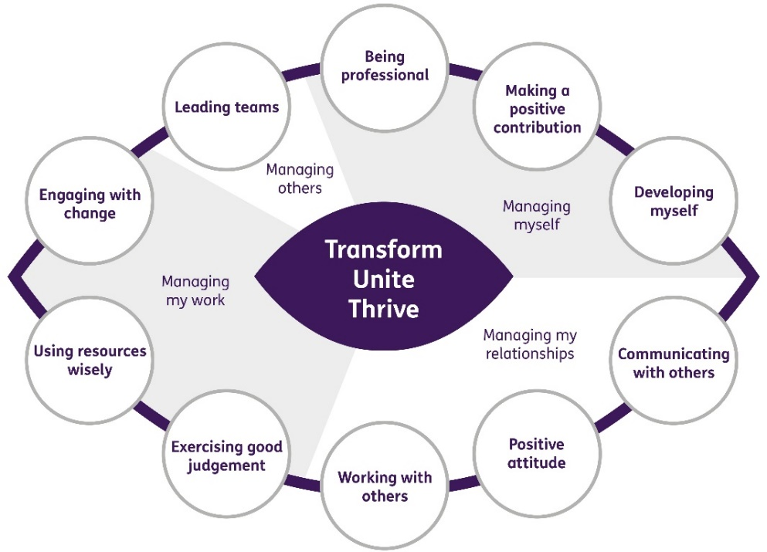

**Our Ways of Working - Managing my Work**

**The main responsibilities and accountabilities of this role are:**

**Trusts**

* Manage and develop the annual trust fundraising plan
* Develop, write and deliver creative funding proposals in line with the organisation’s strategic aims
* Work collaboratively with service managers and colleagues in Finance and Estates & Buildings to develop project plans and budgets for funding bids
* Ensure that all reporting requirements are met, and reports submitted according to agreed schedules and in line with funders’ criteria
* Produce information for relevant KPI reports and provide detailed analysis where relevant on the outcome of applications
* Work closely with finance and operational staff to ensure all funds are correctly used, correctly allocated and conditions and targets are met
* Manage and coordinate funders’ events as part of a stewardship programme
* Build relationships with our major funders and key individual donors ensuring that they clearly understand both what we do and how we make use of their funds
* Maintain accurate records and information on trusts on Raiser’s Edge NXT
* Liaise with wider marketing colleagues to ensure relevant case studies can be used and are available to demonstrate impact to funders
* Support the development of a positive fundraising culture across the charity

**Corporate Fundraising**

* Identify and apply to relevant corporates for funding
* Manage corporate relationships and steward donors
* Identify and apply for Charity of the Year opportunities
* Encourage corporates to support fundraising events, including any potential corporate sponsorship opportunities
* Promote and develop pay roll giving

**Legacies**

* Work with the Head of Fundraising to roll out the future legacy strategy and promotional campaign
* Be the first point of contact for legacy enquiries
* Ensure the management of Raiser’s Edge NXT for all legacies and potential legacy donors
* Coordinate any legator or potential legator events
* Liaise with the Executive Support Manager on the administration of legacies.

**Line Management Responsibilities**

It is expected that this post will have line management responsibility for an officer level post(s) in the future. Timing of this will depend on the development of the Fundraising team structure and growth of funding streams.

**Other**

* Adhere to the highest standards of fundraising practice
* Ensure that all activities comply fully with the relevant Data Protection obligations and any other legislation.
* Build relationships with internal stakeholders and help foster a fundraising culture
* Contribute to the Board report three times a year
* Ensure relevant records on the database are kept up to date and accurate
* Keep up to date with changes in legislation, tax implications for charitable giving and Institute of Fundraising policies

**Contribute to the work of the Marketing and Communications department**

* Support cross team projects and events
* Work effectively and collaboratively with colleagues across the department
* Represent the organisation at conferences, exhibition stands and events

**Our Ways of Working – Managing Myself and Managing my Relationships**

**To do this role, you will have:**

* A proven track record of raising funds from written applications (eg. trusts, foundations, corporates or tenders)
* Experience of working for a charity or third sector organisation
* Strong and accurate writing skills with excellent grammar and the ability to write persuasively
* Experience or understanding of other areas of fundraising (eg. community, individual giving, legacies, events)
* Strong relationship building skills and the confidence to speak to donors in person and by phone / online to pitch funding proposals
* Strong interpersonal skills, with the ability to collaborate effectively with staff at all levels across a diverse organisation
* Effective planning and organisational skills and the ability to maintain accurate records
* Project management skills
* Budget planning skills
* Ability to work independently to tight deadlines
* Experience of using CRM systems, preferably Raiser’s Edge NXT or 7

Knowledge of:

* The Scottish charity sector
* Scottish and UK wide trusts

Other:

* Ability to work flexibly including occasional evenings and at weekends

**It is desirable that you will have:**

* Membership of the Institute of Fundraising
* Qualification in fundraising

**On a day to day basis you will work with different people and teams, these could be:**

* Heads of Service
* Directors
* Senior Leadership and Management Teams
* Service Users
* Families
* Colleagues
* Other Sight Scotland services
* Senior Staff

**Requirements of this role are:**

* You are a member of the PVG scheme (paid for by Sight Scotland)
* You will have a 6 month probation period
* That you participate in all staff training and development and maintain your own professional development
* You will wear the appropriate PPE in accordance with current guidance for the role.
* You will follow Sight Scotland’s guidance, policies and procedures relating to your own health and safety and that of colleagues and service users at all times
* You will uphold the principles of Sight Scotland’s Dignity at Work and Equal Opportunities policies at all times, working in a way which supports an inclusive work environment that is respectful of differences.

**What we can offer you:**

* Generous pension scheme – employee contribution from 3% of salary, employer contribution from 6%. You have the option to increase your contribution, we will double the employer contribution up to a maximum of 12%. Our pension scheme is a salary sacrifice scheme which means you do not pay tax on your contributions.
* Discounts for Carers
* Access to learning and development opportunities
* Employee Perks through the Employee Assistance Programme
* Cycle to Work scheme
* And many more, please visit our website for more information

This job profile is not exhaustive. The duties of the post holder may be reviewed from time to time and the employee may be called upon to work in other locations within Sight Scotland or Sight Scotland Veterans.

**Location**

This position is based in our Head Office in Robertson Avenue, Edinburgh. We are currently operating blended working with a minimum of two days a week at our Head Office premises and the remaining time may be spent working from home.