**CAP Debt Coach**

Dear Enquirer,

We are very pleased you are interested in working with the CAP service of Holy Trinity Church and the community of Wester Hailes.

In this application pack you will find the following:

• Job advert

• Job description and person specification

• Application form

Should you wish to find out more about Holy Trinity Church please do spend some time browsing through our website: holytrinitywesterhailes.org.uk

If you have any questions about the application process or you would like an informal chat about either of the roles, please contact Ian Richardson tel: 01968 682659,

or email: [ianr@holytrinitywesterhailes.org.uk](mailto:ianr@holytrinitywesterhailes.org.uk)

If you would like to apply for this role, please complete the application form electronically and return it by email to: [ianr@holytrinitywesterhailes.org.uk](mailto:ianr@holytrinitywesterhailes.org.uk)

**Please note that the closing date for applications is the 26th of November 2021 at 12, noon, and we are unable to accept applications beyond then.**

Please also note that applications will only be accepted from candidates with a legal right to work in the United Kingdom. Holy Trinity Church of Scotland is committed to the safeguarding and appointment will be subject to membership of the PVG scheme.

Should you be called for interview you will be notified by the 30th of November 2021 at the latest. Interviews will be in person, where at all possible, and conducted during the week of the 13th to the 17th of December 2021. However, if this is not suitable for any reason, please contact me on the above email address to discuss alternative arrangements.

If you have any questions at all, please do not hesitate to be in touch and do be assured of our prayers for you as you discern God’s call for this next stage in your life and ministry.

Every Blessing,

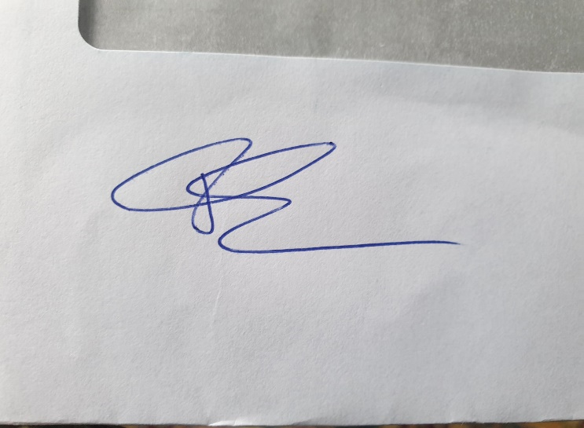

Ian Richardson Discipleship, Holy Trinity, Wester Hailes.