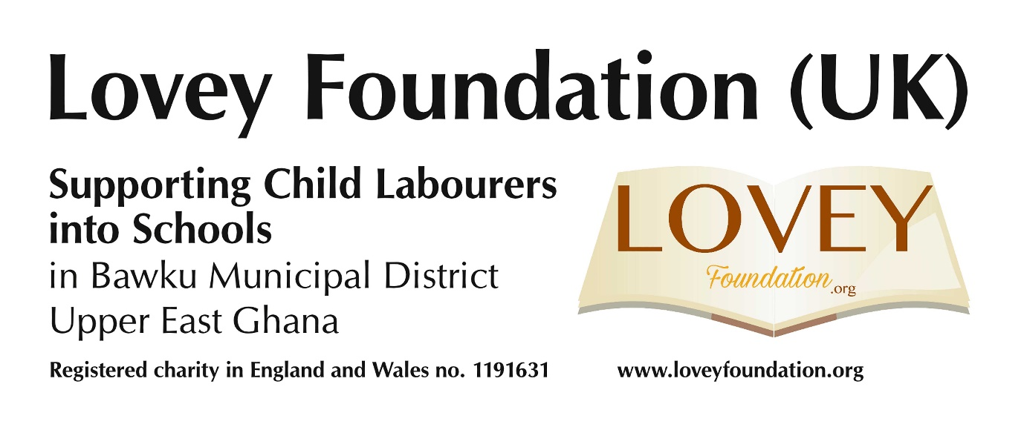

Trustee Vacancy, November/December 2021
Communications and Outreach Officer
Our dynamic team supports children into primary schools in rural north-east Ghana. We need a creative self-starter and team player with a proven talent in marketing and networking to help develop fundraising initiatives and grow our membership.
The Voluntary Role
As one of the trustees on our aptly named Executive Committee or EC (board of trustees), which includes our other officers - Chair, Secretary and Treasurer - you will help to shape the strategy that your ongoing communications and outreach responsibilities will help us to realise. In this role you will receive full support from our EC members, wherever in the UK you are based. Our EC meets on Zoom (evenings) and we work from home.
After your induction, tailored to suit your knowledge, skills and experience, and working closely with your fellow trustees and our external contacts in the UK, you will:
- Help us to generate a wider range of attractive fundraising initiatives, making full use of the interests and skills of our current membership and supporters, liaising with your fellow trustees and contributing items for discussion at our EC meetings
- Enable us to reach out as effectively (and cost-effectively) as possible to our membership and supporters and their networks of friends and relatives, so as to maximise their interest and engagement in our key purpose - fundraising in the UK
- Take a leading but supported role in developing and enhancing our embryonic social media and website presence. Since 2016, when we launched our website, we have shared it with our partner organisation in Ghana, with whom we are in regular contact online, primarily through our Chair, and our donors are naturally interested in how our funding assists the work on the ground which our partners are engaged in, which is changing many young lives.
- Ensure that our fundraising events have a longer-term impact on our success by using these precious opportunities to enhance awareness of our charitable object, attract people into our membership and retain them through subsequent communications
- Maintain our contacts with traditional media - local newspapers (including their online presence), radio and television - and help us gradually to widen that network
- As a trustee, make recommendations to our EC, based on your experience before and after your appointment which will enable us to prioritise our activities as effectively as possible. Like you, we are unpaid and with limited time to fulfil our own voluntary roles and we contribute ideas based on our own professional areas of expertise, our local knowledge and feedback from supporters.
As hands-on trustees with shared legal and practical responsibilities we are open to fresh ideas and work very much as a team, pooling our talents and energy.

What should you be able to bring to this role?
The essential skills required, with proven related professional experience (in any - or a combination - of marketing strategy, public relations or social media marketing, or work requiring some or all of the core skills associated with these) . . .
will be in marketing and communications. In particular the role will demand:
- Familiarity with and first-hand successful use of social media and traditional online and/or offline media to promote supporters' or customers' awareness of and willingness to identify with the key purpose of an organisation and/or its outcomes/products, and to nurture and grow that supporter / customer base
- Confidence and proven success in communicating orally and through the written word and images with both supporters / customers and fellow team members, as appropriate for a variety of types of communication ranging from emails and social media posts through to formal presentations
- Familiarity with and proven, confident professional use of word processing, presentation and desktop publishing software, and basic competence in the use of spreadsheets, graphs and photo editing software and in updating an established website.
- Being a "team player" and able to form positive and lasting working relationships with colleagues is also essential. Flexibility, understanding, open-mindedness, good humour and an active awareness of the other demands on colleagues' time in their working and private lives is key to this.

Desirable skills, experience and talents might include
- Previous successful experience (voluntary or professional) in contributing in any way to the work of a charity or other good cause.
- Knowledge of and an interest in issues affecting access to education in countries such as Ghana.
- Experience of building, launching or developing a new website or social media platform.

How this role will make a difference to our charity

Our new trustee will help us in Lovey Foundation (UK) to achieve our charitable object even more effectively, as we enter our fifth year but are still only in our first year as a registered charity with the benefit of Gift Aided donations - and most of all the young people in Ghana who are its beneficiaries - in three vital ways:
- Changing the lives of children from impoverished rural parts of Bawku Municipal District through providing the uniforms and equipment they need for a basic education.
- Increasing our income by identifying, developing and helping to deliver new fundraising initiatives.
- Gaining and retaining new supporters from events, networking activities and developing our social media channels.

What’s in it for you if you are appointed?
This role offers huge intrinsic rewards, and a clear and life changing goal:
- Working with passionate and energetic volunteers as part of a small, friendly team of hands-on trustees
- A fantastic opportunity to develop new skills and make key strategic decisions within a small organisation whose work is, we believe, possibly unique.
- Opportunities to work closely with our Ghanaian partner organisation and discover
first-hand the impact we are making.
- Flexible working hours to reflect your availability to fulfil this key trustee role.

Where and how to carry out this role?

You would be working from home, on average for up to three hours a week, and very much outside normal office hours.
Though our official address is in Haywards Heath, West Sussex, our hub – where we began – is in Brighton. So far, we have held most of our fundraising events there or in Mid Sussex.
As this role can be fulfilled remotely, the appointed person can be based anywhere in the UK. We meet on Zoom and have done so since March 2020. We can reimburse any essential cost-effective receipted travel expenses where necessary.

The application process

Our application deadline is Tuesday 7 December 2021, and we expect to be holding informal interviews of suitable applicants later in December, or in early January, via Zoom.
If you need any further clarification of the role, having read the details about our charity which follow this section, please email Melvyn Walmsley, who is one of our trustees: melvyn@loveyfoundation.org
Applications will be treated in strict confidence and should:
- Include your curriculum vitae
- Provide contact details of two or more referees, two of whom have supervised your professional work
- Be addressed to melvyn@loveyfoundation.org and be received
by midnight on Tuesday 7 December 2021.

………………………………………………………………………………………..

Lovey Foundation (UK) - reg. charity no. 1191631 (England and Wales)
www.loveyfoundation.org

Our objectives

At Lovey Foundation (UK) we believe that all children, no matter how poor, should have access to a basic education. Every year we raise funds to help young people in Bawku Municipal District, Upper East Ghana to go to school, especially by providing the uniforms and equipment they need to attend primary school. We work closely with our partner organisation in Bawku to distribute these essentials to the children and ensure that they are supported through their primary education.
Our partner organisation in Ghana, Lovey Save Child Workers Foundation, was founded in 2013 by Thomas Aruk Lateef, a teacher who was concerned about the children he saw in the locality of his school in Bawku, north-eastern Ghana, engaged in manual labour rather than attending school. On investigation he learned it was because their parents could not afford school uniforms or basic equipment. Thomas set up the Foundation, establishing support from Yaa Asare (a UK resident who was lecturing in Ghana) and Michael Miller from the Church of the Good Shepherd, Brighton. Since this time, significant funds have been raised in the UK to provide children in Bawku with the uniforms and equipment they need to attend school.
In 2016 Lovey Foundation (UK) was formally established in Brighton as a Community Based Organisation. Our current constitution was adopted on 2 November 2019 and in October 2020 we became a registered charity. Since 2013, as a result of UK fundraising, 312 children have been supplied with the basic equipment (uniforms, sandals, bags, notebooks and pencils) they need to attend school. We need the continued support of the public in the UK so that future cohorts of children in a part of Ghana which is mainly engaged in subsistence agriculture can access the life-changing opportunity that a basic education offers.
Our activities
Lovey Foundation (UK), which has an average income of up to £10,000 a year, has so far raised funds and awareness as follows:
Sponsorship of:
(a) an Executive Committee member in two 10k road races and a televised 70 miles in a month solo run (aged 70), and
(b) four friends who kayaked the length of the River Thames.
Being good cause of the month in a parish in Haywards Heath, including a silent auction.
Illustrated talks to the public and voluntary private organisations - so far, at the Brighton Fringe Festival and, in Sussex, at meetings of four church and secular societies and at the annual performance by a community choir for friends and families.
A concert at a church in Cuckfield, West Sussex (with another booked there for 30 April 2022) and two so far at a Brighton church.
A Caribbean supper at a Brighton church hall followed by a performance by two internationally renowned poets.
The sale of Christmas cards in 2020 and 2021 (ongoing).

