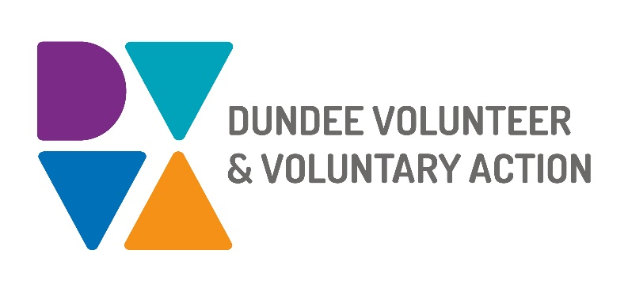
Job Description and
Person Specification

POST TITLE: Peer Recovery Development Worker (Mental Health)

PURPOSE OF POST

To work as part of the Mental Health Engagement and Substance Use team to build on our successful work in Making Recovery Real in Dundee. In collaboration with partner organisations, you will develop capacity for and facilitate development of peer recovery practice as a means of achieving good mental health and wellbeing for all.

To develop and support Dundee Peer Recovery Network.

To develop, promote deliver, and facilitate access to learning and development opportunities for and with individuals who have lived experience of mental health recovery.

In collaboration with others, to develop, create and sustain informal, voluntary and paid peer recovery roles within the field of mental health and wellbeing.

RESPONSIBLE TO: Third Sector Network Coordinator

SALARY: Grade 3 £21,330 - £23,700 pro rata (based on a FTE of 35 hrs)

HOURS OF WORK: 35 Hours per week

DURATION: Permanent

ANNUAL LEAVE: 25 working days per year.

LOCATION: Dundee Volunteer & Voluntary Action, Number Ten, 10 Constitution Road, Dundee, DD1 1LL, and any other location deemed necessary to fulfil the duties of the role

MAIN WORKING CONTACTS

Individuals with lived experience of mental health and Substance Use Team colleagues. Staff, volunteers, and participants in organisations and agencies working on mental health recovery including NHS Tayside, Dundee City Council, National and local voluntary organisations.

KEY DUTIES

Promote Peer Recovery

Promote, advocate for, and facilitate peer recovery to enable citizens of Dundee to enjoy better mental health and wellbeing.
- Work with volunteers to facilitate, and support recovery story-sharing as a peer learning activity, and to promote and inspire hope and optimism.
- Engage, encourage, and support organisations to develop and embed peer recovery opportunities and practice within their provisions; including informal peer support, volunteer roles, and paid positions.
- Delivering Living E-Emotions and Peer to Peer Programmes and working with those with lived experience to increase mental wellbeing training across the city.

Support Peer Recovery Practitioners

Keep lived experience at the heart of all we do.

Engage, encourage and support people at all stages of recovery from mental ill-health to participate in recovery-focussed activities, using lived experiences as assets.
- Collaborate with partner organisations and peer recovery practitioners to develop, deliver, promote, and facilitate access to learning and development programmes that support peer recovery. These will include, but are not restricted to Peer 2 Peer.
- Support people with lived experience to create, shape, and to take up peer recovery opportunities.
- Link with peer recovery initiatives in other sectors such as substance misuse and suicide prevention to maximise resources and reduce barriers for people affected by more than one condition.
- Appropriately record and gather evidence of the impacts of peer recovery on individuals, organisations, and communities.
- Develop and maintain relationships with peer recovery workers across the city and create opportunities and events for them to network.
- Develop and support Dundee Peer Recovery Network as a pool of experts by experience, a mechanism for mutual support, and a vehicle for the continuing development of peer recovery in Dundee.
- Keep up to date with developments in Peer Recovery, sharing and building on good practice models and examples.

Contribute to developing and delivering the Mental Health and Substance Use Team Plan

- Maintain accurate records of attendances, outputs and outcomes to evidence work undertaken.
- Actively and constructively participate in team meetings and activities.
- Contribute to shared team developments including the emerging Mental Wealth Academy.
- Work with team colleagues to ensure the plan and its delivery reflects the needs of individuals, organisations, and communities.
- Strive to maintain good practice in co-production.
General Duties

- Be committed to the work of Dundee Volunteer and Voluntary Action and promote team working.

- Work in accordance with the organisation’s policies and procedures

- Be committed to the work of the Third Sector Interface and promote partnership working

- Be aware of any areas of risk and advise on improvements

- Contribute to quality assurance, which will ensure compliance with existing quality systems such as EFQM and Good Governance Award.

- Undertake personal and professional development as required by the role

OTHER DUTIES
This job description is a broad picture of the post at the date of preparation. It is not an exhaustive list of all possible duties and it is recognised that jobs change and evolve over time. Consequently, this is not a contractual document and the post holder will be required to carry out any other duties to the equivalent level that are necessary to fulfil the purpose of the job.

CONDITIONS OF SERVICE
- These are set out in the organisation’s staff handbook.
- All staff meeting the qualifying criteria may join a defined contribution pension scheme provided by TPT Retirement Solutions.
- The organisation has an equal opportunities policy and seeks to be an equal opportunities employer.

TRAINING: Staff may make application to pursue appropriate training.

This specification sets out the required essential and desirable qualities expected of the successful post holder.

ESSENTIAL | DESIRABLE
Relevant degree level qualification or a minimum of 3 years practical experience.
Demonstrates excellent verbal and written communication skills.
ESSENTIAL | DESIRABLE
Working knowledge of mental health recovery, particularly peer recovery. | Experience of organising recovery focussed activities.

Experience of developing and delivering adult learning opportunities

Experience of working with volunteers

Experience of making effective contributions to team working.

Practical experience of co-production
Experience of establishing and maintaining effective networks.
Experience of cross-sector collaborative working, and delivering in multi-agency partnerships. | Practical experience of the Third Sector and the environment in which it operates.
Ability to independently and proactively plan, deliver, and evaluate work, with minimum supervision. | Working knowledge of Health and Social Care Partnership.
Excellent organisation skills
Experience of producing accurate records of work including plans, meeting notes, and reports.
IT literate – particularly use of Microsoft Office, e-mail, and the internet. | Working knowledge of databases.
Demonstrates personal commitment to equal opportunities. Displays honesty, integrity and a strong sense of ethics in all actions and decisions.
Highly motivated and positive in outlook.
Demonstrates patience and empathy.

