External Trustee
November 2021

Role Description
Overview of the Role:
The Board of Trustees has overall responsibility for the affairs of the Highlands & Islands Association (HISA). In line with Charity Law, they ensure that HISA conducts its affairs in line with its charitable objects and delivers for its members. External Trustees bring additional experience and skills to the Board from outside HISA and the University. Time commitment of the role is attendance at four quarterly Board meetings plus other sub-committee meetings as agreed or required. Maximum expectation of the post is for a total commitment of 2 days per month. External Trustees are appointed for a term of 4 years and may serve a maximum of 2 terms which may be consecutive or non-consecutive. The position of Trustee is a voluntary one, although out of pocket expenses for attending meetings etc. are paid.
Key Responsibilities:
- To ensure that the Association complies with its governing document, charity law, company law and any other relevant legislation or regulations. To ensure that the Association pursues its objectives as defined in its governing document and uses its resources exclusively in pursuance of its objectives.
- To ensure that the Association has a clear strategic direction that meets the needs of its members, clearly outlined goals and performance indicators and is focused on achieving these.
- To agree any delegated authority and ensure such authority is clearly expressed and followed.
- To be an ambassador for the Association, safeguarding and developing its reputation and values.
- To ensure the long-term financial stability of the organisation
- To provide support for the Chief Executive and other staff in protecting and managing the assets of the Association, ensuring they are used exclusively in pursuance of the agreed objectives.
- To provide support and feedback for the Chief Executive, including contributing to annual appraisal and objective-setting.
- To contribute actively to the Board of Trustees, using any specific skills, knowledge or experience to help the Board of Trustees reach sound decisions. This may involve, but is not limited to:
- Scrutinising board papers
- Leading discussions
- Providing guidance on new initiatives
- Hearing specific HR and/or membership discipline cases
- Other issues in which the trustee has special expertise
- To undertake appropriate training and personal development as required for the role.
- To ensure that any and all conflicts of interest that may arise are declared.
- To adhere to all relevant Association policy with particular reference to staffing and health and safety.
The Role of the Trustees
The Board of Trustees has overall responsibility for the oversight of the administration of the Association.
The Board is made up of 10 members:
- The full-time sabbatical officers of the Students’ Association (students elected to a full-time one-year position)
- The Student Trustees (current students appointed by the Board)
- Four External/Lay Trustees (individuals appointed to bring wider expertise, experience and skills to the Board)
In addition, the Chief Executive of the Association attends all meetings of the Board. There are usually 4 meetings of the Board per year, with sub-committee meetings organised ahead of each meeting. Meetings are currently being held virtually, but there is a desire to return to face-to-face meetings as soon as practically possible. An annual Trustee Away Day is held in August/September each year, aligned with the introduction of new Officer Trustees, in order to support the collective relationship and responsibility of the Board.
There are several sub-committees of the Board identified in the governing documents:
- Appointments & Remuneration Committee
- Finance, Audit and Commercial Development Committee

Each sub-committee is made up of 1 External Trustee, who acts as Chair of the committee, along with 1 Officer and 1 Student Trustee.
The Students’ Association is an incorporated charity.
The Board is ultimately responsible to OSCR but it also has accountability to the membership through annual meetings, minutes published on the website etc.
All students at the University are automatically members of the Association although they may opt-out of membership under the provisions of the 1994 Education Act Part II, sections 20-22, which relate to students’ unions.

Letter from the Chair
Thank you for your interest in becoming a Trustee at HISA. We are a relatively young Students’ Association, having only existed in its current format since 2015, but we play an important role in developing the lives of our members. The University of the Highlands and Islands (UHI) is a dispersed and unique institution, playing a key role in providing educational opportunities for some of the most rural areas of Scotland. The combination of both organisations makes the challenges faced in our operation very unique, but with a huge potential impact on our members and communities.
Having recently hired a new Chief Executive, HISA is at the beginning of its development into a more mature organisation. This has been highlighted by the work to take the management of the organisation’s finances in-house over the past year. The Senior Management Team continue to develop and enhance the business to better support our incredible teams and enhance our ability to deliver our charitable objectives in all UHI locations.
During the pandemic, HISA maintained its activities whilst working remotely, increasing engagement with students in some areas and achieving budgetary savings due to not having any commercial activity and the requirement to work from home. Along with an increase in our Block Grant funding from UHI, these savings are being reinvested into the organisation to ensure that we are fit for purpose for a new era. We have expanded our Communications Department, restructured our Operations Department to better meet our needs and sought key partnerships with external providers to progress our ambitions and ensure we have the right expertise in the right place.
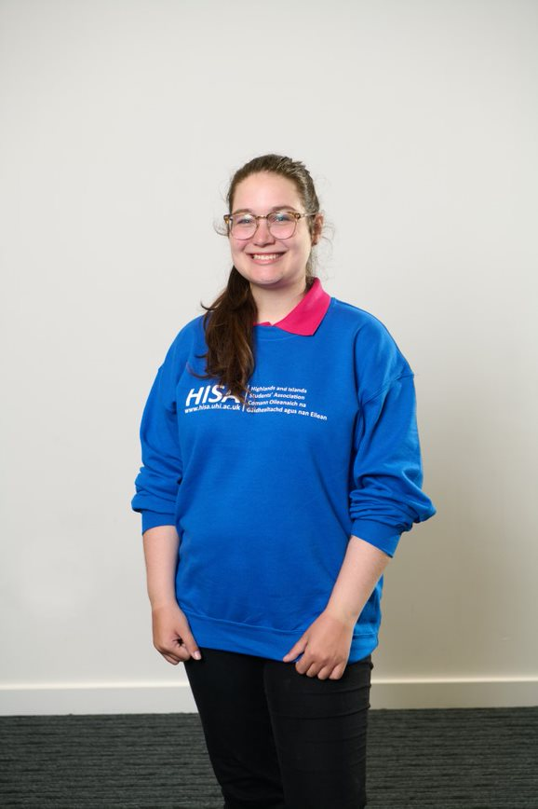
Our amazing team of Student Officers are working collaboratively across the partnership with their local Academic Partner to represent student interests at the highest levels, ensure that quality assurance mechanisms have suitable student involvement and that students have a wide range of opportunities to make their experience the best that it can be.
The organisation has just reached the end of its current strategic period and will be planning for the next period in the coming year ahead. This provides Trustees with a great opportunity to steer the organisation in achieving outcomes from our members in the future.
Flo Jansen
President & Chair of the Trustee Board

Recruitment Process
The recruitment for this role is being overseen by the Appointments & Remuneration Committee, who will be responsible for the selection of the candidate to be put forward to our Regional Student Council for approval in late January 2022.
If you are interested in applying for this role but would like to understand more about the role, organisation, process or role expectation, please contact James Lindsay, Chief Executive (james.lindsay@uhi.ac.uk) to arrange a discussion. Neil Stewart, Chair of the Appointments & Remuneration Committee is also available to discuss the role with applicants should you wish, please contact the Chief Executive as above to organise this.
As part of the recruitment process, Appointments & Remuneration Committee have reviewed the current skills and experience of the Trustee Board and are seeking applications from candidates with the following areas of knowledge and experience.
- Communications, Marketing and Engagement.
- Commercial Development
- Corporate Governance
- Human Resources
We are seeking a committed and engaged individual who will be able to contribute up to 2 days per month to the role. We also welcome applications from candidates with diverse backgrounds and from typically under-represented groups within our communities. We also encourage applications from the Highlands and Islands area.
How to apply
In order to apply for this role, please email your CV and a supporting statement (maximum of 2 A4 pages) to hisa@uhi.ac.uk.
Your supporting statement should outline your experience in charity governance and knowledge of the role of a Trustee, whilst also covering your links to the organisation, the University and/or its Academic Partner Colleges, or the Highlands & Islands region. The Committee would like to see what you could bring to the role to help develop the student body at HISA and any evidence to support the areas of knowledge and experience being sought through this process.
The deadline for applications is Monday 13th December at 8am. Shortlisting for the role will take place on Monday 20th December, with interviews held on Wednesday 12th January 2022.

