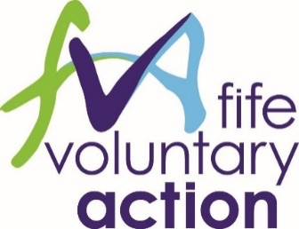
Fife Voluntary Action
Struggle to Strength Project Assistant
Job Description
Post Title: Struggle to Strength Project Assistant
Hours: 21hrs/week
Salary: £16,926 (pro rata)
Reporting to: Jointly reporting to Lived Experience Team and Peer Support Network Coordinators
Main Purpose of Post
The successful applicant will work closely with and support the Lived Experience Team (LET) Coordinator Lived Experience Team (fva.org) and the Mental Health Peer Support Network (PSN) Coordinator with the practical and administrative function of both projects.
Main Duties
- Carry out required administrative duties including but not limited to: preparing agendas and taking minutes at project meetings; maintaining project spreadsheets, volunteer paperwork, expenses and evaluation processes;
- Supporting LET and PSN Coordinators at meetings, events and training including managing event bookings, venue requirements and online support as appropriate;
- Maintain established relationships with staff, volunteers and partners in Fife (and beyond);
- Take personal responsibility for contributing to high quality standards in customer relations, service delivery and communications; and
- Any other duties relating to LET or PSN Teams that may arise in the role.

This job description does not represent an exhaustive list of responsibilities and tasks but indicates the main responsibilities required from employees in the role. The organisation reserves the right to require employees to perform other duties from time to time.
The organisation also reserves the right to vary or amend the duties and responsibilities of the postholder at any time according to the needs of the organisation’s business.
There may be a requirement to work evenings and weekends as necessary to ensure appropriate fulfilment of duties.

Fife Voluntary Action is a Registered Company in Scotland No. SC203613 and Registered Scottish Charity No. SCO28457. Registered Office: Caledonia House, Pentland Park, Saltire Centre, Glenrothes, KY6 2AQ

Personal qualities:
The Struggle to Strength Project Assistant must have lived experience of mental health challenges and unemployment.
They will also be personable, motivated and able to:
- Work well as part of a collaborative project and take instruction;
- Demonstrate a willingness to learn and grow new skills
- Manage their time effectively and prioritise tasks efficiently;
- Communicate well with staff and volunteers both within and outwith FVA;
- Have experience of using Microsoft packages: Teams and Word and online meeting platform Zoom
- Have an inclusive and friendly manner

Desirable requirements:
- Practical experience of working with and supporting volunteers;
- Knowledge of mental health services, employability sector and anti-stigma work in Fife
- Experience of working with or within the third sector;
- Ability to participate and actively engage in meetings, workshops and training.
- Experience of hosting or organising events and training
- Experience of Microsoft Packages: Excel and Powerpoint

