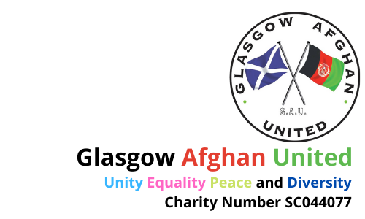

GLASGOW AFGHAN UNITED

JOB DESCRIPTION

Job Title: Administrative Assistant (part-time) 3 Years

12 hours per week £8,784.00 pro-rata + NI/P

Reports To: Glasgow Afghan United Board

Overall Job Purpose

The Administrative Assistant will be responsible for providing support to ensure the efficient running of the charity. The successful candidate will carry out a range of tasks underpinning GAU’s work with Afghan people in Scotland and facilitating successful integration through education, skill-building, mental health and wellbeing, cultural and sporting activities in a culturally-sensitive manner.

Key Responsibilities

- Monitoring communications channels; answering and passing messages to the relevant GAU team member as appropriate and providing relevant information to inquiries
- Diary support to the Director; scheduling meetings and providing relevant information to guests and partners
- Accurate and efficient record-keeping in line with GDPR requirements
- Assisting with the planning and coordination of GAU events and activity programmes, including venue, travel and equipment bookings
- Supporting the GAU team by performing tasks related to the organisation
- Facilitating clear and effective communication within the organisation and with external partners
- Liaising with sessional workers, GAU management and external partners
- Managing the general administrative work
- Carrying out other duties identified by GAU as deemed reasonable to facilitate the running of the organisation

Other Duties

- Maintaining the agreed quality standards and team standards in a consistent manner and across all functions of the team.
- Developing good working relationships with internal and external services and organisations; representing GAU in a professional manner at all times
- Undertaking training and development activities as required to develop skills and abilities which will enable the post-holder to fulfil the purpose of the role and support the success of the organisation
- Participating in and contributing to organisational/team meetings as required.
- Providing reports for the management committee as required.
- Providing appropriate support to volunteers as required
- Ensuring all health and safety requirements are met in the delivery of the services
- Undertaking all work in accordance with GAU policies and procedures
- Ensuring all work is carried out in accordance with GAU values, equality aims, policies and procedures
- Undertaking any other appropriate duties as requested

GLASGOW AFGHAN UNITED
Person Specification

Quality | Essential | Desirable
Education and Training | Educated to HNC level or demonstrate equivalent experience | Knowledge of Scottish National Standards for Information and Advice Providers  Ability to speak Dari, Pashto or Farsi
Job Experience and Skills | Three years of experience within a similar role  Excellent communication skills both verbal and written  Effective negotiating skills with a wide range of individuals and organisations  Interpersonal skills including an awareness of cultural similarities  IT skills including competency in Microsoft Office, Excel and Outlook  Aptitude for problem solving and ability to work under minimal supervision | Experience of working with vulnerable groups  Knowledge of statutory and voluntary services and legislation  Awareness of health and safety requirements and the ability to apply these whilst working in a public access area  Experience of working with volunteers

