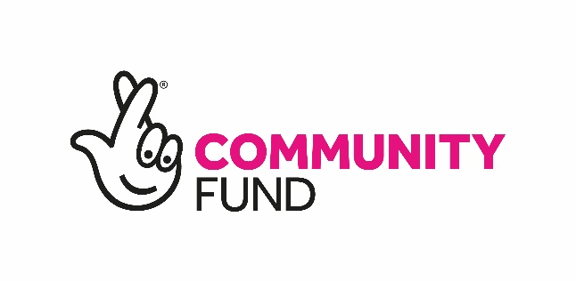

Employer: Fuse Youth Café Glasgow
Title: Shettleston 100 Coordinator
Reports to CEO
Hours: 35 hours per week, varying, including daytime, evening, weekends.
Salary: £28,000
Pension: 3% contributory pension.
Contract: Initially 1 year (key strategic objective for Fuse so trying to make this a core service)

Purpose of Job
Funded by the National Lottery, the Shettleston 100 project brings together key partners in Shettleston, led by Fuse Youth Café. It aims to raise awareness of climate change and help reduce wasteful and unsustainable consumption, showing that people can reduce their climate impact whilst also saving money. Shettleston residents will be asked to volunteer to complete purchase, consumption, and waste diaries, which will identify how households can change behaviours to reduce their costs and environmental impact. Individual reports will be produced, highlighting these changes as well as quantifying potential carbon and financial savings. Following this, volunteers will then be asked to complete diaries for a further period to provide an understanding of the before and after picture. Community engagement will be supported through filming a selection of the diaries, telling the story of what has worked, the benefits of taking part, the challenges, and how they have been overcome. This material will be used in a digital and social media campaign over the life of the project, involving social media advertising, podcasts, and appearances in existing local media. A pop-up shopfront will be established to showcase the project and people’s experiences including opportunities for people in the wider community to reduce their wasteful consumption and their carbon footprint. This will also be a venue in which the wider community will come together for events and activities, such as climate cafes, workshops exploring specific themes, or discussions around experiences and findings. In the final three months of the project, a future strategy will be co-produced for waste reduction and consumption in Shettleston.
This is an opportunity to take a 12-month post and turn it into a career. There is no doubt that this work is needed, and the post-holder will receive the full backing of Fuse. The community needs this service, it is a core objective for us and increasingly funders are willing to support Climate Change projects. We just need someone to work with us to develop it further.
Duties and Responsibilities:
- Day-to-day management of the project, ensuring it is delivered to the highest quality standards, whilst maintaining positive and productive working relationships with partners and funders.
- Leading on the design and development of project materials, including the waste and consumption diaries.
- Setting up and supporting Steering Group meetings to help guide the detailed implementation of the project.
- Setting up and working with a Community Reference Group to provide ongoing community input to the project.
- Overseeing volunteer recruitment and providing ongoing support and liaison with volunteers.
- Overseeing production and delivery of the reports associated with waste and consumption diaries.
- Overseeing marketing and community engagement activities, including capture of video diaries and other promotional material.
- Establishing pop-up shop and overseeing its implementation, including staffing and volunteering input.
- Liaison with local partners to deliver a range of workshops and other engagement activities over the course of the project.
- Putting in place effective monitoring and evaluation processes for the project using the Upshot® client management and reporting system.
- Coordinating subsequent independent evaluation and strategy development activities.
- Leading on the delivery of staff and volunteer training and development.
- Any other duties as requested by the CEO/COO for the benefit of the project and Fuse.
Ensuring compliance with relevant organisational policies such e.g. Health & Safety, Child Protection, COVID (all contained in staff induction pack) as well as membership of the PVG Scheme.
Person Specification
Essential

- Experience of successfully delivering projects that involve a range of partners or stakeholders.
- Project management experience including managing a team and providing effective leadership to, and management of, a team.
- Experience of delivering a Community Learning and Development approach to development of activities and services for the benefit of the community.
- Able to develop project proposals and secure agreement from external partners.
- Experienced in costing/pricing work and negotiating terms.
- Ability to collaborate and work positively across the Fuse team.
- Experience of reporting to funders on project outcomes.
- Excellent communication, project, and partner/stakeholder management skills.
- Commitment to reducing the effects of Climate Change.

Desirable

A relevant professional qualification e.g. Degree Level

Additional desirable attributes:

- Has a working knowledge of the issues around Climate Action.
- Analytical and inquisitive with the ability to draw on research, evidence and learning to develop projects.
- A strong character who is people focused with exceptional interpersonal, organisational and prioritisation skills.
- Commitment to delivering Fuse’s mission in partnership with others
- Proficient in use of Microsoft Office and digital communication platforms such as Zoom and Microsoft Teams.
- Able to manage budgets across different contracts.

We are an equal opportunities employer and welcome applications from all suitably qualified persons regardless of their race, sex, disability, religion/belief, sexual orientation, or age.

