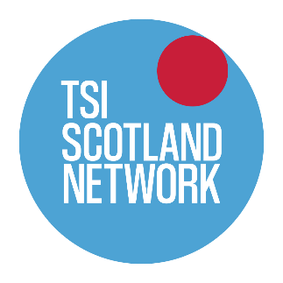


PERSON SPECIFICATION

POST TITLE: TSI Equalities & Human Rights Project Manager

Essential skills for this post

- Strong understanding of legislation, good practice, and challenges in the fields of equalities and human rights and their practical application

- A strong personal commitment to furthering equalities and human rights in Scotland

- An understanding of the third sector in Scotland and the contribution the sector makes to furthering equalities and human rights.

- Strong experience of managing a staff team, developing their capacity and ensuring that team members are able to achieve organisational goals.

- Experience of working in close partnership with other organisations to deliver a project.

- Strong customer-focused skills, communication and interpersonal skills

- Well organised, with the ability to independently plan future work

- Experience of implementing processes to support impact measurement and continuous improvement.

- Excellent written and verbal presentation skills and an ability to act as a strong, effective ambassador for GCVS and the wider third sector

- Educated to SCQF Level 9 or with comparable experience.

Desirable
- Experience of designing and delivering training

- Experience of developing tools and other resources that support capacity building of individuals or organisations.

