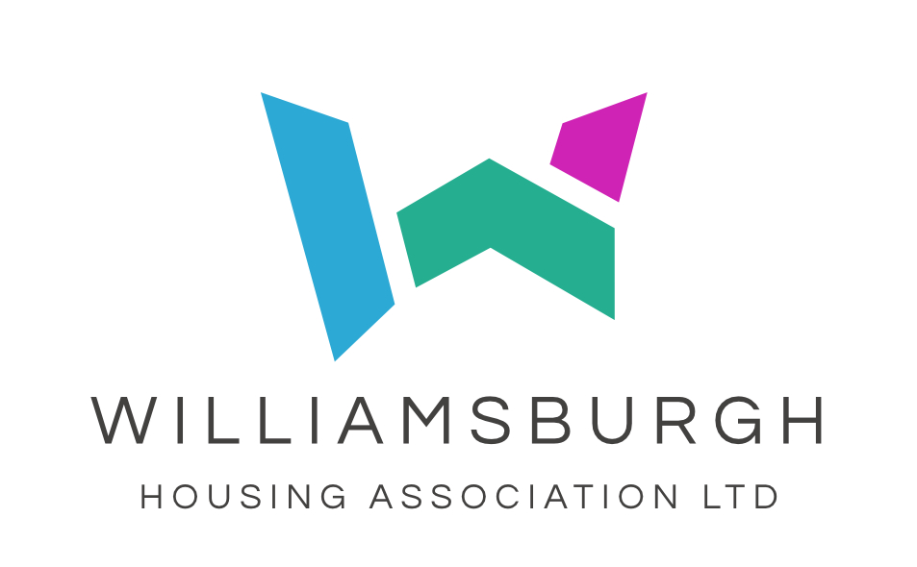

DIVERSITY AND EQUAL OPPORTUNITIES INFORMATION

To help us monitor our Diversity and Equal Opportunities policy and the effectiveness of our recruitment practices, we would like you to answer the following questions. This information will not be circulated to the Interview Panel.

1. Post applied for:

- Where did you see the post advertised?

3. Are you:

Male Female

4. Do you have a disability? By this we mean a condition, which has a long-
term and substantial effect on your ability to carry out normal day-to-day
activities.

Yes No

If yes, is it:

Physical Mental ill health

Learning disability Visual impairment

Hearing impairment

Other (please specify) ……………………………………..

5. Which of the following age bands do you belong to?

16-21 22-30 31-40

41-50 51-60 61-65

65+

A 6. How would you describe your ethnic group?

White Scottish White English

White Welsh White Northern Irish

White British White Irish

Gypsy/Traveller Polish

Other White Background

…… Any Mixed Background (Asian, Asian Scottish or Asian British)

C Pakistani Indian

Bangladeshi Chinese

Other Asian Background (Black, Black Scottish or Black British)

African Caribbean

- Black

- Other Black Background Other Ethnic Background

- Arab Other Background

……

