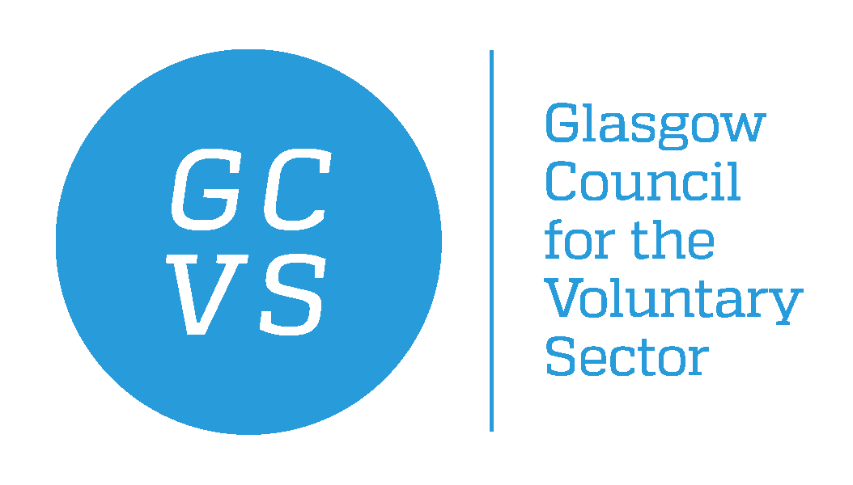
December 2021

Dear Applicant

Gambling Harms Development Worker
Post Title: | Gambling Harms Development Worker
Hours: | Part Time, 14 hours per week
Salary: | £22,791 per annum Pro rata
Term: | Fixed Term for one year
Responsible to: | Partnership Manager (Health and Social Care)
Location: | GCVS / Home based
Thank you for your interest in the above post. In response to your request for an application pack, please find the following enclosed:

GCVS application form comprising four parts:

- Part A – Application Form for Employment
- Part B – Contact Details and Data Protection Declaration
- Part C – Equal Opportunities Form
- Part D – Criminal Declaration Form

Please also find enclosed the following information:
- Guidance notes for candidates (within the application pack)
- Job Description
- Person Specification
- GCVS Equal Opportunities Statement (within the application pack)

When returning completed application, please do so by email to recruitment@gcvs.org.uk , to arrive no later than Sunday 16th January 2022. Late applications may not be considered.

Please notice that due to the high volume of applicants, we will only respond to candidates who are selected for interview.

We thank you for your interest in employment with GCVS.

Yours sincerely,

Farah Portela
HR Manager
GCVS

