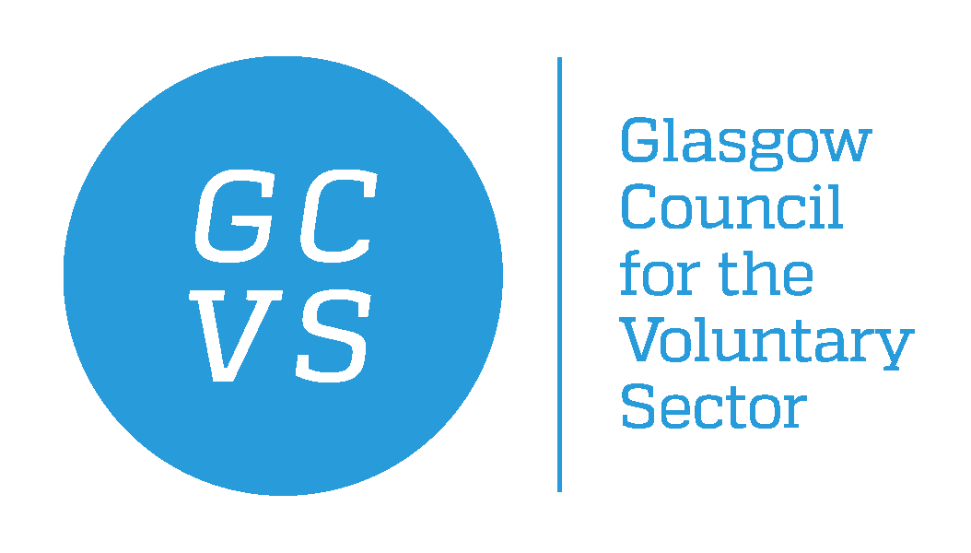
December 2021

Dear Applicant

Organisational Development Manager
Post Title: | Organisational Development Manager
Hours: | Full time - 35 hours per week
Salary: | Grade 7 point 36 – 38 (£30,465 – £32,242)
Term: | Permanent (subject to funding, after the first 2.5 years)
Responsible to: | Head of Sector Development
Location: | Flexible combination of home working and GCVS offices.

Thank you for your interest in the above post. In response to your request for an application pack, please find the following enclosed:

GCVS application form comprising four parts:

- Part A – Application Form for Employment
- Part B – Contact Details and Data Protection Declaration
- Part C – Equal Opportunities Form
- Part D – Criminal Declaration Form

Please also find enclosed the following information:
- Guidance notes for candidates (within the application pack)
- Job Description
- Person Specification
- GCVS Equal Opportunities Statement (within the application pack)

When returning completed application, please do so by email to recruitment@gcvs.org.uk , to arrive no later than Monday 17th January 2022. Late applications may not be considered.

Please notice that due to the high volume of applicants, we will only respond to candidates who are selected for interview.

We thank you for your interest in employment with GCVS.

Yours sincerely,

Farah Portela
HR Manager
GCVS

