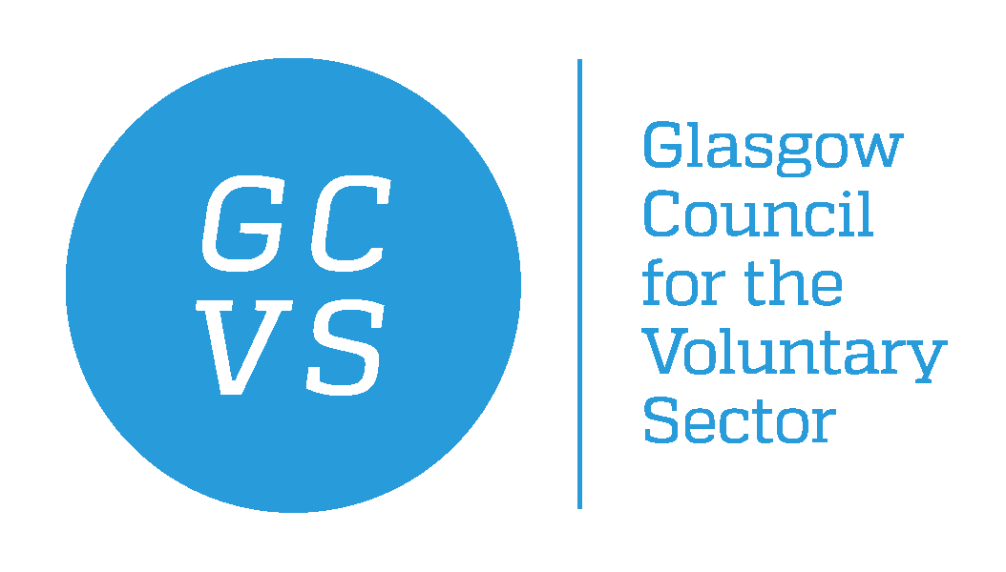

JOB DESCRIPTION

Post Title Gambling Harms Development Worker
Hours Part Time, 14 hours per week
Salary £22,791 per annum Pro rata
Responsible to Partnership Manager (Health and Social Care)
Term Fixed Term for one year
Location GCVS / Home based

Purpose of the Job

This post is part of the GCVS Health and Social Care team who work in partnership with the third sector and Glasgow City Health and Social Care Partnership (GCHSCP) to develop relationships, ensuring the third sector is involved at the earliest opportunity in service design and delivery.

This post will work with community organisations to understand the experiences of gambling participation, risks and harms and identify the priorities for action. There will be a focus on empowering and enabling local people, communities and services to work toward their priorities to tackle gambling harms.

As part of a 3 year pathfinder project, funding is through a regulatory settlement authorised by the UK Gambling Commission, to support the delivery of the National Strategy to Reduce Gambling Harms in Scotland and the Public Health Priorities. A community fund of £30K will provide small grants to support local people, communities and services at each stage.

The post holder will work closely with the GCHSCP, where a health improvement role is being established, to implement the distribution of the community fund. The post holder will also work with an evaluator, based within Public Health Scotland, in the embedding of whole systems thinking and the development of the evidence base. This work will build on extensive engagement undertaken to date with local partners within Glasgow City Council and the third sector.

Connecting with people with lived experience will be important in this role to understand their needs and develop relationships as key partners in this work. We welcome applications from those with lived experience of gambling related harms.

Excellent organisational skills and a commitment to a resourceful approach are necessary, as well as excellent communication skills. Ability to work as part of team and to work on your own initiative will be required.

MAIN TASKS AND RESPONSIBILITIES

- Service Delivery –

- Building and maintaining effective working relationships and knowledge of third sector and statutory partners.
- Researching and providing regular updates on policy and practice developments relating to gambling harms
- Producing and updating e-bulletins, newsletters, websites and social media
- Supporting research into needs and issues within the sector
- Supporting consultation exercises with third sector organisations and their service users;
- Analysing results and responses to consultations and drafting reports
- Arranging meetings and taking minutes
- Organising events and conferences

The post holder will also undertake similar duties around the broader research and support needs of the Policy and Networks Team, as required.

- Working with and Engaging People

- Communicate efficiently and courteously with a range of people
- Work successfully within the team providing the wide range of general duties
- Ensure a culture of enthusiasm, flexibility and co-operation within the Team
- Ensure a positive, customer orientated, solutions-based approach to all activities
- Participate in regular supervision, annual appraisal, staff training and development programmes
- Adhere to GCVS’s policies and procedures, particularly those relating to Equal Opportunities and Health & Safety at Work

- Strategic Understanding and Knowledge –

- Ensure you develop a clear understanding of how your job supports GCVS objectives within GCVS Operational plans
- Be a positive active and flexible participant working alongside the other GCVS staff to ensure that GCVS supports and develops the third sector in Glasgow
- Take an active role in expanding your understanding of other areas of GCVS in relation to your role.
- Support the Health and Social Care Team to develop services in line with identified needs and opportunities
- Take an active interest in expanding your personal knowledge of areas relating to your role as Development Worker

Health and Safety
Everyone in this organisation has a responsibility to ensure their own safety and that of others. Employees must report immediately to their Line Manager/ Team Leader or Supervisor any breaches of Health & Safety procedures, any accidents or safety related incidents and any unsafe acts.

Employment conditions

The following terms and conditions are typically offered to GCVS staff on fixed term and permanent contracts, and are set out here for your information only. Terms and conditions may vary according to circumstances and this summary does not form part of any subsequent employment contract.

- Annual leave entitlement: 25 days per annum and 28 days after 10 years’ service. 13.5 fixed public holidays. Pro rata for Part time employees.
- Paid sickness absence entitlement during first year of service is 4 weeks at full pay and 4 weeks at half pay, based on contractual hours and calculated on a rolling basis. This entitlement increases with service.
- Based primarily at GCVS, The Albany, Ashley Street, Glasgow
- References will be sought from previous employers prior to appointment.

Probationary period: 3 months with a review at 3 months. During the first 3 months the contract may be terminated with 1 weeks’ notice, thereafter it will be 4 weeks.

Pension: Contributory pension through Pension Trust
GCVS contributes 6% salary on condition the member of staff contributes at least 4%. This can be joined on completion of three months employment. Life Assurance when joining the pension: 3 times your salary payable on death in service.

Flexi time; GCVS operates a flexi-time system. Any additional hours or evening work required will be recompensed via flexi-time. GCVS is committed to Work-Life Balance.

